**Facebook**

Introduction

*"Interviewing for a technical job is hard, and so is being the interviewer. You want to get that engineering job at Facebook, and we want to hire the best people (you!). Knowing what to expect on both sides can go a long way toward making the process work better."*

- Carlos Bueno, an engineer in Facebook

Getting well prepared for an interview is important. However, preparing all questions asked is time consuming and stressful. The key points are practice and effective preparation.

We compiled this list thoroughly so you can save time and get well-prepared for a Facebook interview.

Arrays and Strings

 Longest Substring Without Repeating Characters

 String to Integer (atoi)

 Roman to Integer

 3Sum

 Remove Duplicates from Sorted Array

 Next Permutation

 Multiply Strings

 Group Anagrams

 Add Binary

 Minimum Window Substring

 Merge Sorted Array

 Valid Palindrome

 Read N Characters Given Read4

 Read N Characters Given Read4 II - Call multiple times

 One Edit Distance

 Product of Array Except Self

 Integer to English Words

 Move Zeroes

 Longest Substring with At Most K Distinct Characters

 Validate IP Address

 Subarray Sum Equals K

 Valid Palindrome II

Linked Lists

 Add Two Numbers

 Merge Two Sorted Lists

 Copy List with Random Pointer

 Reorder List

Trees and Graphs

 Validate Binary Search Tree

 Flatten Binary Tree to Linked List

 Binary Tree Maximum Path Sum

 Clone Graph

 Binary Tree Right Side View

 Number of Islands

 Lowest Common Ancestor of a Binary Tree

 Binary Tree Paths

 Alien Dictionary

 Shortest Distance from All Buildings

 Diameter of Binary Tree

 Accounts Merge

 Convert Binary Search Tree to Sorted Doubly Linked List

 Is Graph Bipartite?

 Binary Tree Vertical Order Traversal

Recursion

 Letter Combinations of a Phone Number

 Permutations

 Permutations II

 Remove Invalid Parentheses

 Regular Expression Matching

 Subsets

 Strobogrammatic Number II

Sorting and Searching

 Divide Two Integers

 Search in Rotated Sorted Array

 Find First and Last Position of Element in Sorted Array

 Pow(x, n)

 Merge Intervals

 Find Peak Element

 First Bad Version

 Intersection of Two Arrays

 Intersection of Two Arrays II

Dynamic Programming

 Longest Palindromic Substring

 Longest Valid Parentheses

 Decode Ways

 Best Time to Buy and Sell Stock

 Word Break

 Range Sum Query 2D - Immutable

 Continuous Subarray Sum

Design

 LRU Cache

 Binary Search Tree Iterator

 Add and Search Word - Data structure design

 Serialize and Deserialize Binary Tree

Others

 Expression Add Operators

 Find All Anagrams in a String

 Permutation in String

 Verifying an Alien Dictionary

 Interval List Intersections

SQL

 Second Highest Salary

 Nth Highest Salary

 Customers Who Never Order

 Friend Requests I: Overall Acceptance Rate

 Friend Requests II: Who Has the Most Friends

 Department Top Three Salaries

## Arrays and Strings

[Move Zeroes](https://leetcode.com/problems/move-zeroes) is a popular one for phone interviews. Note that you may be asked follow up about analyzing and optimizing the number of steps in your algorithm.

**Longest Substring Without Repeating Characters**

Given a string s, find the length of the **longest substring** without repeating characters.

**Example 1:**

**Input:** s = "abcabcbb"

**Output:** 3

**Explanation:** The answer is "abc", with the length of 3.

**Example 2:**

**Input:** s = "bbbbb"

**Output:** 1

**Explanation:** The answer is "b", with the length of 1.

**Example 3:**

**Input:** s = "pwwkew"

**Output:** 3

**Explanation:** The answer is "wke", with the length of 3.

Notice that the answer must be a substring, "pwke" is a subsequence and not a substring.

**Example 4:**

**Input:** s = ""

**Output:** 0

**Constraints:**

* 0 <= s.length <= 5 * 104
* s consists of English letters, digits, symbols and spaces.

HashTable

**String to Integer (atoi) - EZ**  
Implement the myAtoi(string s) function, which converts a string to a 32-bit signed integer (similar to C/C++'s atoi function).

The algorithm for myAtoi(string s) is as follows:

1. Read in and ignore any leading whitespace.
2. Check if the next character (if not already at the end of the string) is '-' or '+'. Read this character in if it is either. This determines if the final result is negative or positive respectively. Assume the result is positive if neither is present.
3. Read in next the characters until the next non-digit charcter or the end of the input is reached. The rest of the string is ignored.
4. Convert these digits into an integer (i.e. "123" -> 123, "0032" -> 32). If no digits were read, then the integer is 0. Change the sign as necessary (from step 2).
5. If the integer is out of the 32-bit signed integer range [-231, 231 - 1], then clamp the integer so that it remains in the range. Specifically, integers less than -231 should be clamped to -231, and integers greater than 231 - 1 should be clamped to 231 - 1.
6. Return the integer as the final result.

**Note:**

* Only the space character ' ' is considered a whitespace character.
* **Do not ignore** any characters other than the leading whitespace or the rest of the string after the digits.

**Example 1:**

**Input:** s = "42"

**Output:** 42

**Explanation:** The underlined characters are what is read in, the caret is the current reader position.

Step 1: "42" (no characters read because there is no leading whitespace)

^

Step 2: "42" (no characters read because there is neither a '-' nor '+')

^

Step 3: "42" ("42" is read in)

^

The parsed integer is 42.

Since 42 is in the range [-231, 231 - 1], the final result is 42.

**Example 2:**

**Input:** s = " -42"

**Output:** -42

**Explanation:**

Step 1: " -42" (leading whitespace is read and ignored)

^

Step 2: " -42" ('-' is read, so the result should be negative)

^

Step 3: " -42" ("42" is read in)

^

The parsed integer is -42.

Since -42 is in the range [-231, 231 - 1], the final result is -42.

**Example 3:**

**Input:** s = "4193 with words"

**Output:** 4193

**Explanation:**

Step 1: "4193 with words" (no characters read because there is no leading whitespace)

^

Step 2: "4193 with words" (no characters read because there is neither a '-' nor '+')

^

Step 3: "4193 with words" ("4193" is read in; reading stops because the next character is a non-digit)

^

The parsed integer is 4193.

Since 4193 is in the range [-231, 231 - 1], the final result is 4193.

**Example 4:**

**Input:** s = "words and 987"

**Output:** 0

**Explanation:**

Step 1: "words and 987" (no characters read because there is no leading whitespace)

^

Step 2: "words and 987" (no characters read because there is neither a '-' nor '+')

^

Step 3: "words and 987" (reading stops immediately because there is a non-digit 'w')

^

The parsed integer is 0 because no digits were read.

Since 0 is in the range [-231, 231 - 1], the final result is 0.

**Example 5:**

**Input:** s = "-91283472332"

**Output:** -2147483648

**Explanation:**

Step 1: "-91283472332" (no characters read because there is no leading whitespace)

^

Step 2: "-91283472332" ('-' is read, so the result should be negative)

^

Step 3: "-91283472332" ("91283472332" is read in)

^

The parsed integer is -91283472332.

Since -91283472332 is less than the lower bound of the range [-231, 231 - 1], the final result is clamped to -231 = -2147483648.

**Constraints:**

* 0 <= s.length <= 200
* s consists of English letters (lower-case and upper-case), digits (0-9), ' ', '+', '-', and '.'.

**Roman to Integer - EZ**

Roman numerals are represented by seven different symbols: I, V, X, L, C, D and M.

**Symbol** **Value**

I 1

V 5

X 10

L 50

C 100

D 500

M 1000

For example, 2 is written as II in Roman numeral, just two one's added together. 12 is written as XII, which is simply X + II. The number 27 is written as XXVII, which is XX + V + II.

Roman numerals are usually written largest to smallest from left to right. However, the numeral for four is not IIII. Instead, the number four is written as IV. Because the one is before the five we subtract it making four. The same principle applies to the number nine, which is written as IX. There are six instances where subtraction is used:

* I can be placed before V (5) and X (10) to make 4 and 9.
* X can be placed before L (50) and C (100) to make 40 and 90.
* C can be placed before D (500) and M (1000) to make 400 and 900.

Given a roman numeral, convert it to an integer.

**Example 1:**

**Input:** s = "III"

**Output:** 3

**Example 2:**

**Input:** s = "IV"

**Output:** 4

**Example 3:**

**Input:** s = "IX"

**Output:** 9

**Example 4:**

**Input:** s = "LVIII"

**Output:** 58

**Explanation:** L = 50, V= 5, III = 3.

**Example 5:**

**Input:** s = "MCMXCIV"

**Output:** 1994

**Explanation:** M = 1000, CM = 900, XC = 90 and IV = 4.

**Constraints:**

* 1 <= s.length <= 15
* s contains only the characters ('I', 'V', 'X', 'L', 'C', 'D', 'M').
* It is **guaranteed** that s is a valid roman numeral in the range [1, 3999].

**3Sum**

Given an array nums of *n* integers, are there elements *a*, *b*, *c* in nums such that *a* + *b* + *c* = 0? Find all unique triplets in the array which gives the sum of zero.

Notice that the solution set must not contain duplicate triplets.

**Example 1:**

**Input:** nums = [-1,0,1,2,-1,-4]

**Output:** [[-1,-1,2],[-1,0,1]]

**Example 2:**

**Input:** nums = []

**Output:** []

**Example 3:**

**Input:** nums = [0]

**Output:** []

**Constraints:**

* 0 <= nums.length <= 3000
* -105 <= nums[i] <= 105

**Remove Duplicates from Sorted Array**

Given a sorted array *nums*, remove the duplicates [**in-place**](https://en.wikipedia.org/wiki/In-place_algorithm) such that each element appears only *once* and returns the new length.

Do not allocate extra space for another array, you must do this by **modifying the input array**[**in-place**](https://en.wikipedia.org/wiki/In-place_algorithm) with O(1) extra memory.

**Clarification:**

Confused why the returned value is an integer but your answer is an array?

Note that the input array is passed in by **reference**, which means a modification to the input array will be known to the caller as well.

Internally you can think of this:

// **nums** is passed in by reference. (i.e., without making a copy)

int len = removeDuplicates(nums);

// any modification to **nums** in your function would be known by the caller.

// using the length returned by your function, it prints the first **len** elements.

for (int i = 0; i < len; i++) {

    print(nums[i]);

}

**Example 1:**

**Input:** nums = [1,1,2]

**Output:** 2, nums = [1,2]

**Explanation:** Your function should return length = **2**, with the first two elements of *nums* being **1** and **2** respectively. It doesn't matter what you leave beyond the returned length.

Array 101

**Next Permutation**

Implement **next permutation**, which rearranges numbers into the lexicographically next greater permutation of numbers.

If such an arrangement is not possible, it must rearrange it as the lowest possible order (i.e., sorted in ascending order).

The replacement must be [**in place**](http://en.wikipedia.org/wiki/In-place_algorithm) and use only constant extra memory.

**Example 1:**

**Input:** nums = [1,2,3]

**Output:** [1,3,2]

**Example 2:**

**Input:** nums = [3,2,1]

**Output:** [1,2,3]

**Example 3:**

**Input:** nums = [1,1,5]

**Output:** [1,5,1]

**Example 4:**

**Input:** nums = [1]

**Output:** [1]

**Constraints:**

* 1 <= nums.length <= 100
* 0 <= nums[i] <= 100

Google

**Multiply Strings**

Given two non-negative integers num1 and num2 represented as strings, return the product of num1 and num2, also represented as a string.

**Note:** You must not use any built-in BigInteger library or convert the inputs to integer directly.

**Example 1:**

**Input:** num1 = "2", num2 = "3"

**Output:** "6"

**Example 2:**

**Input:** num1 = "123", num2 = "456"

**Output:** "56088"

**Constraints:**

* 1 <= num1.length, num2.length <= 200
* num1 and num2 consist of digits only.
* Both num1 and num2 do not contain any leading zero, except the number 0 itself.

No Answer yet

**Group Anagrams**

Given an array of strings strs, group **the anagrams** together. You can return the answer in **any order**.

An **Anagram** is a word or phrase formed by rearranging the letters of a different word or phrase, typically using all the original letters exactly once.

**Example 1:**

**Input:** strs = ["eat","tea","tan","ate","nat","bat"]

**Output:** [["bat"],["nat","tan"],["ate","eat","tea"]]

**Example 2:**

**Input:** strs = [""]

**Output:** [[""]]

**Example 3:**

**Input:** strs = ["a"]

**Output:** [["a"]]

**Constraints:**

* 1 <= strs.length <= 104
* 0 <= strs[i].length <= 100
* strs[i] consists of lower-case English letters.

HashTable

**Add Binary**

Given two binary strings a and b, return *their sum as a binary string*.

**Example 1:**

**Input:** a = "11", b = "1"

**Output:** "100"

**Example 2:**

**Input:** a = "1010", b = "1011"

**Output:** "10101"

**Constraints:**

* 1 <= a.length, b.length <= 104
* a and b consist only of '0' or '1' characters.
* Each string does not contain leading zeros except for the zero itself.

Array

**Minimum Window Substring**

Given two strings s and t, return *the minimum window in s which will contain all the characters in t*. If there is no such window in s that covers all characters in t, return *the empty string ""*.

**Note** that If there is such a window, it is guaranteed that there will always be only one unique minimum window in s.

**Example 1:**

**Input:** s = "ADOBECODEBANC", t = "ABC"

**Output:** "BANC"

**Example 2:**

**Input:** s = "a", t = "a"

**Output:** "a"

**Constraints:**

* 1 <= s.length, t.length <= 105
* s and t consist of English letters.

**Follow up:** Could you find an algorithm that runs in O(n) time?

Hard

**Merge Sorted Array**

Given two sorted integer arrays nums1 and nums2, merge nums2 into nums1 as one sorted array.

The number of elements initialized in nums1 and nums2 are m and n respectively. You may assume that nums1 has a size equal to m + n such that it has enough space to hold additional elements from nums2.

**Example 1:**

**Input:** nums1 = [1,2,3,0,0,0], m = 3, nums2 = [2,5,6], n = 3

**Output:** [1,2,2,3,5,6]

**Example 2:**

**Input:** nums1 = [1], m = 1, nums2 = [], n = 0

**Output:** [1]

**Constraints:**

* nums1.length == m + n
* nums2.length == n
* 0 <= m, n <= 200
* 1 <= m + n <= 200
* -109 <= nums1[i], nums2[i] <= 109

Array 101

**Valid Palindrome**

Given a string s, determine if it is a palindrome, considering only alphanumeric characters and ignoring cases.

**Example 1:**

**Input:** s = "A man, a plan, a canal: Panama"

**Output:** true

**Explanation:** "amanaplanacanalpanama" is a palindrome.

**Example 2:**

**Input:** s = "race a car"

**Output:** false

**Explanation:** "raceacar" is not a palindrome.

**Constraints:**

* 1 <= s.length <= 2 * 105
* s consists only of printable ASCII characters.

EZ

**Read N Characters Given Read4**

Given a file and assume that you can only read the file using a given method read4, implement a method to read *n* characters.

**Method read4:**

The API read4 reads 4 consecutive characters from the file, then writes those characters into the buffer array buf4.

The return value is the number of actual characters read.

Note that read4() has its own file pointer, much like FILE *fp in C.

**Definition of read4:**

Parameter: char[] buf4

Returns: int

Note: buf4[] is destination not source, the results from read4 will be copied to buf4[]

Below is a high level example of how read4 works:

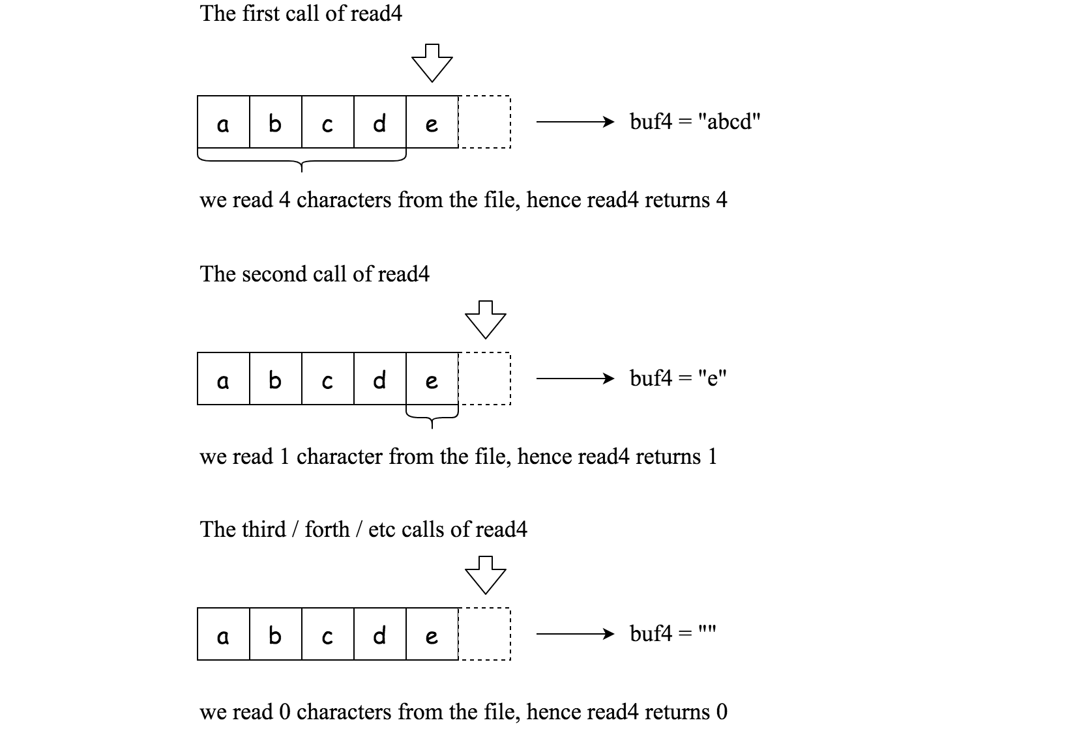

File file("abcde"); // File is "abcde", initially file pointer (fp) points to 'a'

char[] buf4 = new char[4]; // Create buffer with enough space to store characters

read4(buf4); // read4 returns 4. Now buf4 = "abcd", fp points to 'e'

read4(buf4); // read4 returns 1. Now buf4 = "e", fp points to end of file

read4(buf4); // read4 returns 0. Now buf4 = "", fp points to end of file

**Method read:**

By using the read4 method, implement the method read that reads *n* characters from the file and store it in the buffer array buf. Consider that you **cannot** manipulate the file directly.

The return value is the number of actual characters read.

**Definition of read:**

Parameters: char[] buf, int n

Returns: int

Note: buf[] is destination not source, you will need to write the results to buf[]

**Example 1:**

**Input:** file = "abc", n = 4

**Output:** 3

**Explanation:** After calling your read method, buf should contain "abc". We read a total of 3 characters from the file, so return 3. Note that "abc" is the file's content, not buf. buf is the destination buffer that you will have to write the results to.

**Example 2:**

**Input:** file = "abcde", n = 5

**Output:** 5

**Explanation:** After calling your read method, buf should contain "abcde". We read a total of 5 characters from the file, so return 5.

**Example 3:**

**Input:** file = "abcdABCD1234", n = 12

**Output:** 12

**Explanation:** After calling your read method, buf should contain "abcdABCD1234". We read a total of 12 characters from the file, so return 12.

**Example 4:**

**Input:** file = "leetcode", n = 5

**Output:** 5

**Explanation:** After calling your read method, buf should contain "leetc". We read a total of 5 characters from the file, so return 5.

**Note:**

* Consider that you **cannot** manipulate the file directly, the file is only accesible for read4 but **not** for read.
* The read function will only be called once for each test case.
* You may assume the destination buffer array, buf, is guaranteed to have enough space for storing *n* characters.

Solution

Overview

**Interview Tendencies: Google and Facebook**

A long time ago, long ago, so long ago that no one can remember, algorithm interview questions were less popular. Ten years ago big companies mainly filtered the candidates by the university ranks, and the interview questions were like [please describe how DDR memory works](https://hexus.net/tech/tech-explained/ram/702-ddr-ii-how-it-works/).

Nowadays there are some tendencies to merge this "old-style interview" with the modern algorithm questions interview. The idea is to ask a question which sounds like algorithmic but checks your knowledge of how do computers work: [Round-robin CPU scheduling](https://en.wikipedia.org/wiki/Round-robin_scheduling), [C10k problem first solved by nginx](https://en.wikipedia.org/wiki/C10k_problem), etc.

Is it good or bad? That's a reality to deal with, especially if we speak about Google or Facebook interviews.

**Read N Characters Given Read4**

Back to the problem, the question is "how does the memory work":

* Because of the physical implementation, loading 4 bytes in DDR is faster than to load 1 byte 4 times.
* On the majority of computers today, collection of 4 bytes, or 32 bits, is called a *word*. Most modern CPUs are optimized for the operations with *words*.

To sum up, the problem is a practical low-level question. The standard approach (Approach 1) to solve it using the *internal* buffer of 4 characters:

File -> Internal Buffer of 4 Characters -> Buffer of N Characters.

 *Figure 1. Approach 1: solution with internal buffer.*

Once it's done, and you show your understanding of memory operations, the follow-up question is how to speed up. The answer (Approach 2) is quite straightforward. If it's possible, do not use the internal buffer of 4 characters to avoid the double copy:

File -> Buffer of N Characters.

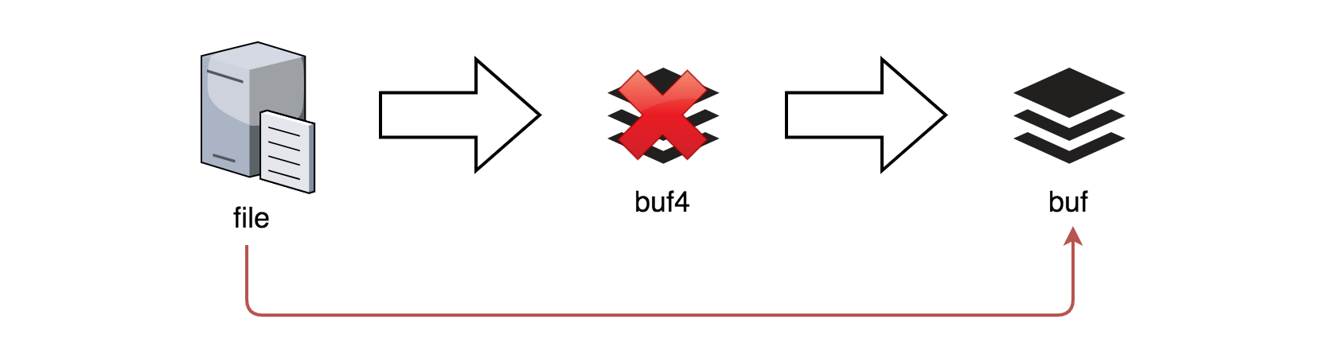 *Figure 2. Approach 2: solution without internal buffer.*

Approach 1: Use Internal Buffer of 4 Characters

 *Figure 3. Solution with internal buffer.*

**Algorithm**

Let's use an internal buffer of 4 characters to solve this problem:

File -> Internal Buffer of 4 Characters -> Buffer of N Characters.

* Initialize the number of copied characters copiedChars = 0, and the number of read characters: readChars = 4. It's convenient initialize readChars to 4 and then use readChars != 4 as EOF marker.
* Initialize an internal buffer of 4 characters: buf4.
* While number of copied characters is less than N: copiedChars < n and there are still characters in the file: readChars == 4:
  + Read from file into internal buffer: readChars = read4(buf4).
  + Copy the characters from internal buffer buf4 into main buffer buf one by one. Increase copiedChars after each character. In the number of copied characters is equal to N: copiedChars == n, interrupt the copy process and return copiedChars.

**Implementation**

|  |
| --- |
| public class Solution extends Reader4 {  public int read(char[] buf, int n) {  int copiedChars = 0, readChars = 4;  char[] buf4 = new char[4];    while (copiedChars < n && readChars == 4) {  readChars = read4(buf4);    for (int i = 0; i < readChars; ++i) {  if (copiedChars == n)  return copiedChars;  buf[copiedChars] = buf4[i];  ++copiedChars;  }  }  return copiedChars;  }  } |

**Complexity Analysis**

* Time complexity: \mathcal{O}(N)O(*N*) to copy N characters.
* Space complexity: \mathcal{O}(1)O(1) to keep buf4 of 4 elements.

#### **Approach 2: Speed Up: No Internal Buffer**

 Figure 4. Solution without internal buffer.

This solution is mainly suitable for the languages (C, C++, Golang) where pointers allow to append directly to the primary buffer buf.

**Algorithm**

* Initialize the number of copied characters copiedChars = 0, and the number of read characters: readChars = 4.
* While number of copied characters is less than N: copiedChars < n and there are still characters in the file: readChars == 4:
  + Read from file directly into buffer: read4(buf + copiedChars).
  + Increase copiedChars: copiedChars += readChars.
* Now buf contains at least N characters. Return min(n, copiedChars).

**Implementation**

|  |
| --- |
| class Solution {  public:  int read(char *buf, int n) {  int copiedChars = 0, readChars = 4;    while (copiedChars < n && readChars == 4) {  readChars = read4(buf + copiedChars);  copiedChars += readChars;  }  return min(n, copiedChars);  }  }; |

**Complexity Analysis**

* Time complexity: \mathcal{O}(N)O(*N*) to copy N characters.
* Space complexity: \mathcal{O}(1)O(1).

**Read N Characters Given Read4 II - Call multiple times**

Given a file and assume that you can only read the file using a given method read4, implement a method read to read *n* characters. **Your method read may be called multiple times.**

**Method read4:**

The API read4 reads 4 consecutive characters from the file, then writes those characters into the buffer array buf4.

The return value is the number of actual characters read.

Note that read4() has its own file pointer, much like FILE *fp in C.

**Definition of read4:**

Parameter: char[] buf4

Returns: int

Note: buf4[] is destination not source, the results from read4 will be copied to buf4[]

Below is a high level example of how read4 works:



File file("abcde"); // File is "abcde", initially file pointer (fp) points to 'a'

char[] buf4 = new char[4]; // Create buffer with enough space to store characters

read4(buf4); // read4 returns 4. Now buf4 = "abcd", fp points to 'e'

read4(buf4); // read4 returns 1. Now buf4 = "e", fp points to end of file

read4(buf4); // read4 returns 0. Now buf4 = "", fp points to end of file

**Method read:**

By using the read4 method, implement the method read that reads *n* characters from the file and store it in the buffer array buf. Consider that you **cannot** manipulate the file directly.

The return value is the number of actual characters read.

**Definition of read:**

Parameters: char[] buf, int n

Returns: int

Note: buf[] is destination not source, you will need to write the results to buf[]

**Example 1:**

File file("abc");

Solution sol;

// Assume buf is allocated and guaranteed to have enough space for storing all characters from the file.

sol.read(buf, 1); // After calling your read method, buf should contain "a". We read a total of 1 character from the file, so return 1.

sol.read(buf, 2); // Now buf should contain "bc". We read a total of 2 characters from the file, so return 2.

sol.read(buf, 1); // We have reached the end of file, no more characters can be read. So return 0.

**Example 2:**

File file("abc");

Solution sol;

sol.read(buf, 4); // After calling your read method, buf should contain "abc". We read a total of 3 characters from the file, so return 3.

sol.read(buf, 1); // We have reached the end of file, no more characters can be read. So return 0.

**Note:**

* Consider that you **cannot** manipulate the file directly, the file is only accesible for read4 but **not** for read.
* The read function may be called **multiple times**.
* Please remember to **RESET** your class variables declared in Solution, as static/class variables are **persisted across multiple test cases**. Please see [here](https://leetcode.com/faq/) for more details.
* You may assume the destination buffer array, buf, is guaranteed to have enough space for storing *n* characters.
* It is guaranteed that in a given test case the same buffer buf is called by read.

**One Edit Distance**

Given two strings s and t, return true if they are both one edit distance apart, otherwise return false.

A string s is said to be one distance apart from a string t if you can:

* Insert **exactly one** character into s to get t.
* Delete **exactly one** character from s to get t.
* Replace **exactly one** character of s with **a different character** to get t.

**Example 1:**

**Input:** s = "ab", t = "acb"

**Output:** true

**Explanation:** We can insert 'c' into s to get t.

**Example 2:**

**Input:** s = "", t = ""

**Output:** false

**Explanation:** We cannot get t from s by only one step.

**Example 3:**

**Input:** s = "a", t = ""

**Output:** true

**Example 4:**

**Input:** s = "", t = "A"

**Output:** true

**Constraints:**

* 0 <= s.length <= 104
* 0 <= t.length <= 104
* s and t consist of lower-case letters, upper-case letters **and/or** digits.

Solution

Approach 1: One pass algorithm

**Intuition**

First of all, let's ensure that the string lengths are not too far from each other. If the length difference is 2 or more characters, then s and t couldn't be one edit away strings.

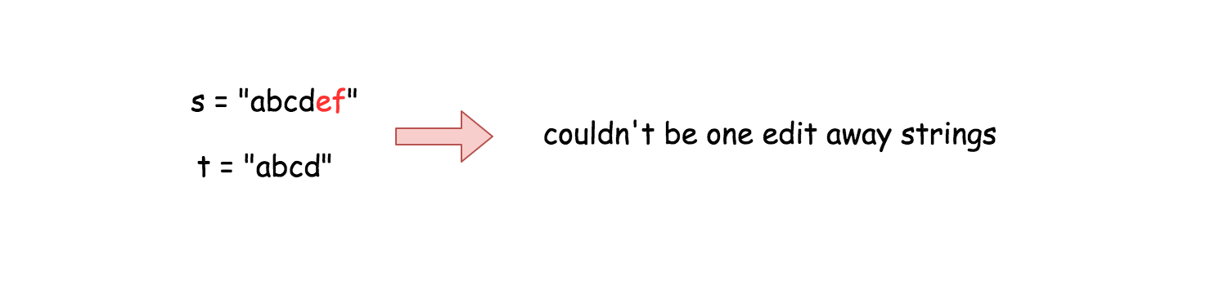

For the next let's assume that s is always shorter or the same length as t. If not, one could always call isOneEditDistance(t, s) to inverse the string order.

Now it's time to pass along the strings and to look for the first different character.

If there is no differences between the first len(s) characters, only two situations are possible :

* The strings are equal.
* The strings are one edit away distance.

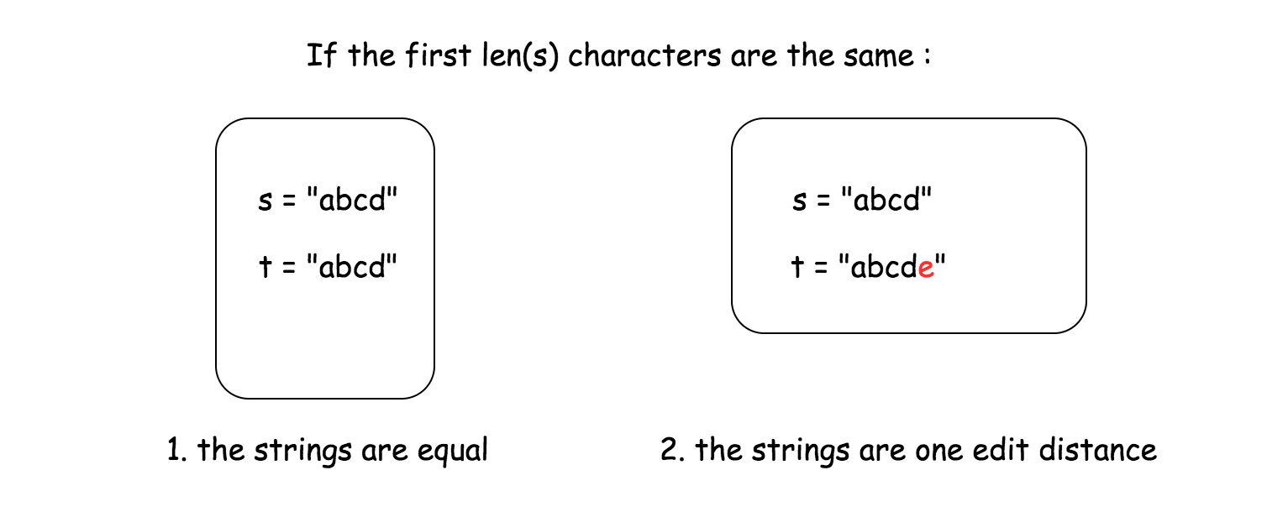

Now what if there *is* a different character so that s[i] != t[i].

* If the strings are of the same length, *all* next characters should be equal to keep one edit away distance. To verify it, one has to compare the substrings of s and t both starting from the i + 1th character.
* If t is one character longer than s, the additional character t[i] should be the only difference between both strings. To verify it, one has to compare a substring of s starting from the ith character and a substring of t starting from the i + 1th character.

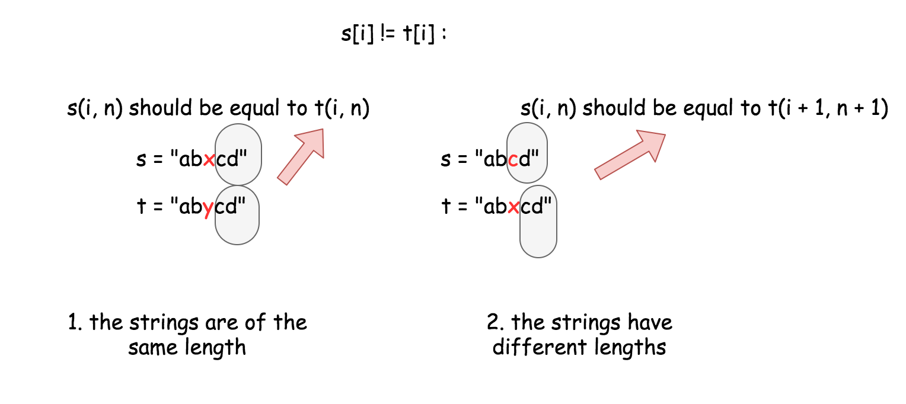

**Implementation**

|  |
| --- |
| class Solution {  public boolean isOneEditDistance(String s, String t) {  int ns = s.length();  int nt = t.length();  // Ensure that s is shorter than t.  if (ns > nt)  return isOneEditDistance(t, s);  // The strings are NOT one edit away distance  // if the length diff is more than 1.  if (nt - ns > 1)  return false;  for (int i = 0; i < ns; i++)  if (s.charAt(i) != t.charAt(i))  // if strings have the same length  if (ns == nt)  return s.substring(i + 1).equals(t.substring(i + 1));  // if strings have different lengths  else  return s.substring(i).equals(t.substring(i + 1));  // If there is no diffs on ns distance  // the strings are one edit away only if  // t has one more character.  return (ns + 1 == nt);  }  } |

**Complexity Analysis**

* Time complexity : \mathcal{O}(N)O(*N*) in the worst case when string lengths are close enough abs(ns - nt) <= 1, where N is a number of characters in the longest string. \mathcal{O}(1)O(1) in the best case when abs(ns - nt) > 1.
* Space complexity : \mathcal{O}(N)O(*N*) because strings are immutable in Python and Java and to create substring costs \mathcal{O}(N)O(*N*) space.

**Problem generalization : Edit distance**

[Given two words word1 and word2, find the minimum number of operations required to convert word1 to word2.](https://leetcode.com/articles/edit-distance/)

**Product of Array Except Self**

Given an array nums of n integers where n > 1,  return an array output such that output[i] is equal to the product of all the elements of nums except nums[i].

**Example:**

**Input:** [1,2,3,4]

**Output:** [24,12,8,6]

**Constraint:** It's guaranteed that the product of the elements of any prefix or suffix of the array (including the whole array) fits in a 32 bit integer.

**Note:**Please solve it **without division** and in O(n).

**Follow up:**  
Could you solve it with constant space complexity? (The output array **does not** count as extra space for the purpose of space complexity analysis.)

Hard

**Integer to English Words**

Convert a non-negative integer num to its English words representation.

**Example 1:**

**Input:** num = 123

**Output:** "One Hundred Twenty Three"

**Example 2:**

**Input:** num = 12345

**Output:** "Twelve Thousand Three Hundred Forty Five"

**Example 3:**

**Input:** num = 1234567

**Output:** "One Million Two Hundred Thirty Four Thousand Five Hundred Sixty Seven"

**Example 4:**

**Input:** num = 1234567891

**Output:** "One Billion Two Hundred Thirty Four Million Five Hundred Sixty Seven Thousand Eight Hundred Ninety One"

**Constraints:**

* 0 <= num <= 231 - 1

Solution

Approach 1: Divide and conquer

Let's simplify the problem by representing it as a set of simple sub-problems. One could split the initial integer 1234567890 on the groups containing not more than three digits 1.234.567.890. That results in representation 1 Billion 234 Million 567 Thousand 890 and reduces the initial problem to how to convert 3-digit integer to English word. One could split further 234 -> 2 Hundred 34 into two sub-problems : convert 1-digit integer and convert 2-digit integer. The first one is trivial. The second one could be reduced to the first one for all 2-digit integers but the ones from 10 to 19 which should be considered separately.



|  |
| --- |
| class Solution {  public String one(int num) {  switch(num) {  case 1: return "One";  case 2: return "Two";  case 3: return "Three";  case 4: return "Four";  case 5: return "Five";  case 6: return "Six";  case 7: return "Seven";  case 8: return "Eight";  case 9: return "Nine";  }  return "";  }  public String twoLessThan20(int num) {  switch(num) {  case 10: return "Ten";  case 11: return "Eleven";  case 12: return "Twelve";  case 13: return "Thirteen";  case 14: return "Fourteen";  case 15: return "Fifteen";  case 16: return "Sixteen";  case 17: return "Seventeen";  case 18: return "Eighteen";  case 19: return "Nineteen";  }  return "";  }  public String ten(int num) {  switch(num) {  case 2: return "Twenty";  case 3: return "Thirty";  case 4: return "Forty";  case 5: return "Fifty";  case 6: return "Sixty";  case 7: return "Seventy";  case 8: return "Eighty";  case 9: return "Ninety";  }  return "";  }  public String two(int num) {  if (num == 0)  return "";  else if (num < 10)  return one(num);  else if (num < 20)  return twoLessThan20(num);  else {  int tenner = num / 10;  int rest = num - tenner * 10;  if (rest != 0)  return ten(tenner) + " " + one(rest);  else  return ten(tenner);  }  }  public String three(int num) {  int hundred = num / 100;  int rest = num - hundred * 100;  String res = "";  if (hundred*rest != 0)  res = one(hundred) + " Hundred " + two(rest);  else if ((hundred == 0) && (rest != 0))  res = two(rest);  else if ((hundred != 0) && (rest == 0))  res = one(hundred) + " Hundred";  return res;  }  public String numberToWords(int num) {  if (num == 0)  return "Zero";  int billion = num / 1000000000;  int million = (num - billion * 1000000000) / 1000000;  int thousand = (num - billion * 1000000000 - million * 1000000) / 1000;  int rest = num - billion * 1000000000 - million * 1000000 - thousand * 1000;  String result = "";  if (billion != 0)  result = three(billion) + " Billion";  if (million != 0) {  if (! result.isEmpty())  result += " ";  result += three(million) + " Million";  }  if (thousand != 0) {  if (! result.isEmpty())  result += " ";  result += three(thousand) + " Thousand";  }  if (rest != 0) {  if (! result.isEmpty())  result += " ";  result += three(rest);  }  return result;  }  } |

**Complexity Analysis**

* Time complexity : \mathcal{O}(N)O(*N*). Intuitively the output is proportional to the number N of digits in the input.
* Space complexity : \mathcal{O}(1)O(1) since the output is just a string.

**Move Zeroes**

Given an array nums, write a function to move all 0's to the end of it while maintaining the relative order of the non-zero elements.

**Example:**

**Input:** [0,1,0,3,12]

**Output:** [1,3,12,0,0]

**Note**:

1. You must do this **in-place** without making a copy of the array.
2. Minimize the total number of operations.

Array 101

**Longest Substring with At Most K Distinct Characters**

Given a string s and an integer k, return *the length of the longest substring of* s *that contains at most* k ***distinct****characters*.

**Example 1:**

**Input:** s = "eceba", k = 2

**Output:** 3

**Explanation:** The substring is "ece" with length 3.

**Example 2:**

**Input:** s = "aa", k = 1

**Output:** 2

**Explanation:** The substring is "aa" with length 2.

**Constraints:**

* 1 <= s.length <= 5 * 104
* 0 <= k <= 50

Hard

**Validate IP Address**

Given a string IP, return "IPv4" if IP is a valid IPv4 address, "IPv6" if IP is a valid IPv6 address or "Neither" if IP is not a correct IP of any type.

**A valid IPv4** address is an IP in the form "x1.x2.x3.x4" where 0 <= xi <= 255 and xi **cannot contain** leading zeros. For example, "192.168.1.1" and "192.168.1.0" are valid IPv4 addresses but "192.168.01.1", while "192.168.1.00" and "192.168@1.1" are invalid IPv4 addresses.

**A valid IPv6** address is an IP in the form "x1:x2:x3:x4:x5:x6:x7:x8" where:

* 1 <= xi.length <= 4
* xi is a **hexadecimal string** which may contain digits, lower-case English letter ('a' to 'f') and upper-case English letters ('A' to 'F').
* Leading zeros are allowed in xi.

For example, "2001:0db8:85a3:0000:0000:8a2e:0370:7334" and "2001:db8:85a3:0:0:8A2E:0370:7334" are valid IPv6 addresses, while "2001:0db8:85a3::8A2E:037j:7334" and "02001:0db8:85a3:0000:0000:8a2e:0370:7334" are invalid IPv6 addresses.

**Example 1:**

**Input:** IP = "172.16.254.1"

**Output:** "IPv4"

**Explanation:** This is a valid IPv4 address, return "IPv4".

**Example 2:**

**Input:** IP = "2001:0db8:85a3:0:0:8A2E:0370:7334"

**Output:** "IPv6"

**Explanation:** This is a valid IPv6 address, return "IPv6".

**Example 3:**

**Input:** IP = "256.256.256.256"

**Output:** "Neither"

**Explanation:** This is neither a IPv4 address nor a IPv6 address.

**Example 4:**

**Input:** IP = "2001:0db8:85a3:0:0:8A2E:0370:7334:"

**Output:** "Neither"

**Example 5:**

**Input:** IP = "1e1.4.5.6"

**Output:** "Neither"

**Constraints:**

* IP consists only of English letters, digits and the characters '.' and ':'.

## Solution

#### **Overview**

The first idea is to use try/catch construct with built-in facilities: [ipaddress](https://docs.python.org/3/library/ipaddress.html) lib in Python and [InetAddress](https://docs.oracle.com/javase/7/docs/api/java/net/InetAddress.html) class in Java.

**Note that the code below validates the real-life IPv4, and real-life IPv6. It will not work for this problem because the problem validates not real-life but "simplified" versions of IPv4 and IPv6.**

Some big companies, for example, Microsoft and Amazon, redefine IPv4 and IPv6 on the interviews for the sake of simplicity. Below one could find an extended discussion about the differences.

|  |
| --- |
| import java.net.*;  class Solution {  public String validIPAddress(String IP) {  try {  return (InetAddress.getByName(IP) instanceof Inet6Address) ? "IPv6": "IPv4";  } catch(Exception e) {}  return "Neither";  }  } |

Note that these facilities both refer to [POSIX-compatible](https://linux.die.net/man/3/inet_addr) inet-addr() routine for parsing addresses. That's why they consider chunks with leading zeros not as an error, but as an octal representation.

Components of the dotted address can be specified in decimal, octal (with a leading 0), or hexadecimal, with a leading 0X).

As a result, 01.01.01.012 will be a valid IP address in octal representation, as it should be. To check this behaviour, one can run the command ping 01.01.01.012 in the console. The address 01.01.01.012 will be considered as the one in octal representation, converted into its decimal representation 1.1.1.10, therefore the ping command would be executed without errors.

By contrary, problem description directly states that leading zeros in the IPv4 is invalid. That's not a real-life case, but probably done for the sake of simplicity. Imho, that makes the problem to be a bit schoolish and less fun. Though let's deal with it anyway, since the problem is very popular recently in Microsoft and Amazon.

There are three main ways to solve it:

* Regex (i.e. regular expression). Less performing one, though it's a good way to demonstrate your knowledge of regex.
* Divide and Conquer, the simplest one.
* Mix of "Divide and Conquer" and "Try/Catch with built-in facilities", this time with ones to convert string to integer. Try/catch in this situation is a sort of "dirty" solution because [usually the code inside try blocks is not optimized as it'd otherwise be by the compiler](https://blogs.msmvps.com/peterritchie/2007/06/22/performance-implications-of-try-catch-finally/), and it's better not to use it during the interview.

#### **Approach 1: Regex**

Let's construct step by step regex for "IPv4" as it's described in the problem description. Note, that it's not a real-life IPv4 because of leading zeros problem as we've discussed above.

Anyway, we start to construct regex pattern by using raw string in Python r'' and standard string "" in Java. Here is how its skeleton looks like for Python

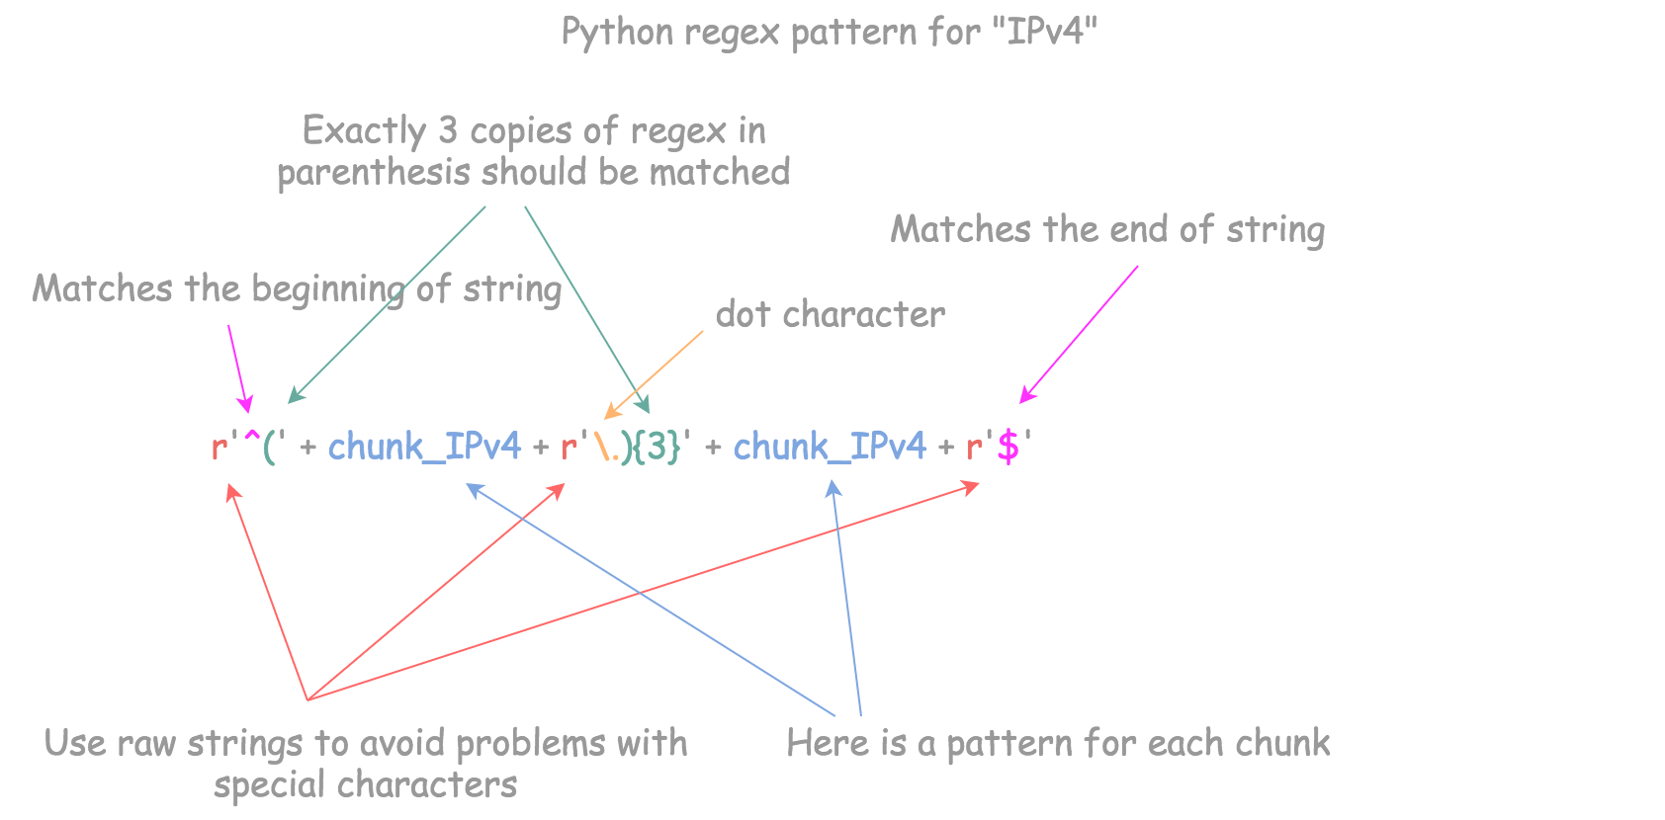

and here is for Java

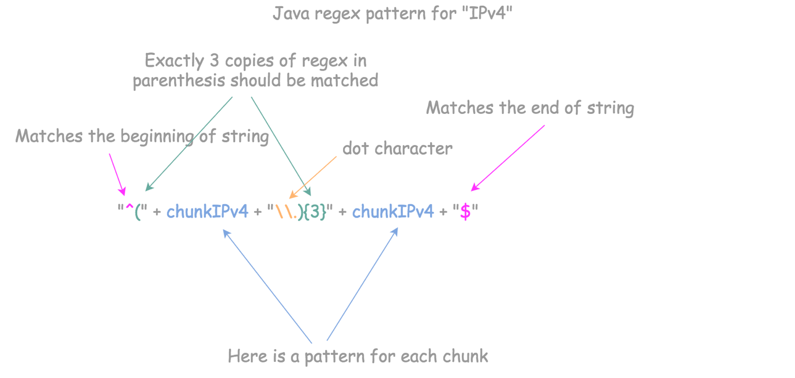

Now the problem is reduced to the construction of pattern to match each chunk. It's an integer in range (0, 255), and the leading zeros are not allowed. That results in five possible situations:

1. Chunk contains only one digit, from 0 to 9.
2. Chunk contains two digits. The first one could be from 1 to 9, and the second one from 0 to 9.
3. Chunk contains three digits, and the first one is 1. The second and the third ones could be from 0 to 9.
4. Chunk contains three digits, the first one is 2 and the second one is from 0 to 4. Then the third one could be from 0 to 9.
5. Chunk contains three digits, the first one is 2, and the second one is 5. Then the third one could be from 0 to 5.

Let's use pipe to create a regular expression that will match either case 1, or case 2, ..., or case 5.

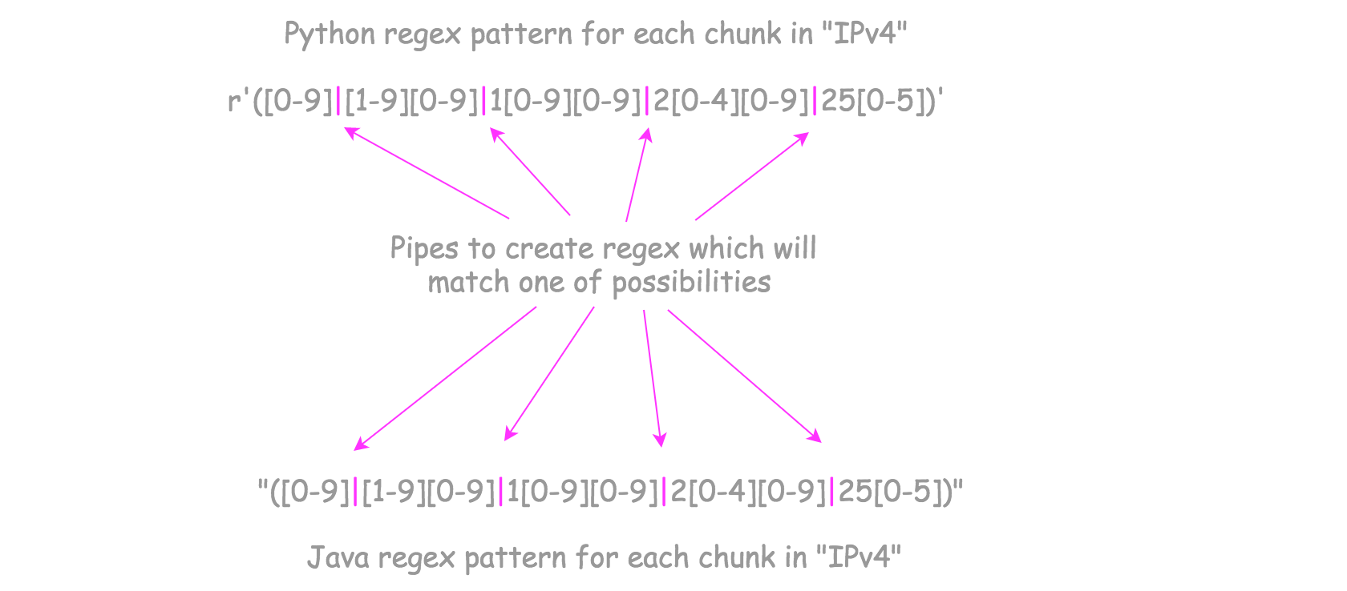

The job is done. The same logic could be used to construct "IPv6" regex pattern.

**Implementation**

|  |
| --- |
| import java.util.regex.Pattern;  class Solution {  String chunkIPv4 = "([0-9]|[1-9][0-9]|1[0-9][0-9]|2[0-4][0-9]|25[0-5])";  Pattern pattenIPv4 =  Pattern.compile("^(" + chunkIPv4 + "\\.){3}" + chunkIPv4 + "$");  String chunkIPv6 = "([0-9a-fA-F]{1,4})";  Pattern pattenIPv6 =  Pattern.compile("^(" + chunkIPv6 + "\\:){7}" + chunkIPv6 + "$");  public String validIPAddress(String IP) {  if (pattenIPv4.matcher(IP).matches()) return "IPv4";  return (pattenIPv6.matcher(IP).matches()) ? "IPv6" : "Neither";  }  } |

**Complexity Analysis**

* Time complexity: \mathcal{O}(1)O(1) because the patterns to match have constant length.
* Space complexity: \mathcal{O}(1)O(1).

#### **Approach 2: Divide and Conquer**

**Intuition**

Both IPv4 and IPv6 addresses are composed of several substrings separated by certain delimiter, and each of the substrings is of the same format.

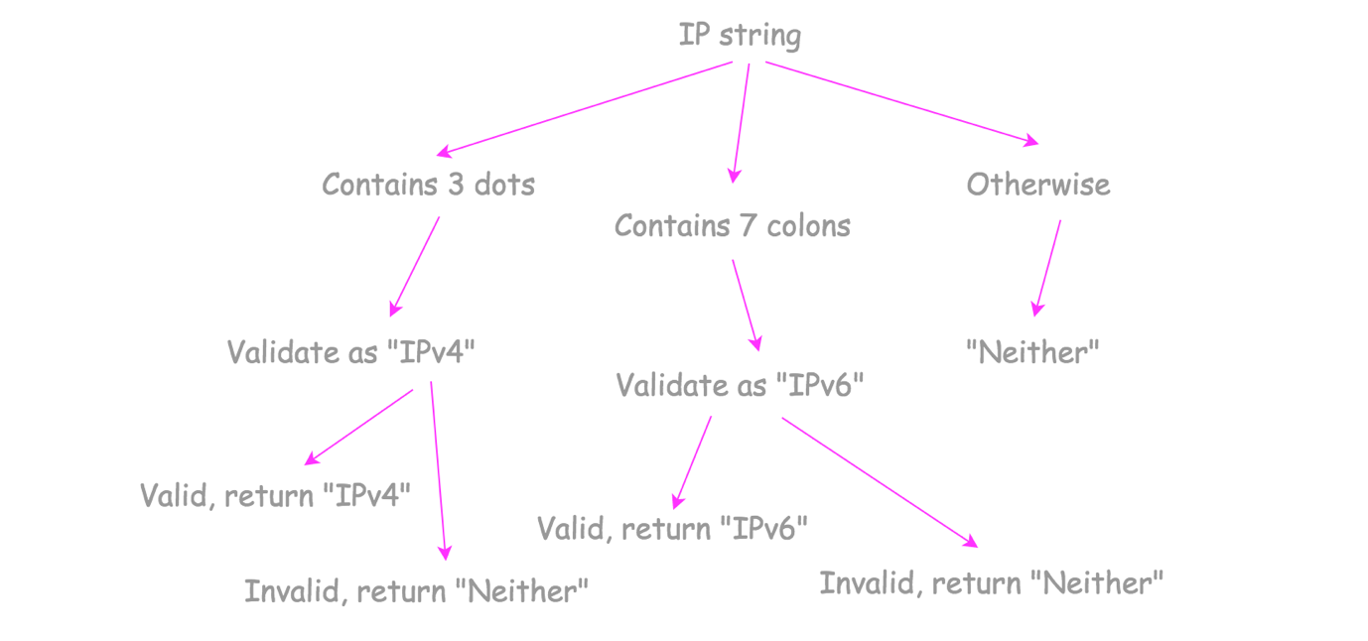

Therefore, intuitively, we could break down the address into chunks, and then verify them one by one.

The address is valid if and only if each of the chunks is valid. We can call this methodology divide and conquer.

**Algorithm**

* For the IPv4 address, we split IP into four chunks by the delimiter ., while for IPv6 address, we split IP into eight chunks by the delimiter :.
* For each substring of "IPv4" address, we check if it is an integer between 0 - 255, and there is no leading zeros.
* For each substring of "IPv6" address, we check if it's a hexadecimal number of length 1 - 4.

**Implementation**

|  |
| --- |
| class Solution {  public String validateIPv4(String IP) {  String[] nums = IP.split("\\.", -1);  for (String x : nums) {  // Validate integer in range (0, 255):  // 1. length of chunk is between 1 and 3  if (x.length() == 0 || x.length() > 3) return "Neither";  // 2. no extra leading zeros  if (x.charAt(0) == '0' && x.length() != 1) return "Neither";  // 3. only digits are allowed  for (char ch : x.toCharArray()) {  if (! Character.isDigit(ch)) return "Neither";  }  // 4. less than 255  if (Integer.parseInt(x) > 255) return "Neither";  }  return "IPv4";  }  public String validateIPv6(String IP) {  String[] nums = IP.split(":", -1);  String hexdigits = "0123456789abcdefABCDEF";  for (String x : nums) {  // Validate hexadecimal in range (0, 2**16):  // 1. at least one and not more than 4 hexdigits in one chunk  if (x.length() == 0 || x.length() > 4) return "Neither";  // 2. only hexdigits are allowed: 0-9, a-f, A-F  for (Character ch : x.toCharArray()) {  if (hexdigits.indexOf(ch) == -1) return "Neither";  }  }  return "IPv6";  }  public String validIPAddress(String IP) {  if (IP.chars().filter(ch -> ch == '.').count() == 3) {  return validateIPv4(IP);  }  else if (IP.chars().filter(ch -> ch == ':').count() == 7) {  return validateIPv6(IP);  }  else return "Neither";  }  } |

**Complexity Analysis**

* Time complexity: \mathcal{O}(N)O(*N*) because to count number of dots requires to parse the entire input string.
* Space complexity: \mathcal{O}(1)O(1).

**Subarray Sum Equals K**

Given an array of integers nums and an integer k, return *the total number of continuous subarrays whose sum equals to k*.

**Example 1:**

**Input:** nums = [1,1,1], k = 2

**Output:** 2

**Example 2:**

**Input:** nums = [1,2,3], k = 3

**Output:** 2

**Constraints:**

* 1 <= nums.length <= 2 * 104
* -1000 <= nums[i] <= 1000
* -107 <= k <= 107

Hide Hint #1

Will Brute force work here? Try to optimize it.

   Hide Hint #2

Can we optimize it by using some extra space?

   Hide Hint #3

What about storing sum frequencies in a hash table? Will it be useful?

   Hide Hint #4

sum(i,j)=sum(0,j)-sum(0,i), where sum(i,j) represents the sum of all the elements from index i to j-1. Can we use this property to optimize it.

## Solution

#### **Approach 1: Brute Force**

**Algorithm**

The simplest method is to consider every possible subarray of the given nums*nums* array, find the sum of the elements of each of those subarrays and check for the equality of the sum obtained with the given k*k*. Whenever the sum equals k*k*, we can increment the count*count* used to store the required result.

|  |
| --- |
| public class Solution {  public int subarraySum(int[] nums, int k) {  int count = 0;  for (int start = 0; start < nums.length; start++) {  for (int end = start + 1; end <= nums.length; end++) {  int sum = 0;  for (int i = start; i < end; i++)  sum += nums[i];  if (sum == k)  count++;  }  }  return count;  }  } |

**Complexity Analysis**

* Time complexity : O(n^3)*O*(*n*3). Considering every possible subarray takes O(n^2)*O*(*n*2) time. For each of the subarray we calculate the sum taking O(n)*O*(*n*) time in the worst case, taking a total of O(n^3)*O*(*n*3) time.
* Space complexity : O(1)*O*(1). Constant space is used.

#### **Approach 2: Using Cumulative Sum**

**Algorithm**

Instead of determining the sum of elements every time for every new subarray considered, we can make use of a cumulative sum array , sum*sum*. Then, in order to calculate the sum of elements lying between two indices, we can subtract the cumulative sum corresponding to the two indices to obtain the sum directly, instead of iterating over the subarray to obtain the sum.

In this implementation, we make use of a cumulative sum array, sum*sum*, such that sum[i]*sum*[*i*] is used to store the cumulative sum of nums*nums* array up to the element corresponding to the (i-1)^{th}(*i*−1)*th* index. Thus, to determine the sum of elements for the subarray nums[i:j]*nums*[*i*:*j*], we can directly use sum[j+1] - sum[i]*sum*[*j*+1]−*sum*[*i*].

|  |
| --- |
| public class Solution {  public int subarraySum(int[] nums, int k) {  int count = 0;  int[] sum = new int[nums.length + 1];  sum[0] = 0;  for (int i = 1; i <= nums.length; i++)  sum[i] = sum[i - 1] + nums[i - 1];  for (int start = 0; start < nums.length; start++) {  for (int end = start + 1; end <= nums.length; end++) {  if (sum[end] - sum[start] == k)  count++;  }  }  return count;  }  } |

**Complexity Analysis**

* Time complexity : O(n^2)*O*(*n*2). Considering every possible subarray takes O(n^2)*O*(*n*2) time. Finding out the sum of any subarray takes O(1)*O*(1) time after the initial processing of O(n)*O*(*n*) for creating the cumulative sum array.
* Space complexity : O(n)*O*(*n*). Cumulative sum array sum*sum* of size n+1*n*+1 is used.

#### **Approach 3: Without Space**

**Algorithm**

Instead of considering all the start*start* and end*end* points and then finding the sum for each subarray corresponding to those points, we can directly find the sum on the go while considering different end*end* points. i.e. We can choose a particular start*start* point and while iterating over the end*end* points, we can add the element corresponding to the end*end* point to the sum formed till now. Whenever the sum*sum* equals the required k*k* value, we can update the count*count* value. We do so while iterating over all the end*end* indices possible for every start*start* index. Whenever, we update the start*start* index, we need to reset the sum*sum* value to 0.

|  |
| --- |
| public class Solution {  public int subarraySum(int[] nums, int k) {  int count = 0;  for (int start = 0; start < nums.length; start++) {  int sum=0;  for (int end = start; end < nums.length; end++) {  sum+=nums[end];  if (sum == k)  count++;  }  }  return count;  }  } |

**Complexity Analysis**

* Time complexity : O(n^2)*O*(*n*2). We need to consider every subarray possible.
* Space complexity : O(1)*O*(1). Constant space is used.

#### **Approach 4: Using Hashmap**

**Algorithm**

The idea behind this approach is as follows: If the cumulative sum(represented by sum[i]*sum*[*i*] for sum up to i^{th}*ith* index) up to two indices is the same, the sum of the elements lying in between those indices is zero. Extending the same thought further, if the cumulative sum up to two indices, say i*i* and j*j* is at a difference of k*k* i.e. if sum[i] - sum[j] = k*sum*[*i*]−*sum*[*j*]=*k*, the sum of elements lying between indices i*i* and j*j* is k*k*.

Based on these thoughts, we make use of a hashmap map*map* which is used to store the cumulative sum up to all the indices possible along with the number of times the same sum occurs. We store the data in the form: (sum_i, no. of occurrences of sum_i)(*sumi*​,*no*.*ofoccurrencesofsumi*​). We traverse over the array nums*nums* and keep on finding the cumulative sum. Every time we encounter a new sum, we make a new entry in the hashmap corresponding to that sum. If the same sum occurs again, we increment the count corresponding to that sum in the hashmap. Further, for every sum encountered, we also determine the number of times the sum sum-k*sum*−*k* has occurred already, since it will determine the number of times a subarray with sum k*k* has occurred up to the current index. We increment the count*count* by the same amount.

After the complete array has been traversed, the count*count* gives the required result.

The animation below depicts the process.



|  |
| --- |
| public class Solution {  public int subarraySum(int[] nums, int k) {  int count = 0, sum = 0;  HashMap < Integer, Integer > map = new HashMap < > ();  map.put(0, 1);  for (int i = 0; i < nums.length; i++) {  sum += nums[i];  if (map.containsKey(sum - k))  count += map.get(sum - k);  map.put(sum, map.getOrDefault(sum, 0) + 1);  }  return count;  }  } |

**Complexity Analysis**

* Time complexity : O(n)*O*(*n*). The entire nums*nums* array is traversed only once.
* Space complexity : O(n)*O*(*n*). Hashmap map*map* can contain up to n*n* distinct entries in the worst case.

**Valid Palindrome II**

Given a non-empty string s, you may delete **at most** one character. Judge whether you can make it a palindrome.

**Example 1:**

**Input:** "aba"

**Output:** True

**Example 2:**

**Input:** "abca"

**Output:** True

**Explanation:** You could delete the character 'c'.

**Note:**

1. The string will only contain lowercase characters a-z. The maximum length of the string is 50000.

Approach #1: Brute Force [Time Limit Exceeded]

**Intuition and Algorithm**

For each index i in the given string, let's remove that character, then check if the resulting string is a palindrome. If it is, (or if the original string was a palindrome), then we'll return true

|  |
| --- |
| class Solution {  public boolean isPalindrome(CharSequence s) {  for (int i = 0; i < s.length() / 2; i++) {  if (s.charAt(i) != s.charAt(s.length() - 1 - i)) {  return false;  }  }  return true;  }  public boolean validPalindrome(String s) {  StringBuilder sb = new StringBuilder(s);  for (int i = 0; i < s.length(); i++) {  char c = sb.charAt(i);  sb.deleteCharAt(i);  if (isPalindrome(sb)) return true;  sb.insert(i, c);  }  return isPalindrome(s);  }  } |

**Complexity Analysis**

* Time Complexity: O(N^2)*O*(*N*2) where N*N* is the length of the string. We do the following N*N* times: create a string of length N*N* and iterate over it.
* Space Complexity: O(N)*O*(*N*), the space used by our candidate answer.

#### **Approach #2: Greedy [Accepted]**

**Intuition**

If the beginning and end characters of a string are the same (ie. s[0] == s[s.length - 1]), then whether the inner characters are a palindrome (s[1], s[2], ..., s[s.length - 2]) uniquely determines whether the entire string is a palindrome.

**Algorithm**

Suppose we want to know whether s[i], s[i+1], ..., s[j] form a palindrome. If i >= j then we are done. If s[i] == s[j] then we may take i++; j--. Otherwise, the palindrome must be either s[i+1], s[i+2], ..., s[j] or s[i], s[i+1], ..., s[j-1], and we should check both cases.

|  |
| --- |
| class Solution {  public boolean isPalindromeRange(String s, int i, int j) {  for (int k = i; k <= i + (j - i) / 2; k++) {  if (s.charAt(k) != s.charAt(j - k + i)) return false;  }  return true;  }  public boolean validPalindrome(String s) {  for (int i = 0; i < s.length() / 2; i++) {  if (s.charAt(i) != s.charAt(s.length() - 1 - i)) {  int j = s.length() - 1 - i;  return (isPalindromeRange(s, i+1, j) ||  isPalindromeRange(s, i, j-1));  }  }  return true;  }  } |

**Complexity Analysis**

* Time Complexity: O(N)*O*(*N*) where N*N* is the length of the string. Each of two checks of whether some substring is a palindrome is O(N)*O*(*N*).
* Space Complexity: O(1)*O*(1) additional complexity. Only pointers were stored in memory.

## Linked Lists

These are some popular Linked List questions being asked by Facebook. Add Two Numbers apparently is a popular one according to our user survey.

**Add Two Numbers**

You are given two **non-empty** linked lists representing two non-negative integers. The digits are stored in **reverse order**, and each of their nodes contains a single digit. Add the two numbers and return the sum as a linked list.

You may assume the two numbers do not contain any leading zero, except the number 0 itself.

**Example 1:**

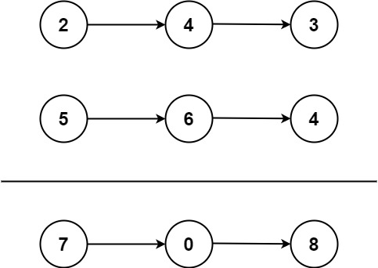

**Input:** l1 = [2,4,3], l2 = [5,6,4]

**Output:** [7,0,8]

**Explanation:** 342 + 465 = 807.

**Example 2:**

**Input:** l1 = [0], l2 = [0]

**Output:** [0]

**Example 3:**

**Input:** l1 = [9,9,9,9,9,9,9], l2 = [9,9,9,9]

**Output:** [8,9,9,9,0,0,0,1]

**Constraints:**

* The number of nodes in each linked list is in the range [1, 100].
* 0 <= Node.val <= 9
* It is guaranteed that the list represents a number that does not have leading zeros.

LinkedList

**Merge Two Sorted Lists**

Merge two sorted linked lists and return it as a **sorted** list. The list should be made by splicing together the nodes of the first two lists.

**Example 1:**

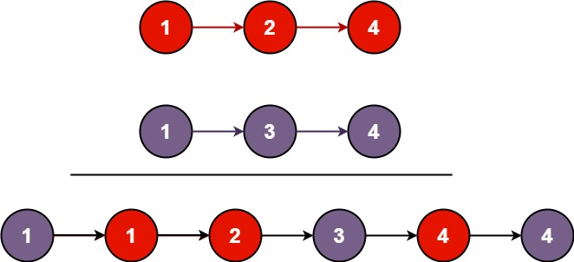

**Input:** l1 = [1,2,4], l2 = [1,3,4]

**Output:** [1,1,2,3,4,4]

**Example 2:**

**Input:** l1 = [], l2 = []

**Output:** []

**Example 3:**

**Input:** l1 = [], l2 = [0]

**Output:** [0]

**Constraints:**

* The number of nodes in both lists is in the range [0, 50].
* -100 <= Node.val <= 100
* Both l1 and l2 are sorted in **non-decreasing** order.

Recursion

**Copy List with Random Pointer**

A linked list of length n is given such that each node contains an additional random pointer, which could point to any node in the list, or null.

Construct a [**deep copy**](https://en.wikipedia.org/wiki/Object_copying#Deep_copy) of the list. The deep copy should consist of exactly n **brand new** nodes, where each new node has its value set to the value of its corresponding original node. Both the next and random pointer of the new nodes should point to new nodes in the copied list such that the pointers in the original list and copied list represent the same list state. **None of the pointers in the new list should point to nodes in the original list**.

For example, if there are two nodes X and Y in the original list, where X.random --> Y, then for the corresponding two nodes x and y in the copied list, x.random --> y.

Return *the head of the copied linked list*.

The linked list is represented in the input/output as a list of n nodes. Each node is represented as a pair of [val, random_index] where:

* val: an integer representing Node.val
* random_index: the index of the node (range from 0 to n-1) that the random pointer points to, or null if it does not point to any node.

Your code will **only** be given the head of the original linked list.

**Example 1:**

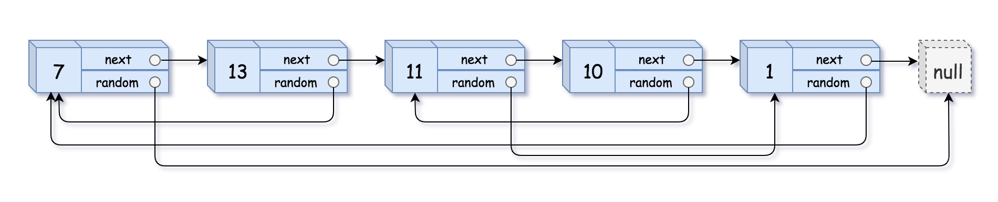

**Input:** head = [[7,null],[13,0],[11,4],[10,2],[1,0]]

**Output:** [[7,null],[13,0],[11,4],[10,2],[1,0]]

**Example 2:**



**Input:** head = [[1,1],[2,1]]

**Output:** [[1,1],[2,1]]

**Example 3:**



**Input:** head = [[3,null],[3,0],[3,null]]

**Output:** [[3,null],[3,0],[3,null]]

**Example 4:**

**Input:** head = []

**Output:** []

**Explanation:** The given linked list is empty (null pointer), so return null.

**Constraints:**

* 0 <= n <= 1000
* -10000 <= Node.val <= 10000
* Node.random is null or is pointing to some node in the linked list.

Hard

**Reorder List**

Given a singly linked list L: L0→L1→…→Ln-1→Ln,  
reorder it to: L0→Ln→L1→Ln-1→L2→Ln-2→…

You may **not** modify the values in the list's nodes, only nodes itself may be changed.

**Example 1:**

Given 1->2->3->4, reorder it to 1->4->2->3.

**Example 2:**

Given 1->2->3->4->5, reorder it to 1->5->2->4->3.

Solution

Solution Bricks

This problem is a combination of these three easy problems:

* [Middle of the Linked List](https://leetcode.com/articles/middle-of-the-linked-list/).
* [Reverse Linked List](https://leetcode.com/articles/reverse-linked-list/).
* [Merge Two Sorted Lists](https://leetcode.com/articles/merged-two-sorted-lists/).

Approach 1: Reverse the Second Part of the List and Merge Two Sorted Lists

**Overview**

* Find a middle node of the linked list. If there are two middle nodes, return the second middle node. Example: for the list 1->2->3->4->5->6, the middle element is 4.
* Once a middle node has been found, reverse the second part of the list. Example: convert 1->2->3->4->5->6 into 1->2->3->4 and 6->5->4.
* Now merge the two sorted lists. Example: merge 1->2->3->4 and 6->5->4 into 1->6->2->5->3->4.

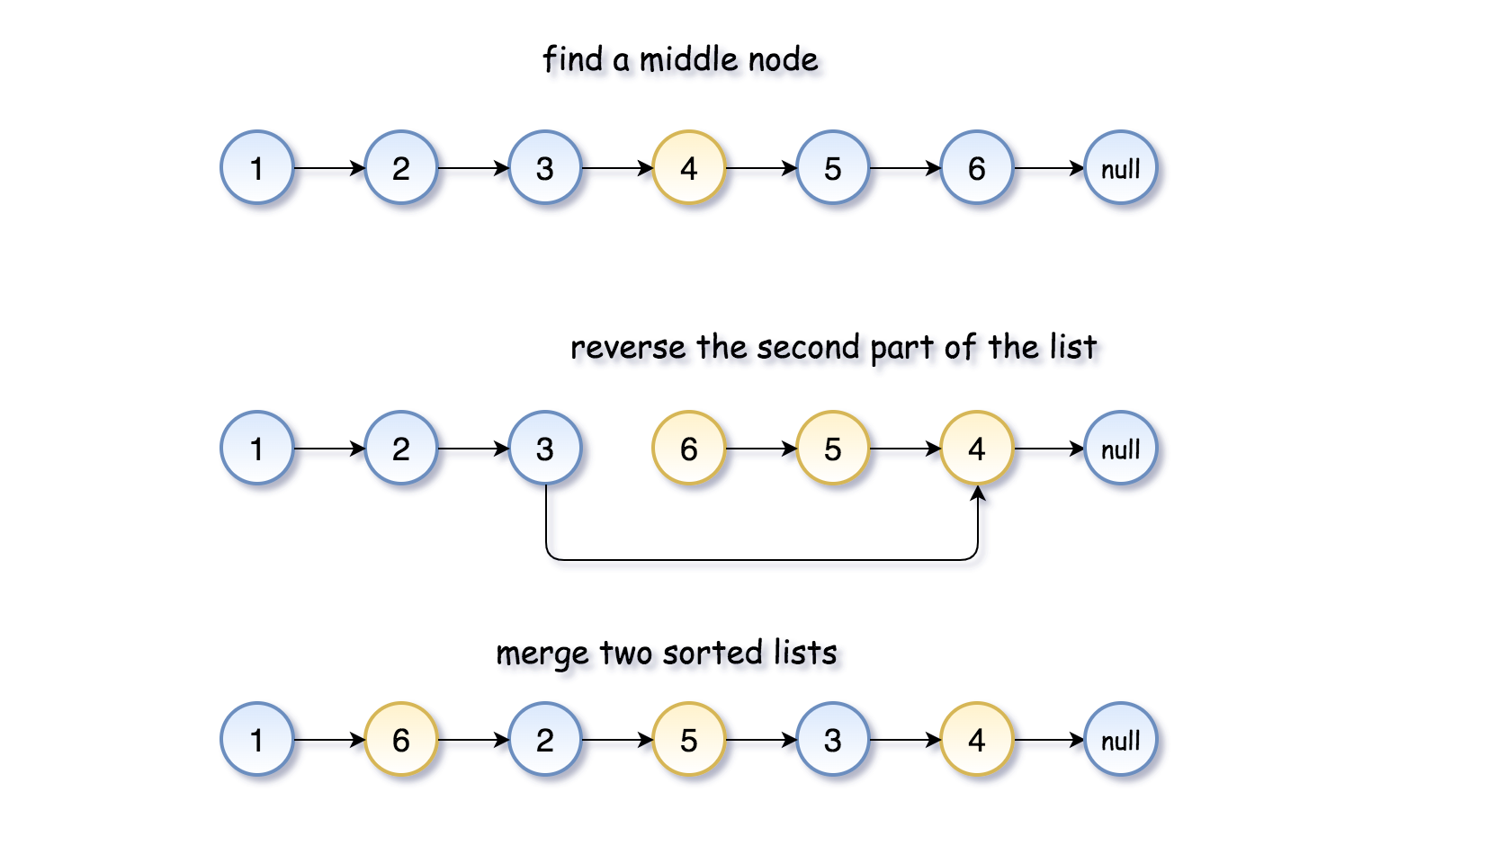

Now let's check each algorithm part in more detail.

**Find a Middle Node**

Let's use two pointers, slow and fast. While the slow pointer moves one step forward slow = slow.next, the fast pointer moves two steps forward fast = fast.next.next, *i.e.* fast traverses twice as fast as slow. When the fast pointer reaches the end of the list, the slow pointer should be in the middle.

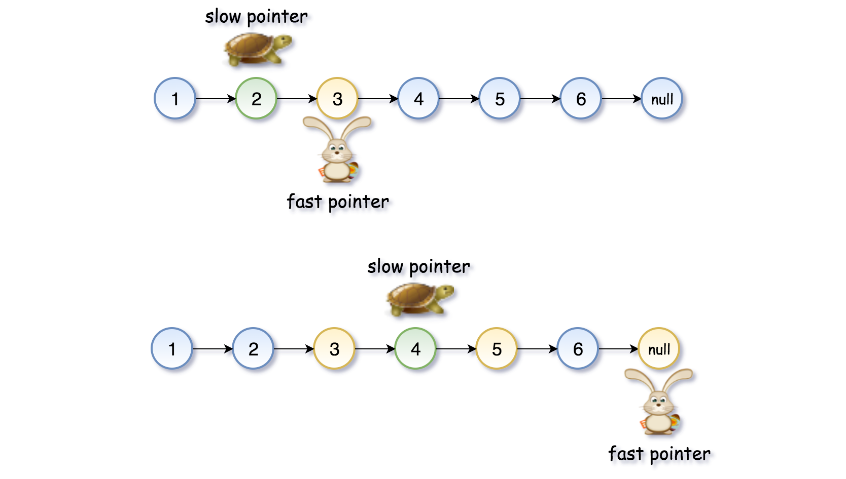

|  |
| --- |
| // find the middle of linked list [Problem 876]  // in 1->2->3->4->5->6 find 4  ListNode slow = head, fast = head;  while (fast != null && fast.next != null) {  slow = slow.next;  fast = fast.next.next;  } |

**Reverse the Second Part of the List**

Let's traverse the list starting from the middle node slow and its virtual predecessor None. For each current node, save its neighbours: the previous node prev and the next node tmp = curr.next.

While you're moving along the list, change the node's next pointer to point to the previous node: curr.next = prev, and shift the current node to the right for the next iteration: prev = curr, curr = tmp.

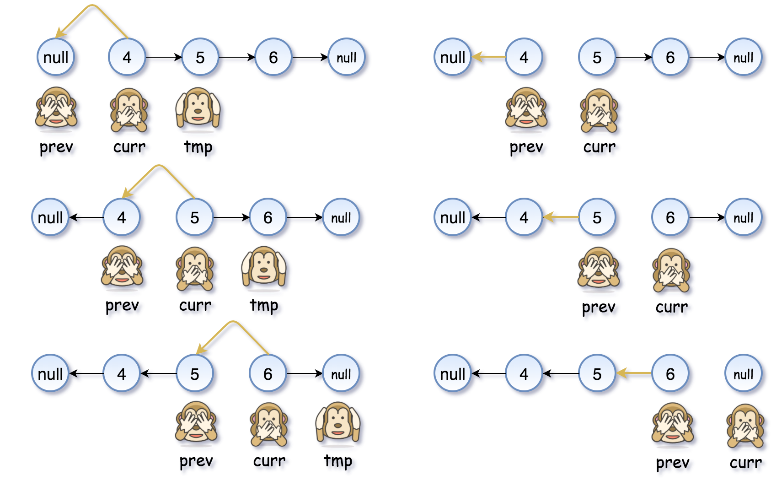

|  |
| --- |
| // reverse the second part of the list [Problem 206]  // convert 1->2->3->4->5->6 into 1->2->3->4 and 6->5->4  // reverse the second half in-place  ListNode prev = null, curr = slow, tmp;  while (curr != null) {  tmp = curr.next;  curr.next = prev;  prev = curr;  curr = tmp;  } |

There is a more elegant way to do it in Python:

|  |
| --- |
| # reverse the second part of the list [Problem 206]  # convert 1->2->3->4->5->6 into 1->2->3->4 and 6->5->4  # reverse the second half in-place  prev, curr = None, slow  while curr:  curr.next, prev, curr = prev, curr, curr.next |

**Merge Two Sorted Lists**

This algorithm is similar to the one for list reversal.

Let's pick the first node of each list - first and second, and save their successors. While you're traversing the list, set the first node's next pointer to point to the second node, and the second node's next pointer to point to the successor of the first node. For this iteration the job is done, and for the next iteration move to the previously saved nodes' successors.

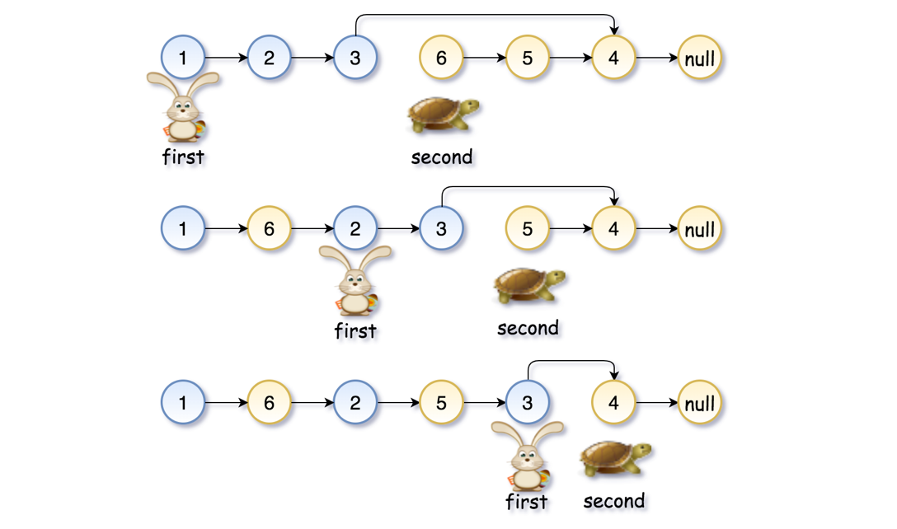

|  |
| --- |
| // merge two sorted linked lists [Problem 21]  // merge 1->2->3->4 and 6->5->4 into 1->6->2->5->3->4  ListNode first = head, second = prev;  while (second.next != null) {  tmp = first.next;  first.next = second;  first = tmp;  tmp = second.next;  second.next = first;  second = tmp;  } |

**Implementation**

Now it's time to put all the pieces together.

|  |
| --- |
| class Solution {  public void reorderList(ListNode head) {  if (head == null) return;  // find the middle of linked list [Problem 876]  // in 1->2->3->4->5->6 find 4  ListNode slow = head, fast = head;  while (fast != null && fast.next != null) {  slow = slow.next;  fast = fast.next.next;  }  // reverse the second part of the list [Problem 206]  // convert 1->2->3->4->5->6 into 1->2->3->4 and 6->5->4  // reverse the second half in-place  ListNode prev = null, curr = slow, tmp;  while (curr != null) {  tmp = curr.next;  curr.next = prev;  prev = curr;  curr = tmp;  }  // merge two sorted linked lists [Problem 21]  // merge 1->2->3->4 and 6->5->4 into 1->6->2->5->3->4  ListNode first = head, second = prev;  while (second.next != null) {  tmp = first.next;  first.next = second;  first = tmp;  tmp = second.next;  second.next = first;  second = tmp;  }  }  } |

**Complexity Analysis**

* Time complexity: \mathcal{O}(N)O(*N*). There are three steps here. To identify the middle node takes \mathcal{O}(N)O(*N*) time. To reverse the second part of the list, one needs N/2*N*/2 operations. The final step, to merge two lists, requires N/2*N*/2 operations as well. In total, that results in \mathcal{O}(N)O(*N*) time complexity.
* Space complexity: \mathcal{O}(1)O(1), since we do not allocate any additional data structures.

## Trees and Graphs

Facebook loves Tree types of problems. One of the Tree questions Facebook really likes to ask is Convert BST to Sorted Doubly Linked List, which you can practice below.

You should also know topological sort and graph traversal as those are still occasionally asked.

**Validate Binary Search Tree**

Given the root of a binary tree, *determine if it is a valid binary search tree (BST)*.

A **valid BST** is defined as follows:

* The left subtree of a node contains only nodes with keys **less than** the node's key.
* The right subtree of a node contains only nodes with keys **greater than** the node's key.
* Both the left and right subtrees must also be binary search trees.

**Example 1:**

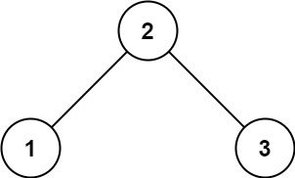

**Input:** root = [2,1,3]

**Output:** true

**Example 2:**

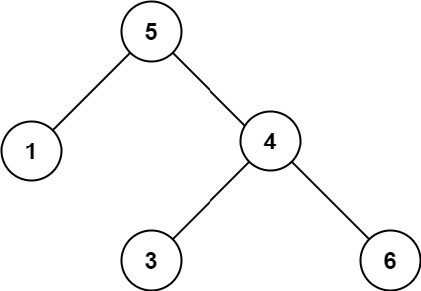

**Input:** root = [5,1,4,null,null,3,6]

**Output:** false

**Explanation:** The root node's value is 5 but its right child's value is 4.

**Constraints:**

* The number of nodes in the tree is in the range [1, 104].
* -231 <= Node.val <= 231 - 1

Recursion 2

**Flatten Binary Tree to Linked List**

Given the root of a binary tree, flatten the tree into a "linked list":

* The "linked list" should use the same TreeNode class where the right child pointer points to the next node in the list and the left child pointer is always null.
* The "linked list" should be in the same order as a [**pre-order traversal**](https://en.wikipedia.org/wiki/Tree_traversal#Pre-order,_NLR) of the binary tree.

**Example 1:**

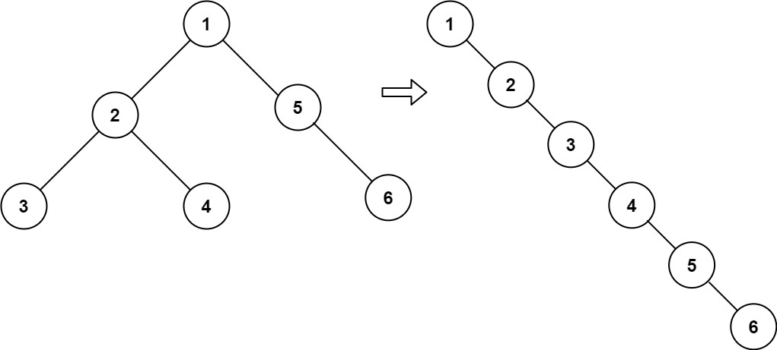

**Input:** root = [1,2,5,3,4,null,6]

**Output:** [1,null,2,null,3,null,4,null,5,null,6]

**Example 2:**

**Input:** root = []

**Output:** []

**Example 3:**

**Input:** root = [0]

**Output:** [0]

**Constraints:**

* The number of nodes in the tree is in the range [0, 2000].
* -100 <= Node.val <= 100

**Follow up:** Can you flatten the tree in-place (with O(1) extra space)?

   Hide Hint #1

If you notice carefully in the flattened tree, each node's right child points to the next node of a pre-order traversal.

Solution

Approach 1: Recursion

**Intuition**

A common strategy for tree modification problems is recursion. A tree is a recursive structure. Every node gets to be a root node of some tree and that tree further has a bunch of smaller subtrees each with their own root nodes. So, when it comes to problems where the structure of the tree has to be modified or we have to traverse the tree in general, recursion is one of the top approaches that comes to mind simply because it's easy enough to code up and also is very intuitive to understand. Let's quickly look at a binary tree structure and then we will talk about how we can solve this problem using a recursive strategy.

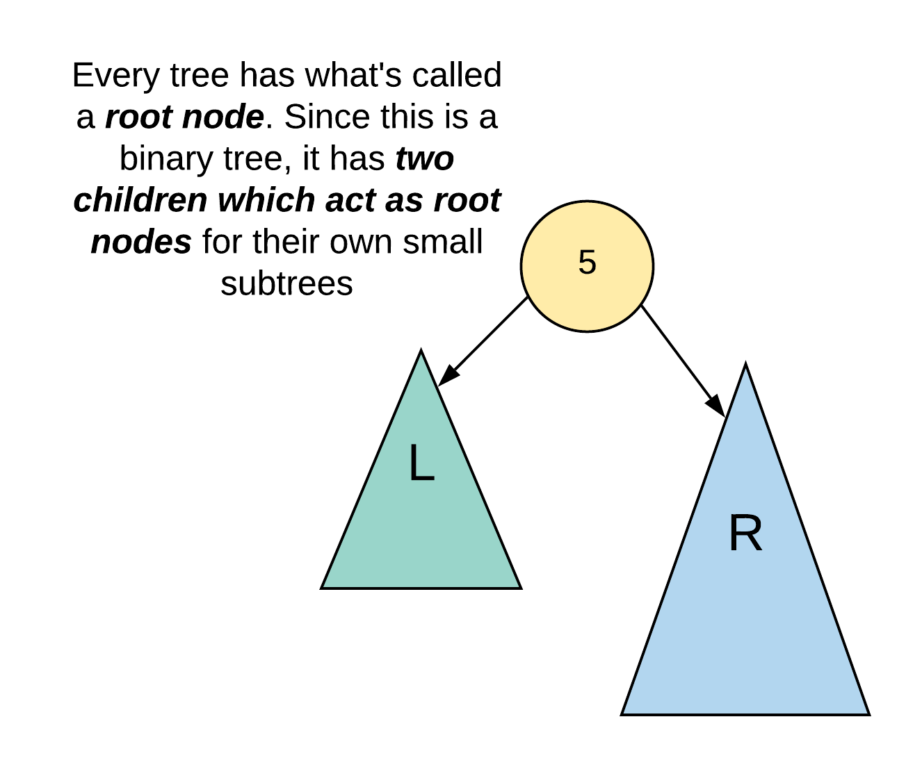

We haven't drawn the entire tree in the above image so as to build that intuition for that recursive solution. The main idea behind a recursive solution is that we use the solutions for subproblems to solve an uber level problem. In the case of a tree, the subtrees are essentially our subproblems. So, a recursive solution for this problem is essentially based on the idea that assuming we have already transformed the left and the right halves of a given root node, how do we establish or modify the necessary connections so that we get a right skewed tree overall. Let's look at what this means diagrammatically to have a better understanding.

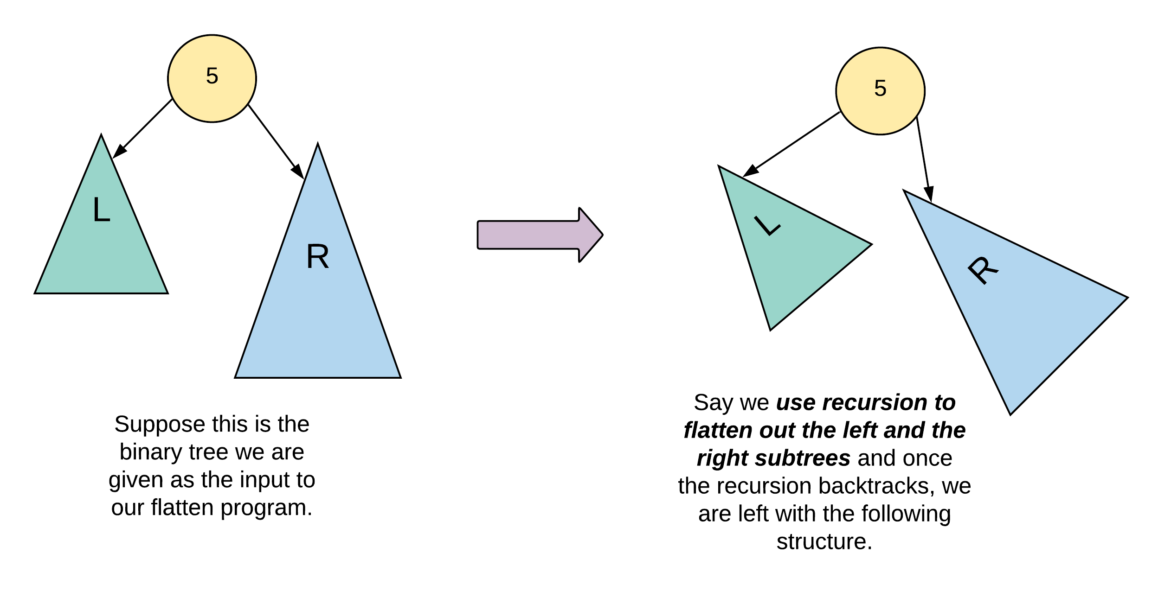

In the above figure, we simply showcase the root node of a tree and its left and right subtrees. A great way to think about recursion here is that we "suppose" that recursion does all the hard work for us and flattens out the left and the right subtrees as shown in the figure. What is it that we have to do then to get our final result? We need a right skewed tree, right? Well, we simply have to shuffle around some pointers to get our final result as shown below.

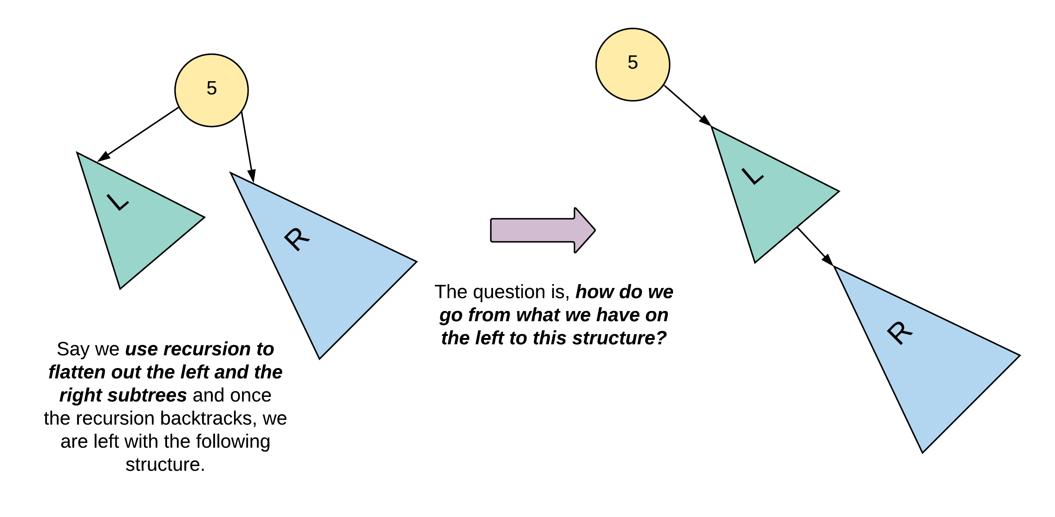

Let's dive a bit deeper and take a look at an exact tree now to see what exact connections we'll need to establish exactly for this work.

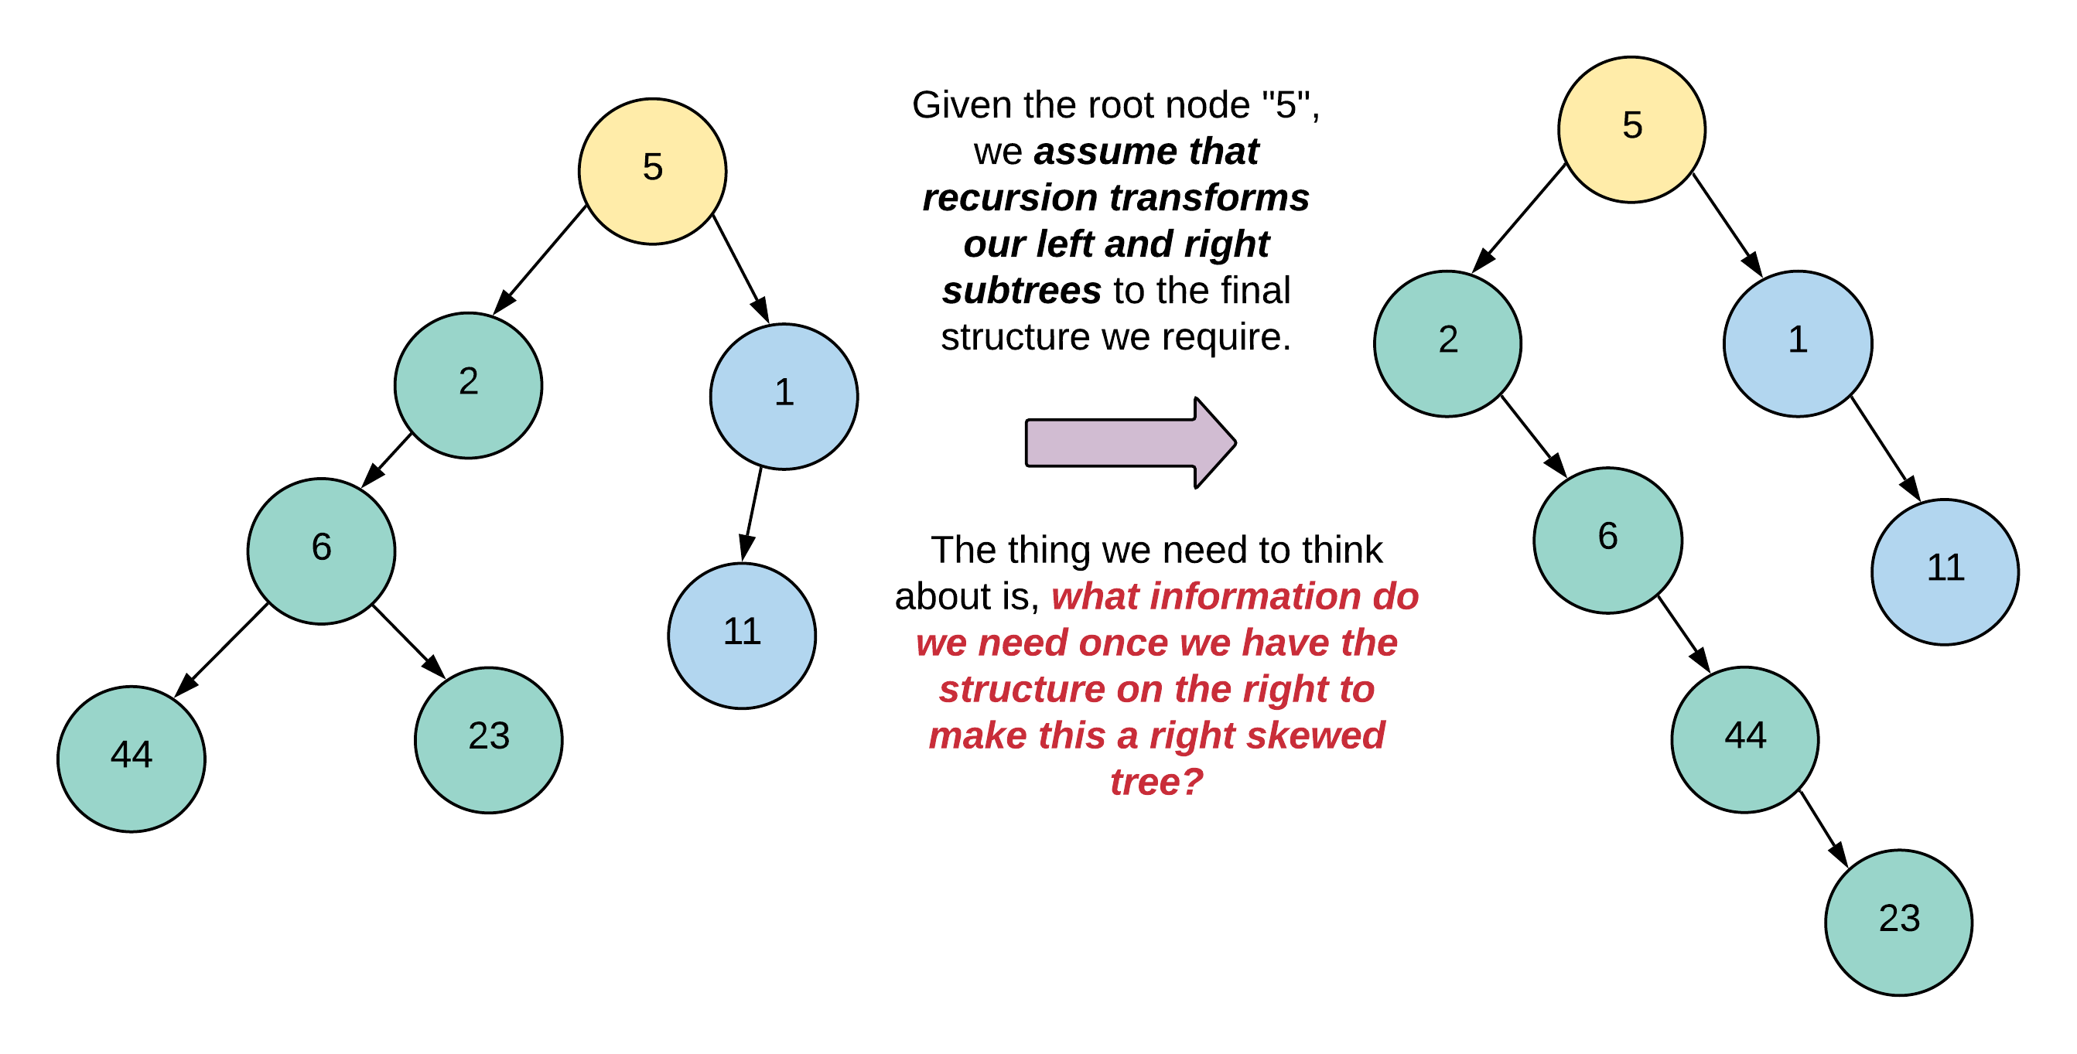

The figure shown below essentially highlights the exact set of nodes that are required for re-wiring the tree to our final right skewed tree. We've marked them "L" for left, "R" for right, and LT for "left tail". We'll get to the reason as to why we call that third node "left tail", later.

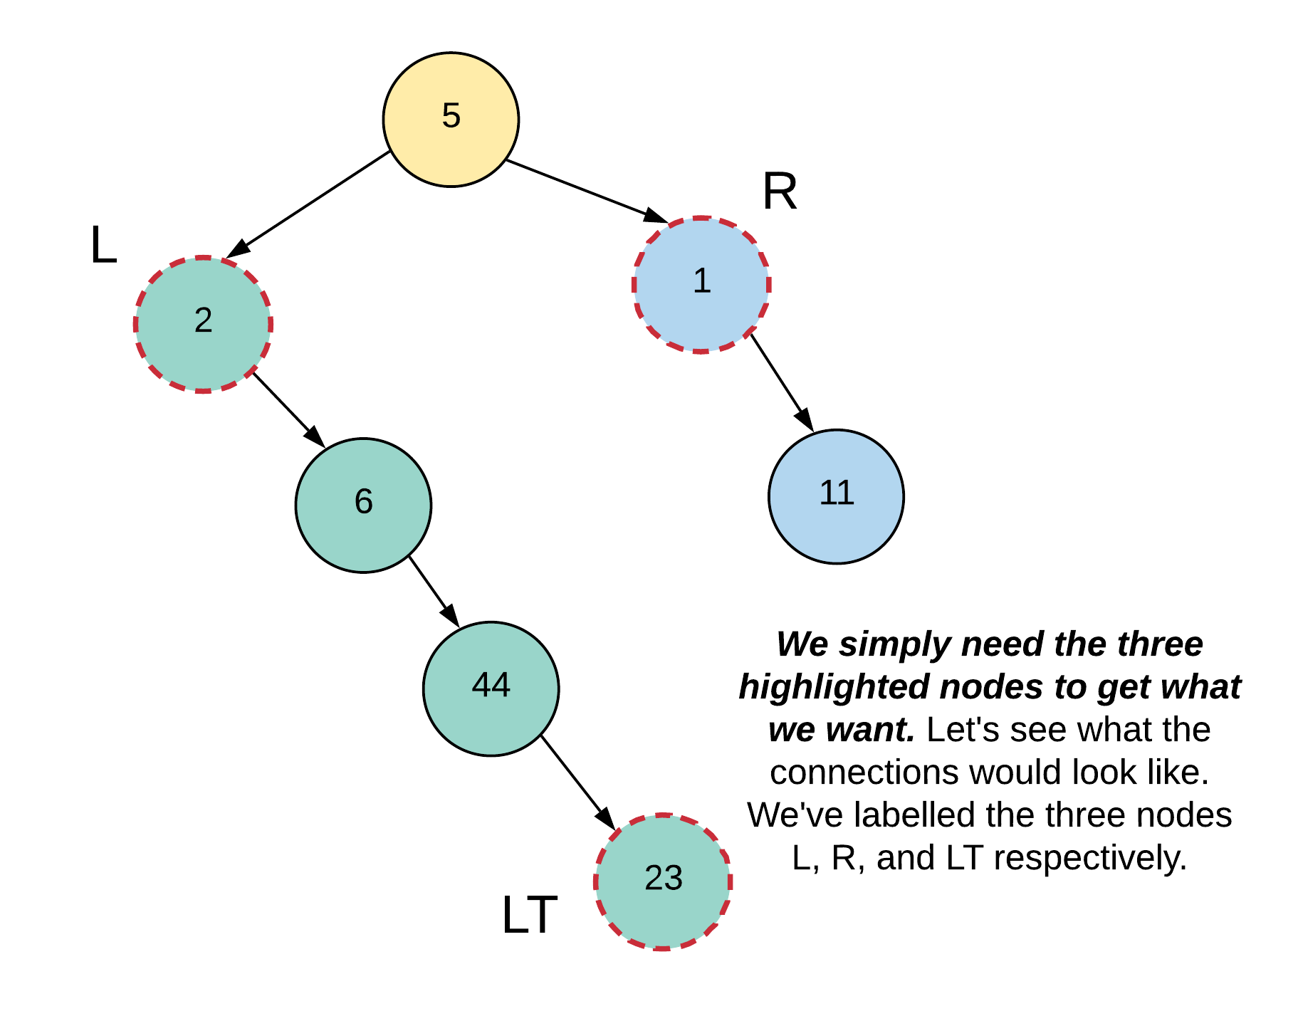

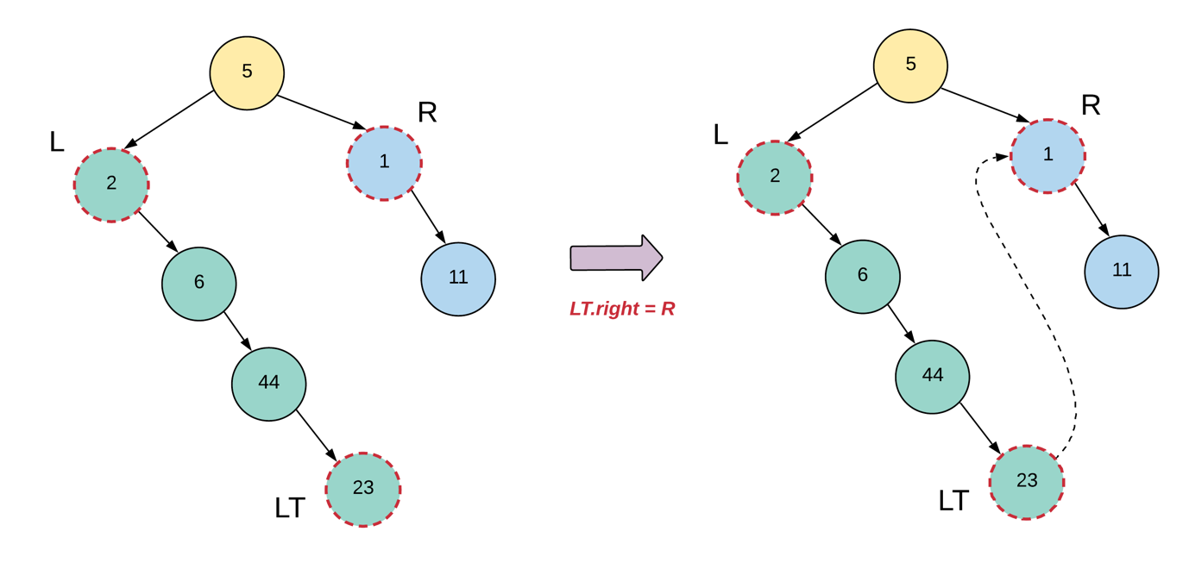

And finally, let's see how our tree looks like once we rewire the "L" and the "R" nodes properly as well.

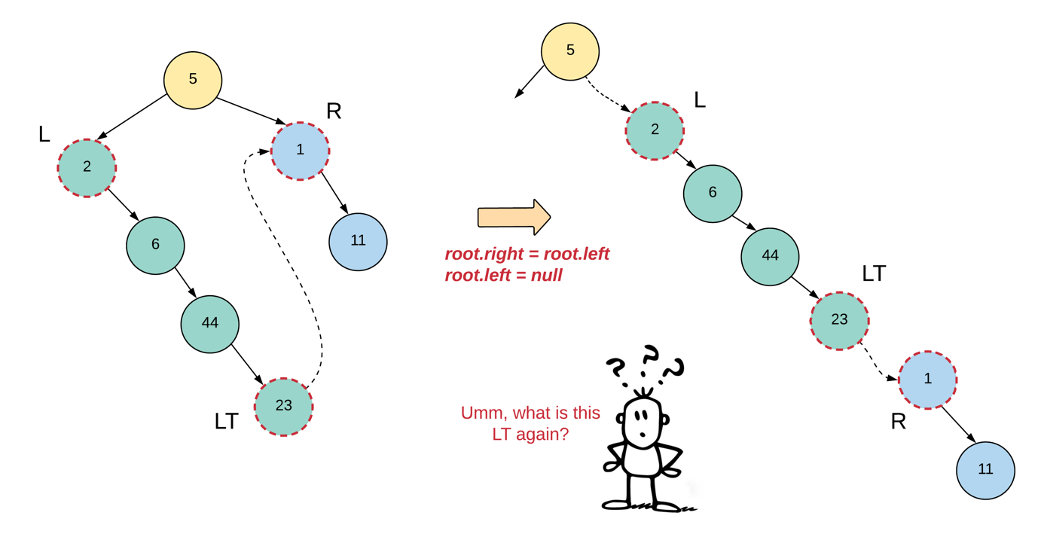

Yeah, we haven't exactly explained what this left tail means. So, if you go back a few figures to the point where we had the left and the right subtrees all flattened out and we hadn't done any pointer manipulation yet, you'll notice that each subtree actually looks like a Linked List. Every linked list has a head node and in this case, we also need the tail node. Once recursion does the hard work for us and flattens out the subtrees, we will essentially get two linked lists and we need the tail end of the left one to attach it to the right one. Let's see what all information we will need in our recursive function at a given node.

* *_node_* = The current node
* *_leftChild_* = the left child of our current node
* *_rightChild_* = the right child of our current node
* *_leftTail_* = The tail node of the flattened out left subtree
* *_rightTail_* = The tail node of the fully formed tree rooted at *_node_*. This information is needed by the parent recursive calls since the tree rooted at the current node can be some other's node's left subtree or right subtree.

We have all the information available with us except the tail nodes. That's something that our recursion function will have to return. So, a recursion call for a given node will return the tail node of the flattened out tree. In our example, we will return the node 11 as the tail end of our final flattened out tree.

**Algorithm**

1. We'll have a separate function for flattening out the tree since the main function provided in the problem isn't supposed to return anything and our algorithm will return the tail node of the flattened out tree.
2. For a given node, we will recursively flatten out the left and the right subtrees and store their corresponding tail nodes in leftTail and rightTail respectively.
3. Next, we will make the following connections (only if there is a left child for the current node, else the leftTail would be null)
4. leftTail.right = node.right
5. node.right = node.left
6. node.left = None

1. Next we have to return the tail of the final, flattened out tree rooted at node. So, if the node has a right child, then we will return the rightTail, else, we'll return the leftTail.

|  |
| --- |
| /**  * Definition for a binary tree node.  * public class TreeNode {  * int val;  * TreeNode left;  * TreeNode right;  * TreeNode(int x) { val = x; }  * }  */  class Solution {    private TreeNode flattenTree(TreeNode node) {    // Handle the null scenario  if (node == null) {  return null;  }    // For a leaf node, we simply return the  // node as is.  if (node.left == null && node.right == null) {  return node;  }    //Recursively flatten the left subtree  TreeNode leftTail = this.flattenTree(node.left);    // Recursively flatten the right subtree  TreeNode rightTail = this.flattenTree(node.right);    // If there was a left subtree, we shuffle the connections  // around so that there is nothing on the left side  // anymore.  if (leftTail != null) {  leftTail.right = node.right;  node.right = node.left;  node.left = null;  }    // We need to return the "rightmost" node after we are  // done wiring the new connections.  return rightTail == null ? leftTail : rightTail;  }    public void flatten(TreeNode root) {    this.flattenTree(root);  }  } |

**Complexity Analysis**

* Time Complexity: O(N)*O*(*N*) since we process each node of the tree exactly once.
* Space Complexity: O(N)*O*(*N*) which is occupied by the recursion stack. The problem statement doesn't mention anything about the tree being balanced or not and hence, the tree could be e.g. left skewed and in that case the longest branch (and hence the number of nodes in the recursion stack) would be N*N*.

#### **Approach 2: Iterative Solution using Stack**

**Intuition**

This approach is exactly the same as the previous one except the implementation. In the previous approach we rely on the system stack for our recursion's space requirements. However, as we all know, that stack is limited and for extremely long trees, it might not be feasible to use the system stack. So, we need to use our own stack that will be allocated memory on the heap and will be able to handle much larger sized trees easily.

**Algorithm**

1. So the implementation for this algorithm using a custom stack is a tad bit tricky because now, we have to go one step further and understand how the different states of recursion will unfold and more importantly, we'll have to see how and when to add different nodes to our stack and when to pop them out for good. The basic idea however still follows along the same lines as the previous approach.
2. We will initialize a stack which will contain a tuple. The first entry in the tuple will represent our node. The second entry will represent the recursion state that the node is in. We have two different recursion states namely START and END.
   * START basically means that we haven't started processing the node yet and so, we will try and process its left side if one exists. If not, we will process its right side.
   * When the node is in an END state, that implies we are done processing one side (subtree) of it. If we did process the left subtree of the node, then we need to re-wire the connections so as to make this a right skewed tree. Also, in the END state, we add the right child of the current node to the stack.

It's important to understand the different cases around these recursion states based on different kinds of (sub)trees.

Case 1: START recursion state, node has a left child

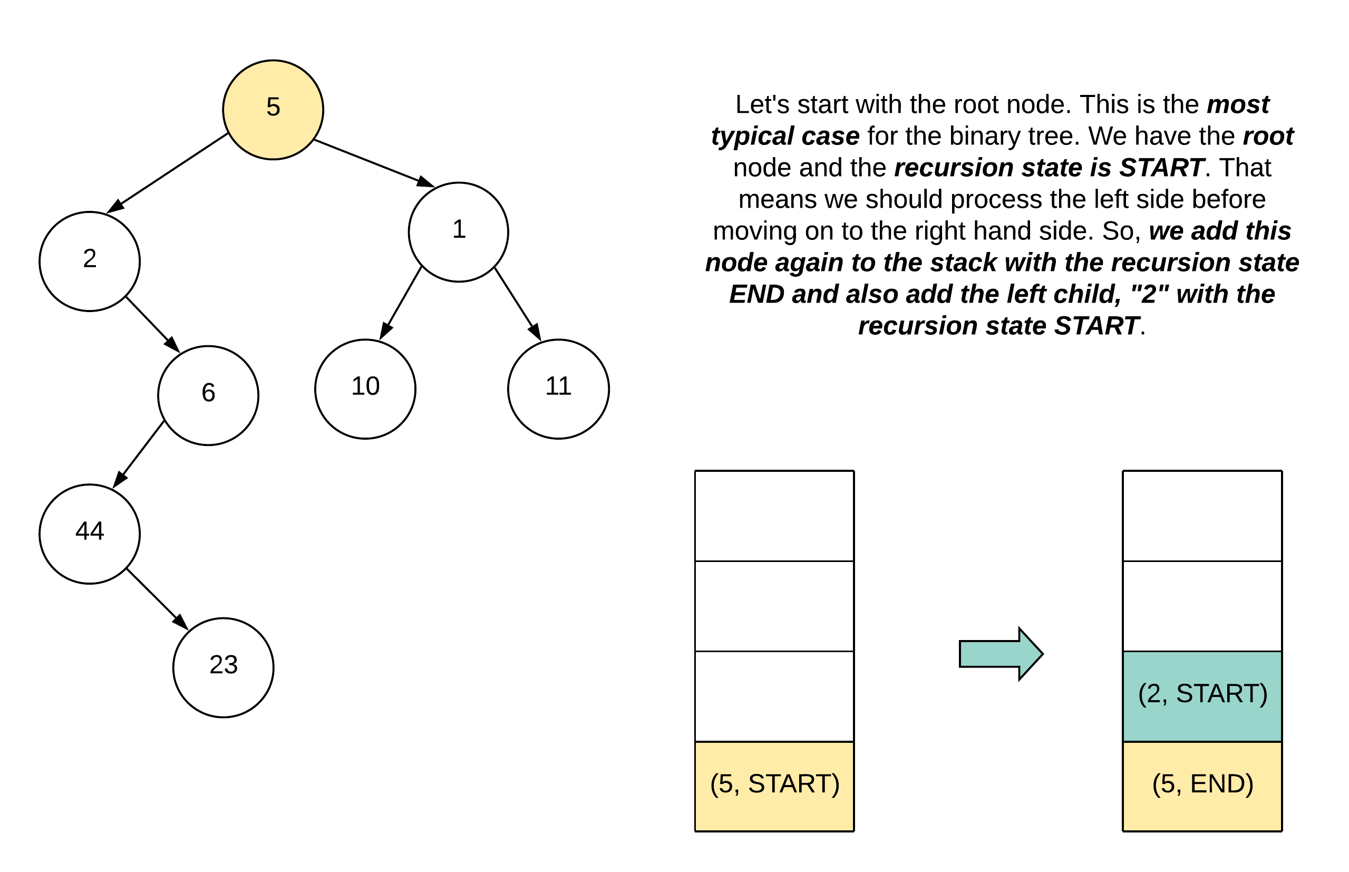

Case 2: START recursion state, node has NO left child

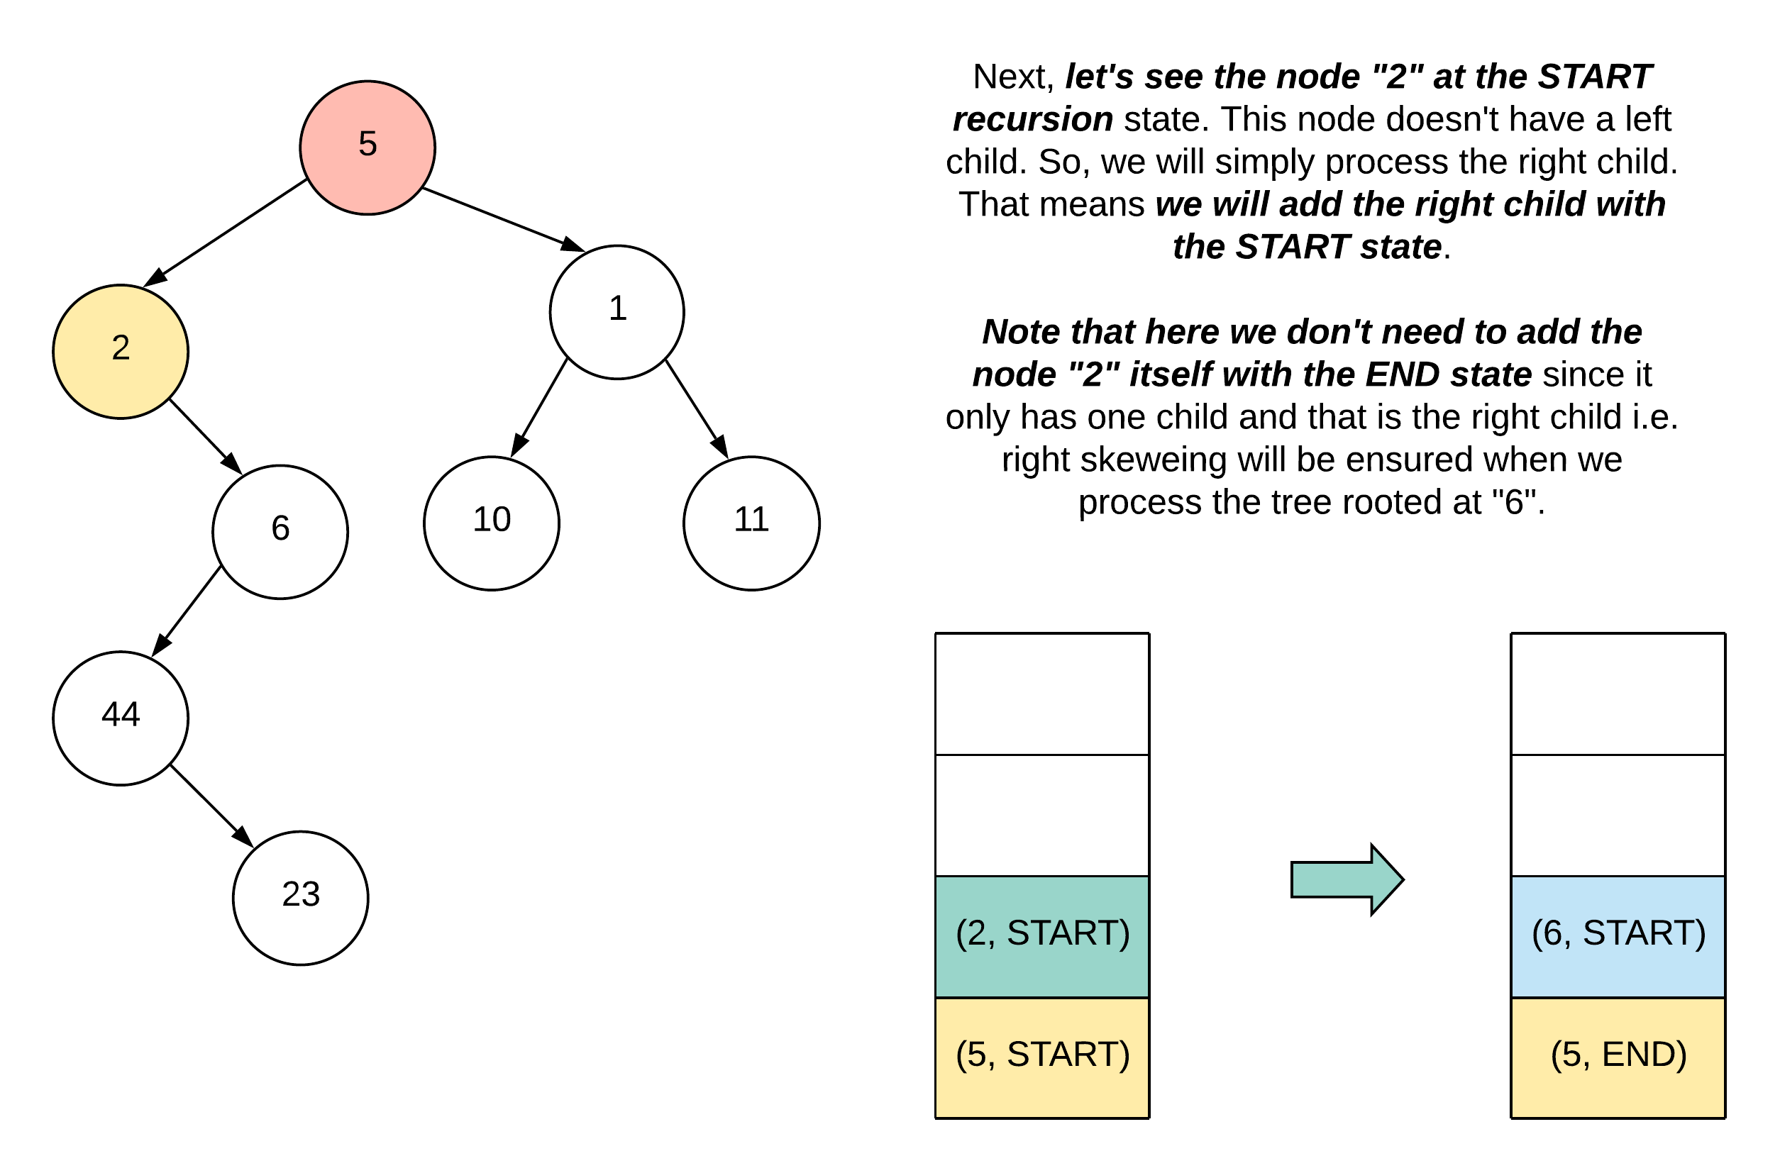

Case 3: END recursion state, node has a right child

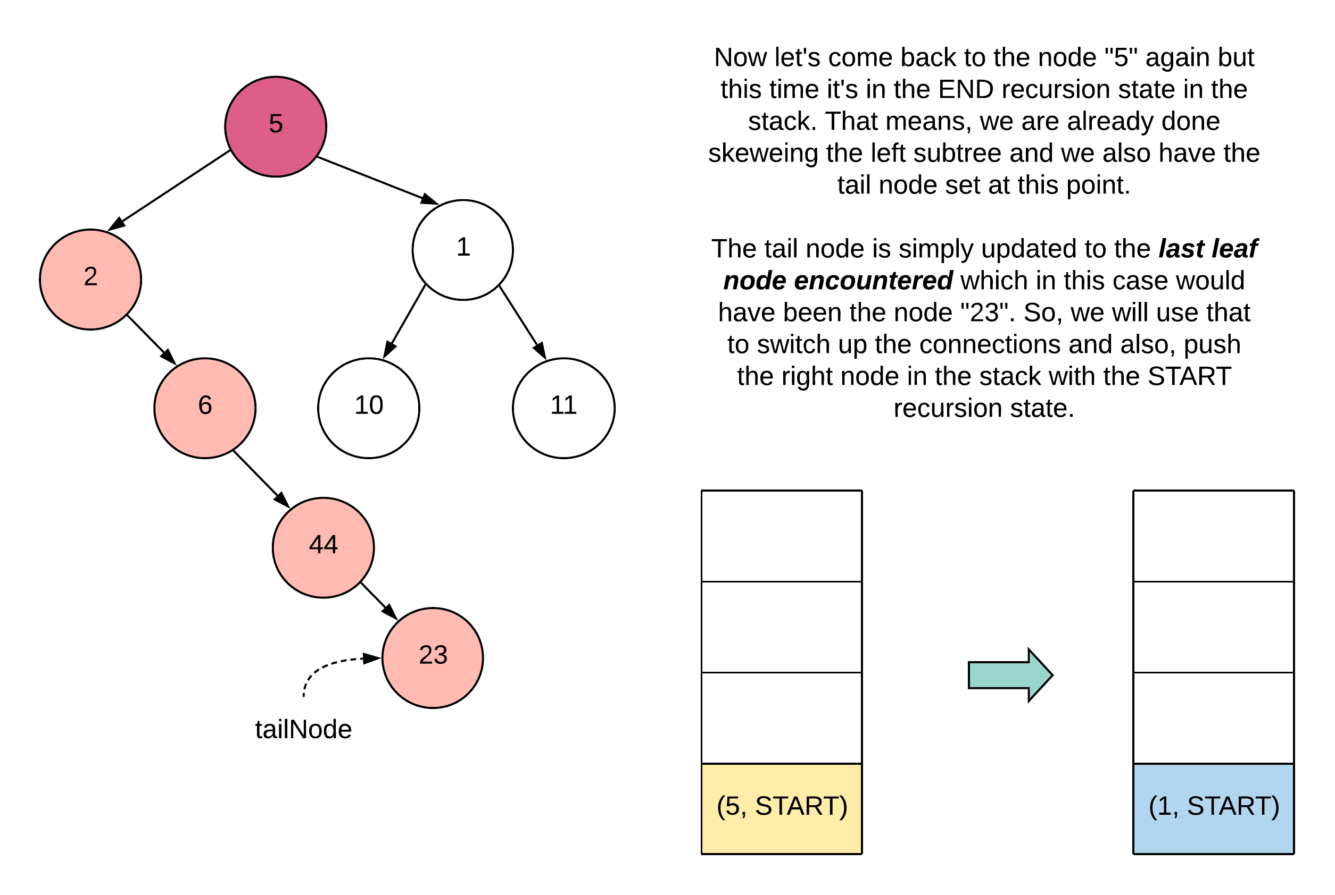

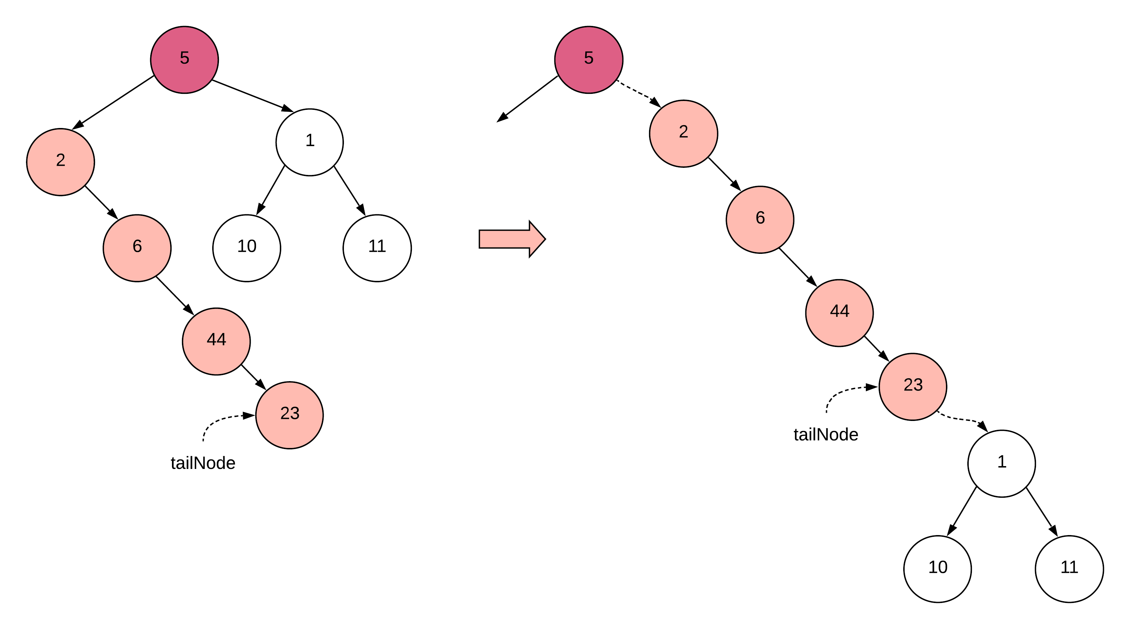

1. If the recursion state of a popped node is START, we will check if the node has a left child or not. If it does, we will add the node back to the stack with the END recursion state and also add the left child with the START recursion state. If there is no left child, then we add the right child only with the START state.
2. If a node popped from the stack is in the END state, that implies it must have had a left child and that means we have a valid tailNode set up for re-wiring the connections as shown in the previous figure. Once we are done re-wiring the connections, we push the right child into the stack with the START recursion state.
3. Finally, for a popped node that is a leaf node, we will set our tailNode.

|  |
| --- |
| class Pair<K, V> {  K key;  V value;  Pair(K a, V b) {  this.key = a;  this.value = b;  }  public K getKey() {  return this.key;  }  public V getValue() {  return this.value;  }  }  class Solution {    public void flatten(TreeNode root) {    // Handle the null scenario  if (root == null) {  return;  }    int START = 1, END = 2;    TreeNode tailNode = null;  Stack<Pair<TreeNode, Integer>> stack = new Stack<Pair<TreeNode, Integer>>();  stack.push(new Pair<TreeNode, Integer>(root, START));    while (!stack.isEmpty()) {    Pair<TreeNode, Integer> nodeData = stack.pop();  TreeNode currentNode = nodeData.getKey();  int recursionState = nodeData.getValue();    // We reached a leaf node. Record this as a tail  // node and move on.  if (currentNode.left == null && currentNode.right == null) {  tailNode = currentNode;  continue;  }    // If the node is in the START state, it means we still  // haven't processed it's left child yet.  if (recursionState == START) {    // If the current node has a left child, we add it  // to the stack AFTER adding the current node again  // to the stack with the END recursion state.  if (currentNode.left != null) {    stack.push(new Pair<TreeNode, Integer>(currentNode, END));  stack.push(new Pair<TreeNode, Integer>(currentNode.left, START));    } else if (currentNode.right != null) {    // In case the current node didn't have a left child  // we will add it's right child  stack.push(new Pair<TreeNode, Integer>(currentNode.right, START));  }    } else {    // If the current node is in the END recursion state,  // that means we did process one of it's children. Left  // if it existed, else right.  TreeNode rightNode = currentNode.right;    // If there was a left child, there must have been a leaf  // node and so, we would have set the tailNode  if (tailNode != null) {    // Establish the proper connections.  tailNode.right = currentNode.right;  currentNode.right = currentNode.left;  currentNode.left = null;  rightNode = tailNode.right;    }    if (rightNode != null) {  stack.push(new Pair<TreeNode, Integer>(rightNode, START));  }  }  }  }  } |

**Complexity Analysis**

* Time Complexity: O(N)*O*(*N*) since we process each node of the tree exactly once.
* Space Complexity: O(N)*O*(*N*) which is occupied by the stack. The problem statement doesn't mention anything about the tree being balanced or not and hence, the tree could be e.g. left skewed and in that case the longest branch (and hence the number of nodes in the recursion stack) would be N*N*.

#### **Approach 3: O(1) Iterative Solution**

**Intuition**

We'll get to the intuition for this approach in a bit, but first let's talk about the motivation. For any kind of tree traversal, we always have the easiest of solutions which is based on recursion. Next, we have a custom stack based iterative version of the same solution. Finally, we want a tree traversal that doesn't use any kind of additional space at all. There is a well known tree traversal out there that doesn't use any additional space at all. It's known as Morris Traversal. Our solution is based off of the same ideology, but Morris Traversal is not a pre-requisite here.

To understand what's difference between the nodes processing of this approach and basic recursion, let's look at a sample tree.

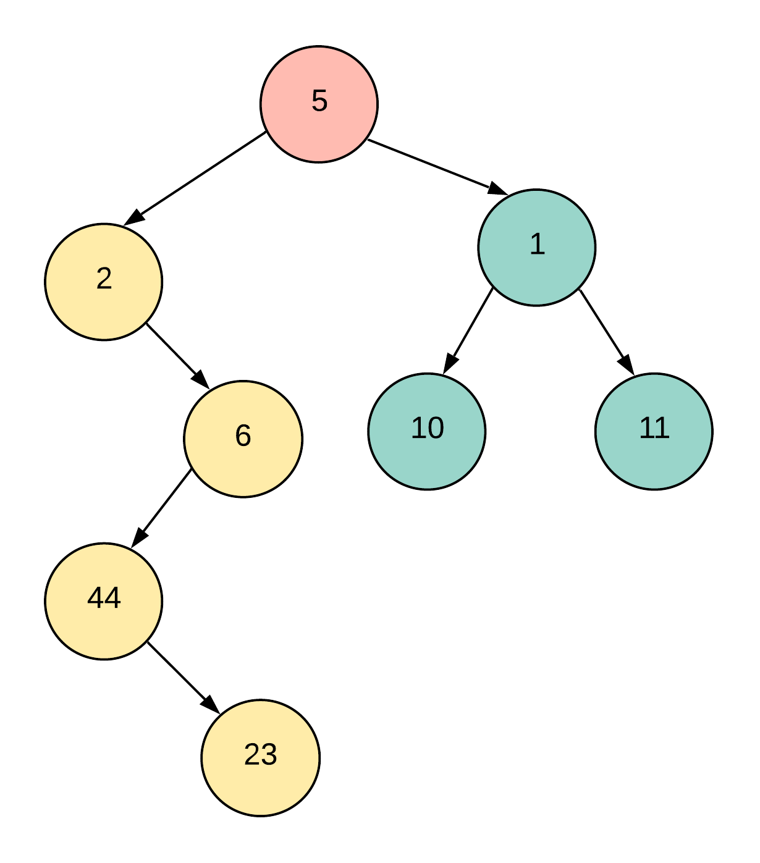

With recursion, we only re-wire the connections for the "current node" once we are already done processing the left and the right subtrees completely. Let's see what that looks like in a figure.

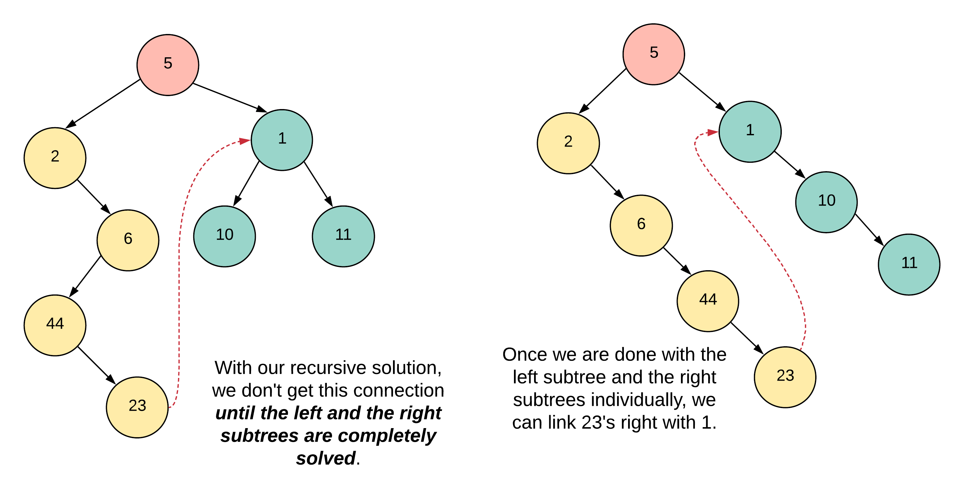

However, the postponing of rewiring of connections on the current node until the left subtree is done, is basically what recursion is. Recursion is all about postponing decisions until something else is completed. In order for us to be able to postpone stuff, we need to use the stack. However, in our current approach we want to get rid of the stack altogether. So, we will have to come up with a greedy way that will be costlier in terms of time, but will be space efficient in achieving the same results.

For a current node, we will check if it has a left child or not. If it does, we will find the last node in the rightmost branch of the subtree rooted at this left child. Once we find this "rightmost" node, we will hook it up with the right child of the current node.

Let's look at this idea on our current sample tree.

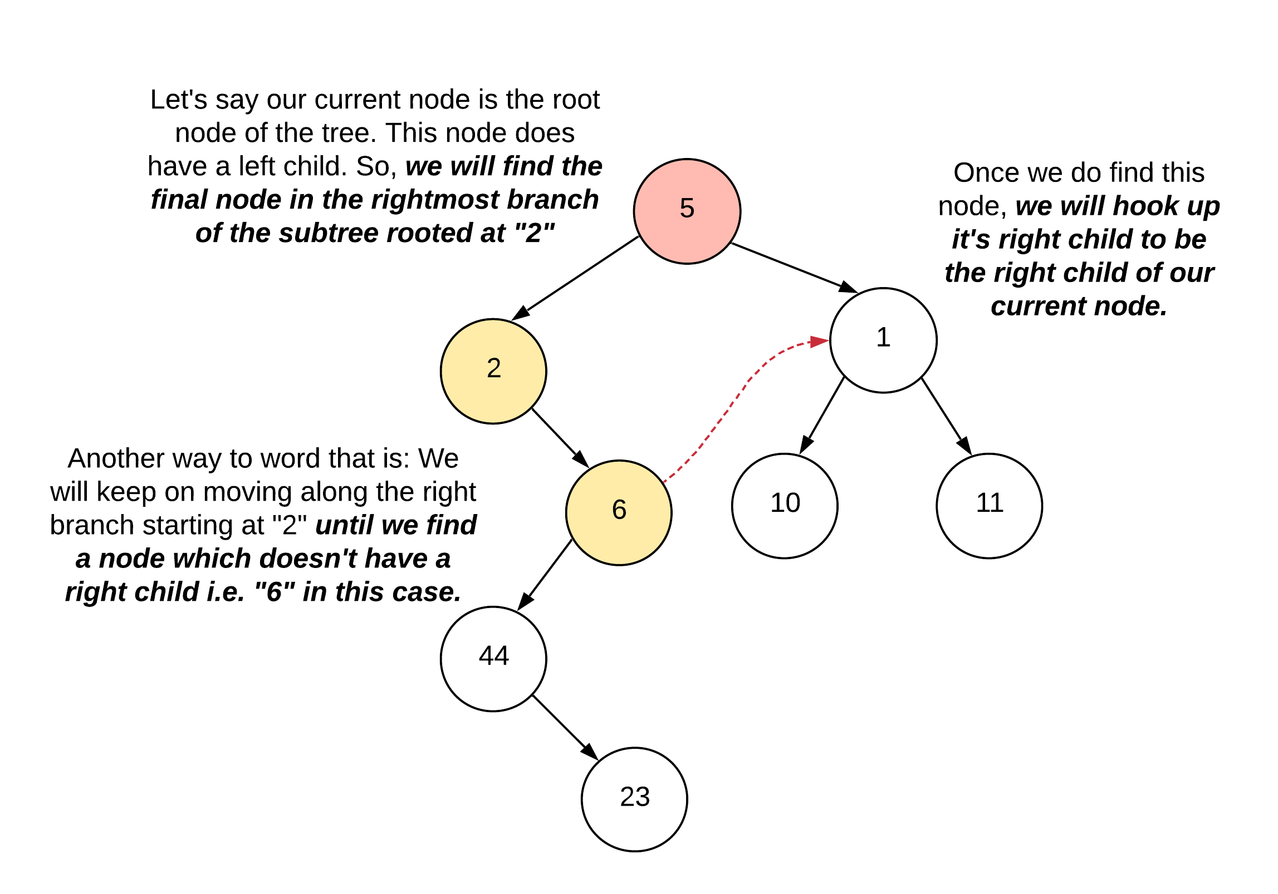

This might not make a lot of sense just yet. But, bear with me and read on. Let's see what connections we need to establish or shuffle once we find that "rightmost node". We are highlighting "rightmost" here because technically, even without knowing this approach, the node 23 would have made much more sense here, right? Instead, we are doing some vodoo with the node 6. God knows why!

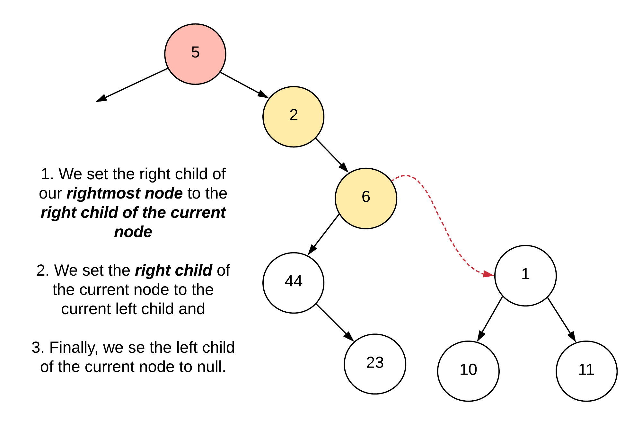

As mentioned in the previous paragraph, this figure would make much more sense if we had just found out the node 23, and set its right child to 1 instead of doing all this with 6. Why did we do that you might ask? Well, it's an optimization of sorts. To find the actual "rightmost" node of subtree, we might have to potentially traverse most of that subtree. Like in our example. To actually get to the node 23, we would have had to traverse all of the nodes: 2, 6, 44, 23. Instead, we simply stop at the node 6. We'll see why that also achieves our final purpose. For now, let's move on.

By doing the following operation for every node, we are simply try ing to move stuff to the right hand side one step at a time. The reason we used the node 6 in the above example and not 23 is the very reason we called this approach somewhat greedy.

Processing of the node 2 is simple since it doesn't have a left child at all. So we have nothing to do here. Let's come over to the node 6 since this is where things get interesting and start to make sense. We'll again use the same logic as before.

For a current node, we will check if it has a left child or not. If it does, we will find the last node in the rightmost branch of the subtree rooted at this left child. Once we find this "rightmost" node, we will hook it up with the right child of the current node.

As we can clearly see from the previous figures, the rightmost node here would be 23. So, let's look at the tree after we are done rewiring the connections.

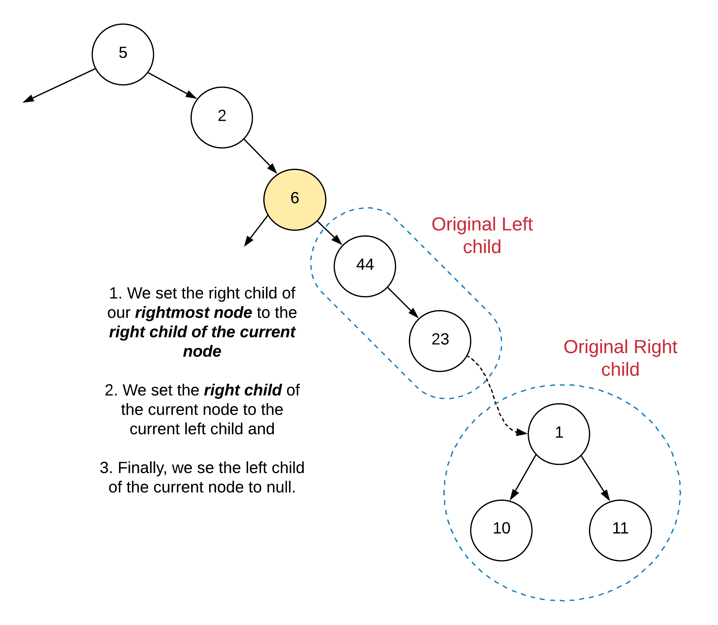

Now this looks just like the tree after the recursion would have completed on the left subtree and we rewired the connections, right? Exactly!. The reason we stopped at the first rightmost node with no right child was because we would eventually end up rightyfying all the subtrees through that connection. Even though before we didn't hook up the node 23, we were able to do it when we arrived at the node 6 here.

**Algorithm**

1. So basically, this is going to be a super short algorithm and a short-er implementation :)
2. We use a pointer for traversing the nodes of our tree starting from the root. We have a loop that keeps going until the node pointer becomes null which is when we would be done processing the entire tree.
3. For every node we check if it has a left child or not. If it doesn't we simply move on to the right hand side i.e.

node = node.right

1. If the node does have a left child, we find the first node on the rightmost branch of the left subtree which doesn't have a right child i.e. the almost rightmost node.

rightmost = node.left

while rightmost != null:

rightmost = rightmost.right

1. Once we find this rightmost node, we rewire the connections as explained in the intuition section.

rightmost.right = node.right

node.right = node.left

node.left = null

1. And we move on to the right node to continue processing of our tree.

|  |
| --- |
| class Solution {    public void flatten(TreeNode root) {    // Handle the null scenario  if (root == null) {  return;  }    TreeNode node = root;    while (node != null) {    // If the node has a left child  if (node.left != null) {    // Find the rightmost node  TreeNode rightmost = node.left;  while (rightmost.right != null) {  rightmost = rightmost.right;  }    // rewire the connections  rightmost.right = node.right;  node.right = node.left;  node.left = null;  }    // move on to the right side of the tree  node = node.right;  }  }  } |

**Complexity Analysis**

* Time Complexity: O(N)*O*(*N*) since we process each node of the tree at most twice. If you think about it, we process the nodes once when we actually run our algorithm on them as the currentNode. The second time when we come across the nodes is when we are trying to find our rightmost node. Sure, this algorithm is slower than the previous two approaches but it doesn't use any additional space which is a big win.
* Space Complexity: O(1)*O*(1) boom!.

**Binary Tree Maximum Path Sum**

A **path** in a binary tree is a sequence of nodes where each pair of adjacent nodes in the sequence has an edge connecting them. A node can only appear in the sequence **at most once**. Note that the path does not need to pass through the root.

The **path sum** of a path is the sum of the node's values in the path.

Given the root of a binary tree, return *the maximum****path sum****of any path*.

**Example 1:**

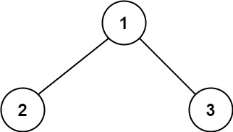

**Input:** root = [1,2,3]

**Output:** 6

**Explanation:** The optimal path is 2 -> 1 -> 3 with a path sum of 2 + 1 + 3 = 6.

**Example 2:**

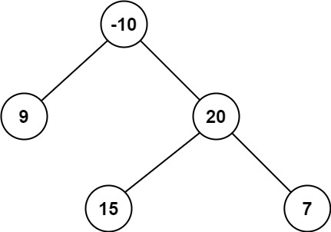

**Input:** root = [-10,9,20,null,null,15,7]

**Output:** 42

**Explanation:** The optimal path is 15 -> 20 -> 7 with a path sum of 15 + 20 + 7 = 42.

**Constraints:**

* The number of nodes in the tree is in the range [1, 3 * 104].
* -1000 <= Node.val <= 1000

Hard

**Clone Graph**

Given a reference of a node in a [**connected**](https://en.wikipedia.org/wiki/Connectivity_(graph_theory)#Connected_graph) undirected graph. Return a [**deep copy**](https://en.wikipedia.org/wiki/Object_copying#Deep_copy) (clone) of the graph.

Each node in the graph contains a val (int) and a list (List[Node]) of its neighbors.

class Node {

public int val;

public List<Node> neighbors;

}

**Test case format:**

For simplicity sake, each node's value is the same as the node's index (1-indexed). For example, the first node with val = 1, the second node with val = 2, and so on. The graph is represented in the test case using an adjacency list.

**Adjacency list** is a collection of unordered **lists** used to represent a finite graph. Each list describes the set of neighbors of a node in the graph.

The given node will always be the first node with val = 1. You must return the **copy of the given node** as a reference to the cloned graph.

**Example 1:**

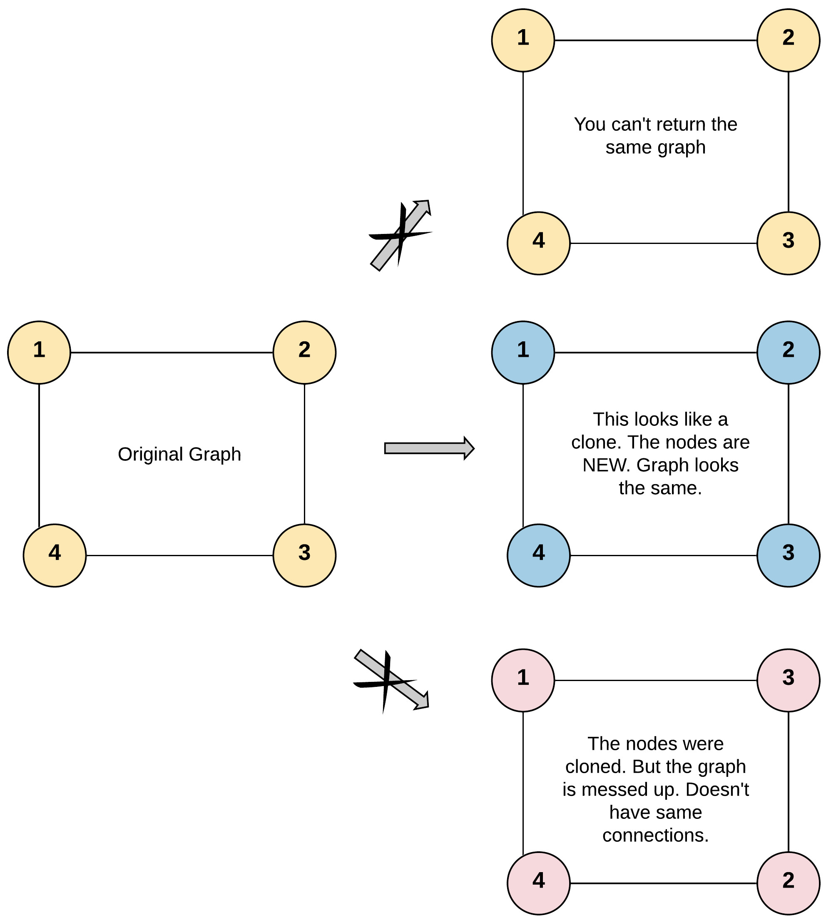

**Input:** adjList = [[2,4],[1,3],[2,4],[1,3]]

**Output:** [[2,4],[1,3],[2,4],[1,3]]

**Explanation:** There are 4 nodes in the graph.

1st node (val = 1)'s neighbors are 2nd node (val = 2) and 4th node (val = 4).

2nd node (val = 2)'s neighbors are 1st node (val = 1) and 3rd node (val = 3).

3rd node (val = 3)'s neighbors are 2nd node (val = 2) and 4th node (val = 4).

4th node (val = 4)'s neighbors are 1st node (val = 1) and 3rd node (val = 3).

**Example 2:**

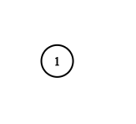

**Input:** adjList = [[]]

**Output:** [[]]

**Explanation:** Note that the input contains one empty list. The graph consists of only one node with val = 1 and it does not have any neighbors.

**Example 3:**

**Input:** adjList = []

**Output:** []

**Explanation:** This an empty graph, it does not have any nodes.

**Example 4:**

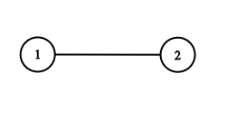

**Input:** adjList = [[2],[1]]

**Output:** [[2],[1]]

**Constraints:**

* 1 <= Node.val <= 100
* Node.val is unique for each node.
* Number of Nodes will not exceed 100.
* There is no repeated edges and no self-loops in the graph.
* The Graph is connected and all nodes can be visited starting from the given node.

Queue Stack

**Binary Tree Right Side View**

Given the root of a binary tree, imagine yourself standing on the **right side** of it, return *the values of the nodes you can see ordered from top to bottom*.

**Example 1:**

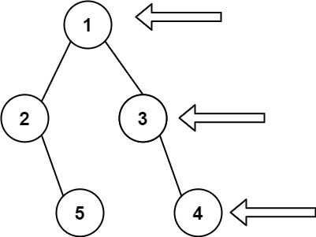

**Input:** root = [1,2,3,null,5,null,4]

**Output:** [1,3,4]

**Example 2:**

**Input:** root = [1,null,3]

**Output:** [1,3]

**Example 3:**

**Input:** root = []

**Output:** []

**Constraints:**

* The number of nodes in the tree is in the range [0, 100].
* -100 <= Node.val <= 100

Solution

Overview

**DFS vs. BFS**

There are two ways to traverse the tree: DFS *depth first search* and BFS *breadth first search*. Here is a small summary

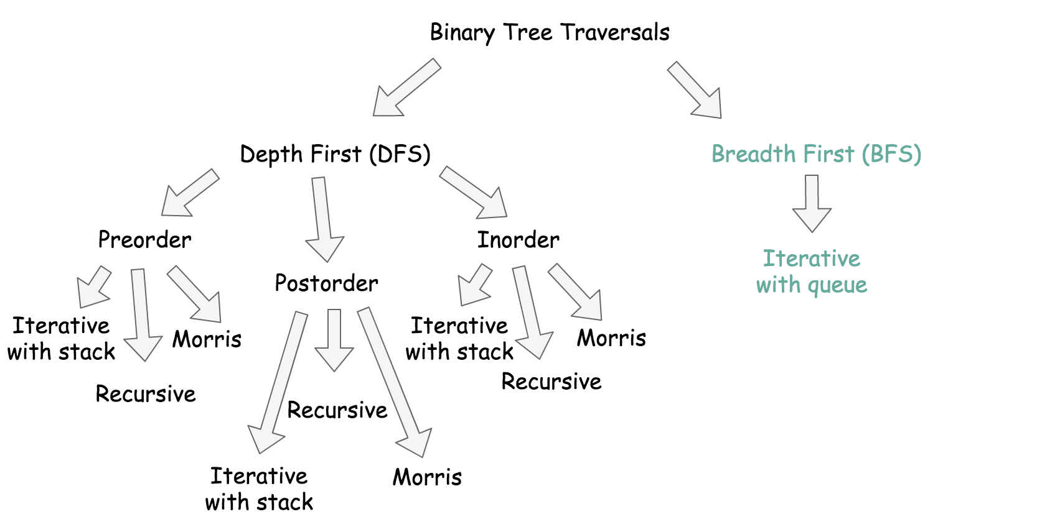

BFS traverses level by level, and DFS first goes to the leaves.

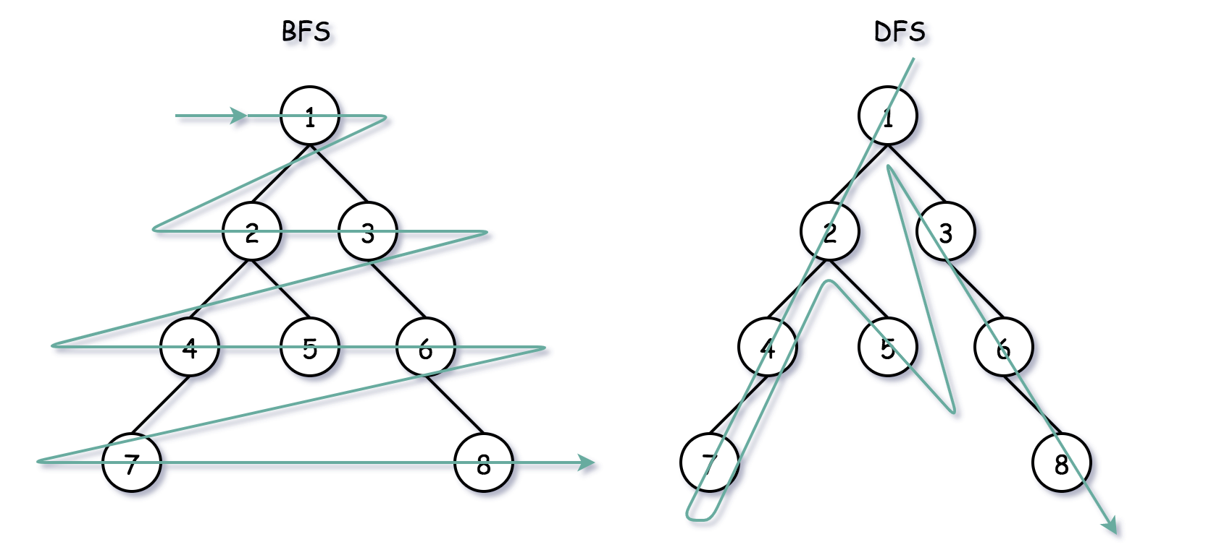

Which approach to choose, BFS or DFS?

* The problem is to return a list of last elements from all levels, so it's the way more natural to implement BFS here.
* Time complexity is the same \mathcal{O}(N)O(*N*) both for DFS and BFS since one has to visit all nodes.
* Space complexity is \mathcal{O}(H)O(*H*) for DFS and  
  \mathcal{O}(D)O(*D*) for BFS, where H*H* is a tree height, and D*D* is a tree diameter. They both result in \mathcal{O}(N)O(*N*) space in the worst-case scenarios: skewed tree for DFS and complete tree for BFS.

BFS wins for this problem, so let's use the opportunity to check out three different BFS implementations with the queue.

**BFS implementation**

All three implementations use the queue in a standard BFS way:

* Push the root into the queue.
* Pop-out a node from the *left*.
* Push the *left* child into the queue, and then push the *right* child.

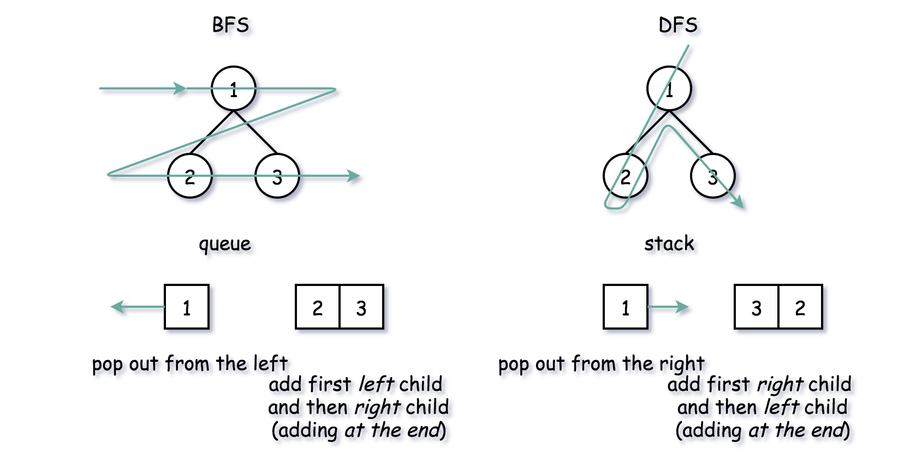

**Three BFS approaches**

The difference is how to find the end of the level, i.e. the rightmost element:

* Two queues, one for the previous level and one for the current.
* One queue with sentinel to mark the end of the level.
* One queue + level size measurement.

Approach 1: BFS: Two Queues

Let's use two queues: one for the current level, and one for the next. The idea is to pop the nodes one by one from the current level and push their children into the next level queue. Each time the current queue is empty, we have the right side element in hands.

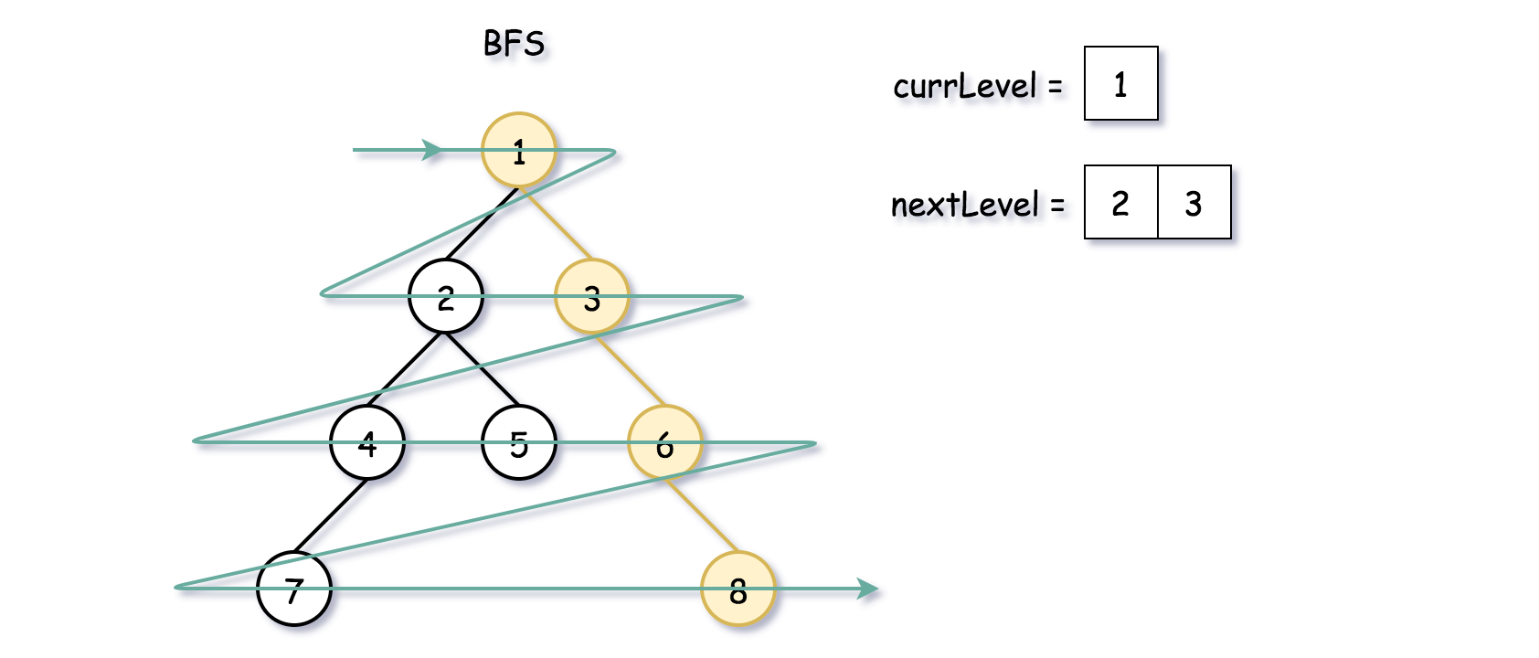

**Algorithm**

* Initiate the list of the right side view rightside.
* Initiate two queues: one for the current level, and one for the next. Add root into nextLevel queue.
* While nextLevel queue is not empty:
  + Initiate the current level: currLevel = nextLevel, and empty the next level nextLevel.
  + While current level queue is not empty:
    - Pop out a node from the current level queue.
    - Add first *left* and then *right* child node into nextLevel queue.
  + Now currLevel is empty, and the node we have in hands is the last one, and makes a part of the right side view. Add it into rightside.
* Return rightside.

**Implementation**

|  |
| --- |
| class Solution {  public List<Integer> rightSideView(TreeNode root) {  if (root == null) return new ArrayList<Integer>();    ArrayDeque<TreeNode> nextLevel = new ArrayDeque() {{ offer(root); }};  ArrayDeque<TreeNode> currLevel = new ArrayDeque();  List<Integer> rightside = new ArrayList();    TreeNode node = null;  while (!nextLevel.isEmpty()) {  // prepare for the next level  currLevel = nextLevel.clone();  nextLevel.clear();  while (! currLevel.isEmpty()) {  node = currLevel.poll();  // add child nodes of the current level  // in the queue for the next level  if (node.left != null)  nextLevel.offer(node.left);  if (node.right != null)  nextLevel.offer(node.right);  }    // The current level is finished.  // Its last element is the rightmost one.  if (currLevel.isEmpty())  rightside.add(node.val);  }  return rightside;  }  } |

**Complexity Analysis**

* Time complexity: \mathcal{O}(N)O(*N*) since one has to visit each node.
* Space complexity: \mathcal{O}(D)O(*D*) to keep the queues, where D*D* is a tree diameter. Let's use the last level to estimate the queue size. This level could contain up to N/2*N*/2 tree nodes in the case of [complete binary tree](https://leetcode.com/problems/count-complete-tree-nodes/).

#### **Approach 2: BFS: One Queue + Sentinel**

Another approach is to push all the nodes in one queue and to use a [sentinel node](https://en.wikipedia.org/wiki/Sentinel_node) to separate the levels. Typically, one could use null as a sentinel.

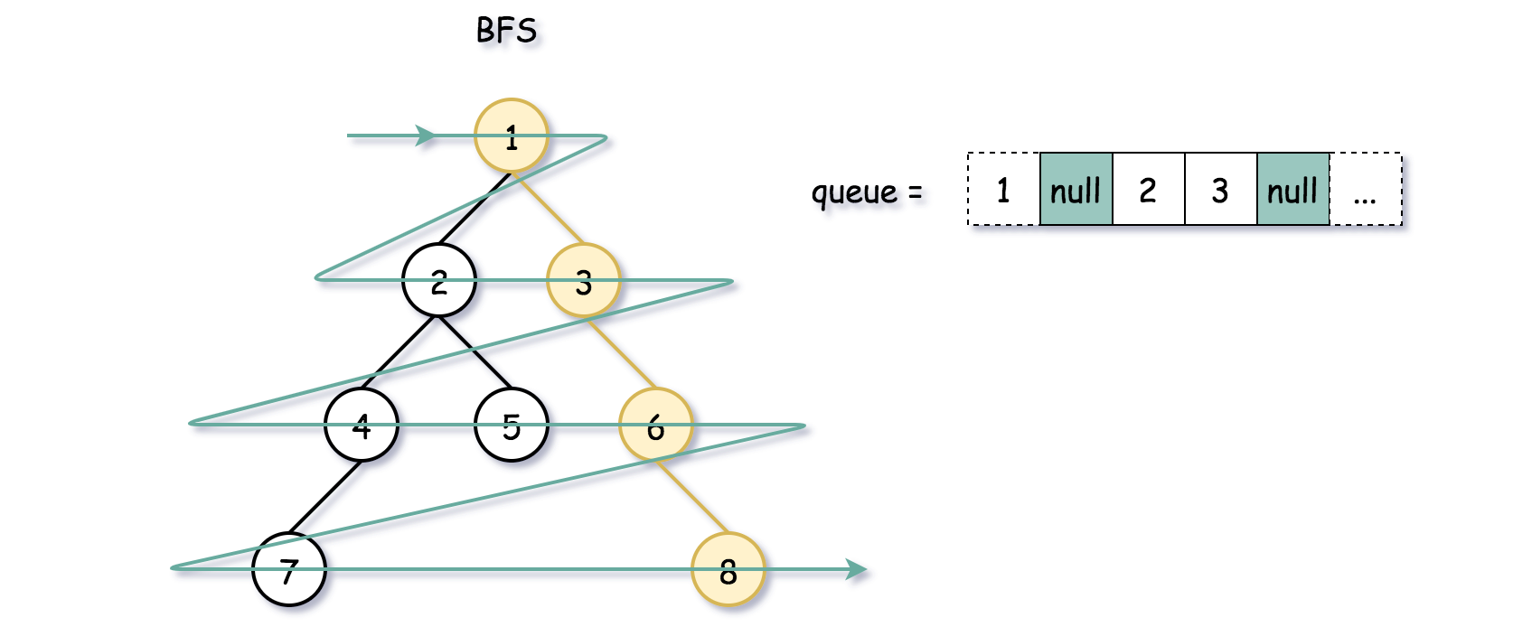

The first step is to initiate the first level: root + null as a sentinel. Once it's done, continue to pop the nodes one by one from the left and push their children to the right. Stop each time the current node is null because it means we hit the end of the current level. Each stop is a time to update a right side view list and to push null in the queue to mark the end of the next level.

**Algorithm**

* Initiate the list of the right side view rightside.
* Initiate the queue by adding a root. Add null sentinel to mark the end of the first level.
* Initiate the current node as root.
* While queue is not empty:
  + Save the previous node prev = curr and pop the current node from the queue curr = queue.poll().
  + While the current node is not null:
    - Add first left and then right child node into the queue.
    - Update both previous and current nodes: prev = curr, curr = queue.poll().
  + Now the current node is null, i.e. we reached the end of the current level. Hence the previous node is the rightmost one and makes a part of the right side view. Add it into rightside.
  + If the queue is not empty, push the null node as a sentinel, to mark the end of the next level.
* Return rightside.

**Implementation**

Note, that ArrayDeque in Java doesn't support null elements, and hence the data structure to use here is LinkedList.

|  |
| --- |
| class Solution {  public List<Integer> rightSideView(TreeNode root) {  if (root == null) return new ArrayList<Integer>();    Queue<TreeNode> queue = new LinkedList(){{ offer(root); offer(null); }};  TreeNode prev, curr = root;  List<Integer> rightside = new ArrayList();    while (!queue.isEmpty()) {  prev = curr;  curr = queue.poll();  while (curr != null) {  // add child nodes in the queue  if (curr.left != null) {  queue.offer(curr.left);  }  if (curr.right != null) {  queue.offer(curr.right);  }    prev = curr;  curr = queue.poll();  }  // the current level is finished  // and prev is its rightmost element  rightside.add(prev.val);  // add a sentinel to mark the end  // of the next level  if (!queue.isEmpty())  queue.offer(null);  }  return rightside;  }  } |

**Complexity Analysis**

* Time complexity: \mathcal{O}(N)O(*N*) since one has to visit each node.
* Space complexity: \mathcal{O}(D)O(*D*) to keep the queues, where D*D* is a tree diameter. Let's use the last level to estimate the queue size. This level could contain up to N/2*N*/2 tree nodes in the case of [complete binary tree](https://leetcode.com/problems/count-complete-tree-nodes/).

#### **Approach 3: BFS: One Queue + Level Size Measurements**

Instead of using the sentinel, we could write down the length of the current level.

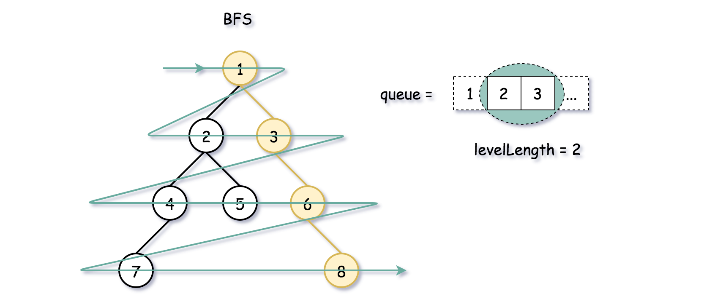

**Algorithm**

* Initiate the list of the right side view rightside.
* Initiate the queue by adding a root.
* While the queue is not empty:
  + Write down the length of the current level: levelLength = queue.size().
  + Iterate over i from 0 to level_length - 1:
    - Pop the current node from the queue: node = queue.poll().
    - If i == levelLength - 1, then it's the last node in the current level, push it to rightsize list.
    - Add first left and then right child node into the queue.
* Return rightside.

**Implementation**

|  |
| --- |
| class Solution {  public List<Integer> rightSideView(TreeNode root) {  if (root == null) return new ArrayList<Integer>();    ArrayDeque<TreeNode> queue = new ArrayDeque(){{ offer(root); }};  List<Integer> rightside = new ArrayList();    while (!queue.isEmpty()) {  int levelLength = queue.size();  for(int i = 0; i < levelLength; ++i) {  TreeNode node = queue.poll();  // if it's the rightmost element  if (i == levelLength - 1) {  rightside.add(node.val);  }  // add child nodes in the queue  if (node.left != null) {  queue.offer(node.left);  }  if (node.right != null) {  queue.offer(node.right);  }  }  }  return rightside;  }  } |

**Complexity Analysis**

* Time complexity: \mathcal{O}(N)O(*N*) since one has to visit each node.
* Space complexity: \mathcal{O}(D)O(*D*) to keep the queues, where D*D* is a tree diameter. Let's use the last level to estimate the queue size. This level could contain up to N/2*N*/2 tree nodes in the case of [complete binary tree](https://leetcode.com/problems/count-complete-tree-nodes/).

#### **Approach 4: Recursive DFS**

Everyone likes recursive DFS, so let's add it here as well. The idea is simple: to traverse the tree level by level, starting each time from the rightmost child.

**Implementation**

|  |
| --- |
| class Solution {  List<Integer> rightside = new ArrayList();    public void helper(TreeNode node, int level) {  if (level == rightside.size())  rightside.add(node.val);    if (node.right != null)  helper(node.right, level + 1);  if (node.left != null)  helper(node.left, level + 1);  }    public List<Integer> rightSideView(TreeNode root) {  if (root == null) return rightside;    helper(root, 0);  return rightside;  }  } |

**Complexity Analysis**

* Time complexity: \mathcal{O}(N)O(*N*) since one has to visit each node.
* Space complexity: \mathcal{O}(H)O(*H*) to keep the recursion stack, where H*H* is a tree height. The worst-case situation is a skewed tree, when H = N*H*=*N*.

Simple level order traversal

|  |
| --- |
| class Solution {  public List<Integer> rightSideView(TreeNode root) {  List<Integer> ans = new LinkedList<>();  if(root==null) return ans;  Deque<TreeNode> q = new LinkedList<>();  q.add(root);  while(!q.isEmpty()){  int size = q.size();  for(int i = 0; i<size; i++){  TreeNode node = q.poll();  if(i==size-1){  ans.add(node.val);  }  if(node.left!=null) q.add(node.left);  if(node.right!=null) q.add(node.right);  }  }  return ans;  }  } |

**Number of Islands**

Given an m x n 2d grid map of '1's (land) and '0's (water), return *the number of islands*.

An **island** is surrounded by water and is formed by connecting adjacent lands horizontally or vertically. You may assume all four edges of the grid are all surrounded by water.

**Example 1:**

**Input:** grid = [

["1","1","1","1","0"],

["1","1","0","1","0"],

["1","1","0","0","0"],

["0","0","0","0","0"]

]

**Output:** 1

**Example 2:**

**Input:** grid = [

["1","1","0","0","0"],

["1","1","0","0","0"],

["0","0","1","0","0"],

["0","0","0","1","1"]

]

**Output:** 3

**Constraints:**

* m == grid.length
* n == grid[i].length
* 1 <= m, n <= 300
* grid[i][j] is '0' or '1'.

Queue Stack

**Lowest Common Ancestor of a Binary Tree**

Given a binary tree, find the lowest common ancestor (LCA) of two given nodes in the tree.

According to the [definition of LCA on Wikipedia](https://en.wikipedia.org/wiki/Lowest_common_ancestor): “The lowest common ancestor is defined between two nodes p and q as the lowest node in T that has both p and q as descendants (where we allow **a node to be a descendant of itself**).”

**Example 1:**

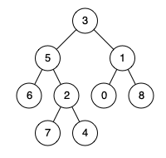

**Input:** root = [3,5,1,6,2,0,8,null,null,7,4], p = 5, q = 1

**Output:** 3

**Explanation:** The LCA of nodes 5 and 1 is 3.

**Example 2:**



**Input:** root = [3,5,1,6,2,0,8,null,null,7,4], p = 5, q = 4

**Output:** 5

**Explanation:** The LCA of nodes 5 and 4 is 5, since a node can be a descendant of itself according to the LCA definition.

**Example 3:**

**Input:** root = [1,2], p = 1, q = 2

**Output:** 1

**Constraints:**

* The number of nodes in the tree is in the range [2, 105].
* -109 <= Node.val <= 109
* All Node.val are **unique**.
* p != q
* p and q will exist in the tree.

Binary Tree

**Binary Tree Paths**

Given a binary tree, return all root-to-leaf paths.

**Note:** A leaf is a node with no children.

**Example:**

**Input:**

1

/ \

2 3

\

5

**Output:** ["1->2->5", "1->3"]

**Explanation:** All root-to-leaf paths are: 1->2->5, 1->3

Solution

Binary tree definition

First of all, here is the definition of the TreeNode which we would use in the following implementation.

|  |
| --- |
| /* Definition for a binary tree node. */  public class TreeNode {  int val;  TreeNode left;  TreeNode right;  TreeNode(int x) {  val = x;  }  } |

#### **Approach 1: Recursion**

The most intuitive way is to use a recursion here. One is going through the tree by considering at each step the node itself and its children. If node is not a leaf, one extends the current path by a node value and calls recursively the path construction for its children. If node is a leaf, one closes the current path and adds it into the list of paths.

|  |
| --- |
| class Solution {  public void construct_paths(TreeNode root, String path, LinkedList<String> paths) {  if (root != null) {  path += Integer.toString(root.val);  if ((root.left == null) && (root.right == null)) // if reach a leaf  paths.add(path); // update paths  else {  path += "->"; // extend the current path  construct_paths(root.left, path, paths);  construct_paths(root.right, path, paths);  }  }  }  public List<String> binaryTreePaths(TreeNode root) {  LinkedList<String> paths = new LinkedList();  construct_paths(root, "", paths);  return paths;  }  } |

**Complexity Analysis**

* Time complexity : we visit each node exactly once, thus the time complexity is \mathcal{O}(N)O(*N*), where N*N* is the number of nodes.
* Space complexity : \mathcal{O}(N)O(*N*). Here we use the space for a stack call and for a paths list to store the answer. paths contains as many elements as leafs in the tree and hence couldn't be larger than \log Nlog*N* for the trees containing more than one element. Hence the space complexity is determined by a stack call. In the worst case, when the tree is completely unbalanced, e.g. each node has only one child node, the recursion call would occur N*N* times (the height of the tree), therefore the storage to keep the call stack would be \mathcal{O}(N)O(*N*). But in the best case (the tree is balanced), the height of the tree would be \log(N)log(*N*). Therefore, the space complexity in this case would be \mathcal{O}(\log(N))O(log(*N*)).

#### **Approach 2: Iterations**

The approach above could be rewritten with the help of iterations. This way we initiate the stack by a root node and then at each step we pop out one node and its path. If the poped node is a leaf, one update the list of all paths. If not, one pushes its child nodes and corresponding paths into stack till all nodes are checked.



|  |
| --- |
| class Solution {  public List<String> binaryTreePaths(TreeNode root) {  LinkedList<String> paths = new LinkedList();  if (root == null)  return paths;  LinkedList<TreeNode> node_stack = new LinkedList();  LinkedList<String> path_stack = new LinkedList();  node_stack.add(root);  path_stack.add(Integer.toString(root.val));  TreeNode node;  String path;  while ( !node_stack.isEmpty() ) {  node = node_stack.pollLast();  path = path_stack.pollLast();  if ((node.left == null) && (node.right == null))  paths.add(path);  if (node.left != null) {  node_stack.add(node.left);  path_stack.add(path + "->" + Integer.toString(node.left.val));  }  if (node.right != null) {  node_stack.add(node.right);  path_stack.add(path + "->" + Integer.toString(node.right.val));  }  }  return paths;  }  } |

Time complexity : \mathcal{O}(N)O(N) since each node is visited exactly once.

Space complexity : \mathcal{O}(N)O(*N*) as we could keep up to the entire tree.

**Alien Dictionary**

There is a new alien language that uses the English alphabet. However, the order among letters are unknown to you.

You are given a list of strings words from the dictionary, where words are **sorted lexicographically** by the rules of this new language.

*Derive the order of letters in this language, and return it*. If the given input is invalid, return "". If there are multiple valid solutions, return **any of them**.

**Example 1:**

**Input:** words = ["wrt","wrf","er","ett","rftt"]

**Output:** "wertf"

**Example 2:**

**Input:** words = ["z","x"]

**Output:** "zx"

**Example 3:**

**Input:** words = ["z","x","z"]

**Output:** ""

**Explanation:** The order is invalid, so return "".

**Constraints:**

* 1 <= words.length <= 100
* 1 <= words[i].length <= 100
* words[i] consists of only lowercase English letters.

Hard

**Shortest Distance from All Buildings**

You want to build a house on an *empty* land which reaches all buildings in the shortest amount of distance. You can only move up, down, left and right. You are given a 2D grid of values **0**, **1** or **2**, where:

* Each **0** marks an empty land which you can pass by freely.
* Each **1** marks a building which you cannot pass through.
* Each **2** marks an obstacle which you cannot pass through.

**Example:**

**Input:** [[1,0,2,0,1],[0,0,0,0,0],[0,0,1,0,0]]

1 - 0 - 2 - 0 - 1

| | | | |

0 - 0 - 0 - 0 - 0

| | | | |

0 - 0 - 1 - 0 - 0

**Output:** 7

**Explanation:** Given three buildings at (0,0), (0,4), (2,2), and an obstacle at (0,2),

the point (1,2) is an ideal empty land to build a house, as the total

  travel distance of 3+3+1=7 is minimal. So return 7.

**Note:**  
There will be at least one building. If it is not possible to build such house according to the above rules, return -1.

**Diameter of Binary Tree**

Given a binary tree, you need to compute the length of the diameter of the tree. The diameter of a binary tree is the length of the **longest** path between any two nodes in a tree. This path may or may not pass through the root.

**Example:**  
Given a binary tree

1

/ \

2 3

/ \

4 5

Return **3**, which is the length of the path [4,2,1,3] or [5,2,1,3].

**Note:** The length of path between two nodes is represented by the number of edges between them.

Google

**Accounts Merge**

Given a list accounts, each element accounts[i] is a list of strings, where the first element accounts[i][0] is a *name*, and the rest of the elements are *emails* representing emails of the account.

Now, we would like to merge these accounts. Two accounts definitely belong to the same person if there is some email that is common to both accounts. Note that even if two accounts have the same name, they may belong to different people as people could have the same name. A person can have any number of accounts initially, but all of their accounts definitely have the same name.

After merging the accounts, return the accounts in the following format: the first element of each account is the name, and the rest of the elements are emails **in sorted order**. The accounts themselves can be returned in any order.

**Example 1:**

**Input:**

accounts = [["John", "johnsmith@mail.com", "john00@mail.com"], ["John", "johnnybravo@mail.com"], ["John", "johnsmith@mail.com", "john_newyork@mail.com"], ["Mary", "mary@mail.com"]]

**Output:** [["John", 'john00@mail.com', 'john_newyork@mail.com', 'johnsmith@mail.com'], ["John", "johnnybravo@mail.com"], ["Mary", "mary@mail.com"]]

**Explanation:**

The first and third John's are the same person as they have the common email "johnsmith@mail.com".

The second John and Mary are different people as none of their email addresses are used by other accounts.

We could return these lists in any order, for example the answer [['Mary', 'mary@mail.com'], ['John', 'johnnybravo@mail.com'],

['John', 'john00@mail.com', 'john_newyork@mail.com', 'johnsmith@mail.com']] would still be accepted.

**Note:**

• The length of accounts will be in the range [1, 1000].

• The length of accounts[i] will be in the range [1, 10].

• The length of accounts[i][j] will be in the range [1, 30].

For every pair of emails in the same account, draw an edge between those emails. The problem is about enumerating the connected components of this graph.

#### **Approach #1: Depth-First Search [Accepted]**

**Intuition**

Draw an edge between two emails if they occur in the same account. The problem comes down to finding connected components of this graph.

**Algorithm**

For each account, draw the edge from the first email to all other emails. Additionally, we'll remember a map from emails to names on the side. After finding each connected component using a depth-first search, we'll add that to our answer.

|  |
| --- |
| class Solution {  public List<List<String>> accountsMerge(List<List<String>> accounts) {  Map<String, String> emailToName = new HashMap();  Map<String, ArrayList<String>> graph = new HashMap();  for (List<String> account: accounts) {  String name = "";  for (String email: account) {  if (name == "") {  name = email;  continue;  }  graph.computeIfAbsent(email, x-> new ArrayList<String>()).add(account.get(1));  graph.computeIfAbsent(account.get(1), x-> new ArrayList<String>()).add(email);  emailToName.put(email, name);  }  }  Set<String> seen = new HashSet();  List<List<String>> ans = new ArrayList();  for (String email: graph.keySet()) {  if (!seen.contains(email)) {  seen.add(email);  Stack<String> stack = new Stack();  stack.push(email);  List<String> component = new ArrayList();  while (!stack.empty()) {  String node = stack.pop();  component.add(node);  for (String nei: graph.get(node)) {  if (!seen.contains(nei)) {  seen.add(nei);  stack.push(nei);  }  }  }  Collections.sort(component);  component.add(0, emailToName.get(email));  ans.add(component);  }  }  return ans;  }  } |

**Complexity Analysis**

* Time Complexity: O(\sum a_i \log a_i)*O*(∑*ai*​log*ai*​), where a_i*ai*​ is the length of accounts[i]. Without the log factor, this is the complexity to build the graph and search for each component. The log factor is for sorting each component at the end.
* Space Complexity: O(\sum a_i)*O*(∑*ai*​), the space used by our graph and our search.

#### **Approach #2: Union-Find [Accepted]**

**Intuition**

As in Approach #1, our problem comes down to finding the connected components of a graph. This is a natural fit for a Disjoint Set Union (DSU) structure.

**Algorithm**

As in Approach #1, draw edges between emails if they occur in the same account. For easier interoperability between our DSU template, we will map each email to some integer index by using emailToID. Then, dsu.find(email) will tell us a unique id representing what component that email is in.

For more information on DSU, please look at Approach #2 in the [article here](https://leetcode.com/articles/redundant-connection/). For brevity, the solutions showcased below do not use union-by-rank.

|  |
| --- |
| class Solution {  public List<List<String>> accountsMerge(List<List<String>> accounts) {  DSU dsu = new DSU();  Map<String, String> emailToName = new HashMap();  Map<String, Integer> emailToID = new HashMap();  int id = 0;  for (List<String> account: accounts) {  String name = "";  for (String email: account) {  if (name == "") {  name = email;  continue;  }  emailToName.put(email, name);  if (!emailToID.containsKey(email)) {  emailToID.put(email, id++);  }  dsu.union(emailToID.get(account.get(1)), emailToID.get(email));  }  }  Map<Integer, List<String>> ans = new HashMap();  for (String email: emailToName.keySet()) {  int index = dsu.find(emailToID.get(email));  ans.computeIfAbsent(index, x-> new ArrayList()).add(email);  }  for (List<String> component: ans.values()) {  Collections.sort(component);  component.add(0, emailToName.get(component.get(0)));  }  return new ArrayList(ans.values());  }  }  class DSU {  int[] parent;  public DSU() {  parent = new int[10001];  for (int i = 0; i <= 10000; ++i)  parent[i] = i;  }  public int find(int x) {  if (parent[x] != x) parent[x] = find(parent[x]);  return parent[x];  }  public void union(int x, int y) {  parent[find(x)] = find(y);  }  } |

**Complexity Analysis**

* Time Complexity: O(A \log A)*O*(*A*log*A*), where A = \sum a_i*A*=∑*ai*​, and a_i*ai*​ is the length of accounts[i]. If we used union-by-rank, this complexity improves to O(A \alpha(A)) \approx O(A)*O*(*Aα*(*A*))≈*O*(*A*), where \alpha*α* is the *Inverse-Ackermann* function.
* Space Complexity: O(A)*O*(*A*), the space used by our DSU structure.

**Convert Binary Search Tree to Sorted Doubly Linked List**

Convert a **Binary Search Tree** to a sorted **Circular Doubly-Linked List** in place.

You can think of the left and right pointers as synonymous to the predecessor and successor pointers in a doubly-linked list. For a circular doubly linked list, the predecessor of the first element is the last element, and the successor of the last element is the first element.

We want to do the transformation **in place**. After the transformation, the left pointer of the tree node should point to its predecessor, and the right pointer should point to its successor. You should return the pointer to the smallest element of the linked list.

**Example 1:**

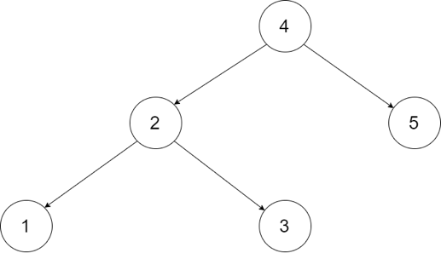

**Input:** root = [4,2,5,1,3]

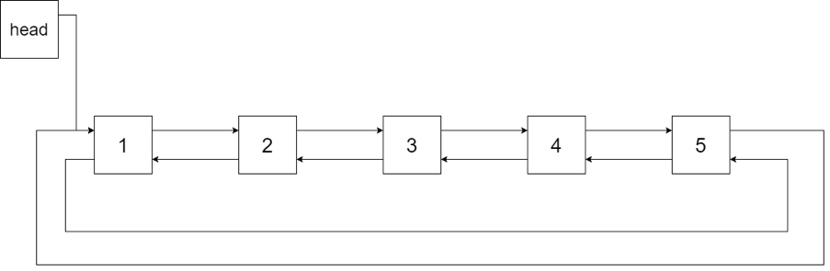

**Output:** [1,2,3,4,5]

**Explanation:** The figure below shows the transformed BST. The solid line indicates the successor relationship, while the dashed line means the predecessor relationship.

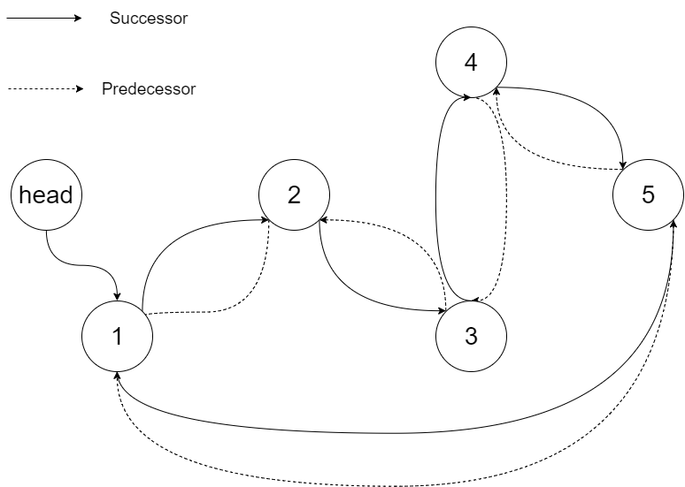

**Example 2:**

**Input:** root = [2,1,3]

**Output:** [1,2,3]

**Example 3:**

**Input:** root = []

**Output:** []

**Explanation:** Input is an empty tree. Output is also an empty Linked List.

**Example 4:**

**Input:** root = [1]

**Output:** [1]

**Constraints:**

* -1000 <= Node.val <= 1000
* Node.left.val < Node.val < Node.right.val
* All values of Node.val are unique.
* 0 <= Number of Nodes <= 2000

Recursion 2

**Is Graph Bipartite?**

**Solution**

There is an **undirected** graph with n nodes, where each node is numbered between 0 and n - 1. You are given a 2D array graph, where graph[u] is an array of nodes that node u is adjacent to. More formally, for each v in graph[u], there is an undirected edge between node u and node v. The graph has the following properties:

* There are no self-edges (graph[u] does not contain u).
* There are no parallel edges (graph[u] does not contain duplicate values).
* If v is in graph[u], then u is in graph[v] (the graph is undirected).
* The graph may not be connected, meaning there may be two nodes u and v such that there is no path between them.

A graph is **bipartite** if the nodes can be partitioned into two independent sets A and B such that **every** edge in the graph connects a node in set A and a node in set B.

Return true*if and only if it is****bipartite***.

**Example 1:**

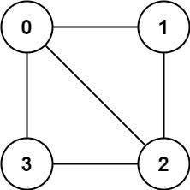

**Input:** graph = [[1,2,3],[0,2],[0,1,3],[0,2]]

**Output:** false

**Explanation:** There is no way to partition the nodes into two independent sets such that every edge connects a node in one and a node in the other.

**Example 2:**

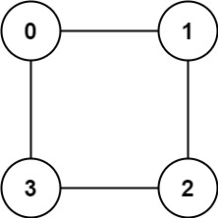

**Input:** graph = [[1,3],[0,2],[1,3],[0,2]]

**Output:** true

**Explanation:** We can partition the nodes into two sets: {0, 2} and {1, 3}.

**Constraints:**

* graph.length == n
* 1 <= n <= 100
* 0 <= graph[u].length < n
* 0 <= graph[u][i] <= n - 1
* graph[u] does not contain u.
* All the values of graph[u] are **unique**.
* If graph[u] contains v, then graph[v] contains u.

#### **Approach #1: Coloring by Depth-First Search [Accepted]**

**Intuition**

Color a node blue if it is part of the first set, else red. We should be able to greedily color the graph if and only if it is bipartite: one node being blue implies all it's neighbors are red, all those neighbors are blue, and so on.

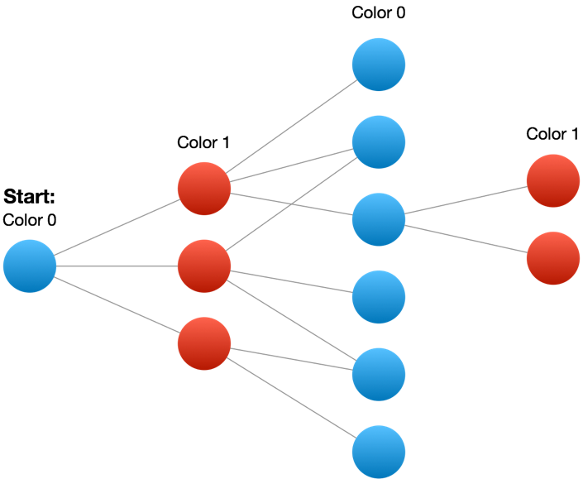

**Algorithm**

We'll keep an array (or hashmap) to lookup the color of each node: color[node]. The colors could be 0, 1, or uncolored (-1 or null).

We should be careful to consider disconnected components of the graph, by searching each node. For each uncolored node, we'll start the coloring process by doing a depth-first-search on that node. Every neighbor gets colored the opposite color from the current node. If we find a neighbor colored the same color as the current node, then our coloring was impossible.

To perform the depth-first search, we use a stack. For each uncolored neighbor in graph[node], we'll color it and add it to our stack, which acts as a sort of "todo list" of nodes to visit next. Our larger loop for start... ensures that we color every node. Here is a visual dry-run of the algorithm whose Python code is below.

|  |
| --- |
| class Solution {  public boolean isBipartite(int[][] graph) {  int n = graph.length;  int[] color = new int[n];  Arrays.fill(color, -1);  for (int start = 0; start < n; ++start) {  if (color[start] == -1) {  Stack<Integer> stack = new Stack();  stack.push(start);  color[start] = 0;  while (!stack.empty()) {  Integer node = stack.pop();  for (int nei: graph[node]) {  if (color[nei] == -1) {  stack.push(nei);  color[nei] = color[node] ^ 1;  } else if (color[nei] == color[node]) {  return false;  }  }  }  }  }  return true;  }  } |

**Complexity Analysis**

* Time Complexity: O(N + E)*O*(*N*+*E*), where N*N* is the number of nodes in the graph, and E*E* is the number of edges. We explore each node once when we transform it from uncolored to colored, traversing all its edges in the process.
* Space Complexity: O(N)*O*(*N*), the space used to store the color.

**Binary Tree Vertical Order Traversal**

Given the root of a binary tree, return ***the vertical order traversal****of its nodes' values*. (i.e., from top to bottom, column by column).

If two nodes are in the same row and column, the order should be from **left to right**.

**Example 1:**

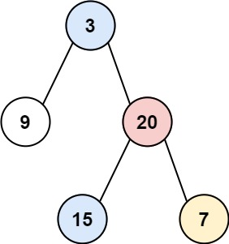

**Input:** root = [3,9,20,null,null,15,7]

**Output:** [[9],[3,15],[20],[7]]

**Example 2:**

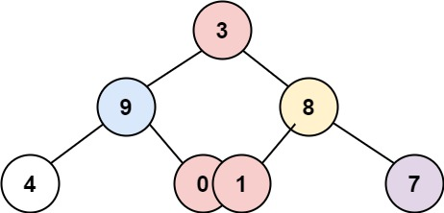

**Input:** root = [3,9,8,4,0,1,7]

**Output:** [[4],[9],[3,0,1],[8],[7]]

**Example 3:**

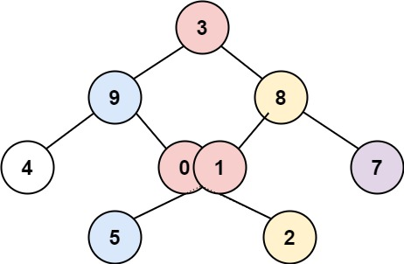

**Input:** root = [3,9,8,4,0,1,7,null,null,null,2,5]

**Output:** [[4],[9,5],[3,0,1],[8,2],[7]]

**Example 4:**

**Input:** root = []

**Output:** []

**Constraints:**

* The number of nodes in the tree is in the range [0, 100].
* -100 <= Node.val <= 100

## Solution

#### **Overview**

This is yet another problem about Binary Tree traversals. As one would probably know, the common strategies to traverse a Tree data structure are **Breadth-First Search** (a.k.a BFS) and **Depth-First Search** (a.k.a. DFS).

The DFS strategy can be further distinguished as preorder DFS, inorder DFS and postorder DFS, depending on the relative order of visit among the node itself and its child nodes.

If one is not familiar with the concepts of BFS and DFS, one can find the corresponding problems on LeetCode to practice with. Also, we have an Explore card called [Queue & Stack](https://leetcode.com/explore/learn/card/queue-stack/) where we cover both [the BFS traversal](https://leetcode.com/explore/learn/card/queue-stack/231/practical-application-queue/) as well as [the DFS traversal](https://leetcode.com/explore/learn/card/queue-stack/232/practical-application-stack/). Hence, in this article, we won't repeat ourselves on these concepts.

In the problem description, we are asked to return the **vertical** order of a binary tree, which actually implies two sub-orders, where each node would have a 2-dimensional index (denoted as <column, row>)

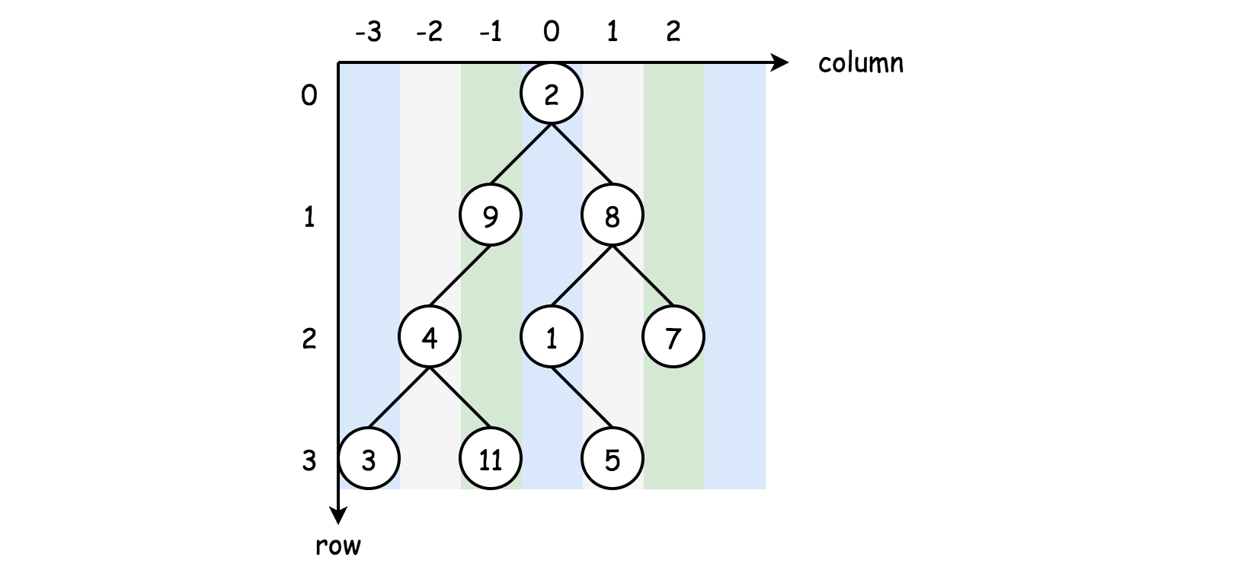

* **column-wise order**

If we look at a binary tree horizontally, each node can be aligned to a specific column, based on its relative offset to the root node of the tree.

Let us assume that the root node has a column index of 0, then its left child node would have a column index of -1 and its right child node would have a column index of +1, and so on.

* **row-wise order**  
  Now if we put the nodes into a vertical dimension, each node would be assigned to a specific row, based on its level (i.e. the vertical distance to the root node).

Let us assume that the root node has a row index of 0, then both its child nodes would have the row index of 1.

Given the above definitions, we can now formulate the problem as a task to order the nodes based on the 2-dimensional coordinates that we defined above.

More specifically, the nodes should be ordered by column first, and further the nodes on the same column should be ordered ***vertically*** based on their row indices.

#### **Approach 1: Breadth-First Search (BFS)**

**Intuition**

With the formulation of the problem in the overview section, one of the most intuitive solutions to tackle the problem would be applying the BFS traversal, where the nodes would be visited level by level.

With the BFS traversal, we naturally can guarantee the vertical order of the visits, i.e. the nodes at higher levels (large row values) would get visited later than the ones at lower levels.

However, we are still missing the horizontal order ( the column order). To ensure this order, we need to do some additional processing during the BFS traversal.

The idea is that we keep a hash table (let's denote it as columnTable<key, value>), where we keep the node values grouped by the column index.

The key in the hash table would be the column index, and the corresponding value would be a list which contains the values of all the nodes that share the same column index.

In addition, the values in the corresponding list should be ordered by their row indices, which would be guaranteed by the BFS traversal as we mentioned before.

**Algorithm**

We elaborate on the steps to implement the above idea.

* First, we create a hash table named columnTable to keep track of the results.
* As to the BFS traversal, a common code pattern would be to use a queue data structure to keep track of the order we need to visit nodes. We initialize the queue by putting the root node along with its column index value (0).
* We then run the BFS traversal with a loop consuming the elements from the queue.
* At each iteration within the BFS, we pop out an element from the queue. The element consists of a node and its corresponding column index. If the node is not empty, we then populate the columnTable with the value of the node. Subsequently, we then put its child nodes along with their respective column indices (i.e. column-1 and column+1) into the queue.
* At the end of the BFS traversal, we obtain a hash table that contains the desired node values grouped by their column indices. For each group of values, they are further ordered by their row indices.
* We then sort the hash table by its keys, i.e. column index in ascending order. And finally we return the results column by column.

|  |
| --- |
| /**  * Definition for a binary tree node.  * public class TreeNode {  * int val;  * TreeNode left;  * TreeNode right;  * TreeNode(int x) { val = x; }  * }  */  class Solution {  public List<List<Integer>> verticalOrder(TreeNode root) {  List<List<Integer>> output = new ArrayList();  if (root == null) {  return output;  }  Map<Integer, ArrayList> columnTable = new HashMap();  Queue<Pair<TreeNode, Integer>> queue = new ArrayDeque();  int column = 0;  queue.offer(new Pair(root, column));  while (!queue.isEmpty()) {  Pair<TreeNode, Integer> p = queue.poll();  root = p.getKey();  column = p.getValue();  if (root != null) {  if (!columnTable.containsKey(column)) {  columnTable.put(column, new ArrayList<Integer>());  }  columnTable.get(column).add(root.val);  queue.offer(new Pair(root.left, column - 1));  queue.offer(new Pair(root.right, column + 1));  }  }  List<Integer> sortedKeys = new ArrayList<Integer>(columnTable.keySet());  Collections.sort(sortedKeys);  for(int k : sortedKeys) {  output.add(columnTable.get(k));  }  return output;  }  } |

**Complexity Analysis**

* Time Complexity: \mathcal{O}(N \log N)O(*N*log*N*) where N*N* is the number of nodes in the tree.

In the first part of the algorithm, we do the BFS traversal, whose time complexity is \mathcal{O}(N)O(*N*) since we traversed each node once and only once.

In the second part, in order to return the ordered results, we then sort the obtained hash table by its keys, which could result in the \mathcal{O}(N \log N)O(*N*log*N*) time complexity in the worst case scenario where the binary tree is extremely imbalanced (for instance, each node has only left child node.)

As a result, the overall time complexity of the algorithm would be \mathcal{O}(N \log N)O(*N*log*N*).

* Space Complexity: \mathcal{O}(N)O(*N*) where N*N* is the number of nodes in the tree.

First of all, we use a hash table to group the nodes with the same column index. The hash table consists of keys and values. In any case, the values would consume \mathcal{O}(N)O(*N*) memory. While the space for the keys could vary, in the worst case, each node has a unique column index, i.e. there would be as many keys as the values. Hence, the total space complexity for the hash table would still be \mathcal{O}(N)O(*N*).

During the BFS traversal, we use a queue data structure to keep track of the next nodes to visit. At any given moment, the queue would hold no more two levels of nodes. For a binary tree, the maximum number of nodes at a level would be \frac{N+1}{2}2*N*+1​ which is also the number of leafs in a full binary tree. As a result, in the worst case, our queue would consume at most \mathcal{O}(\frac{N+1}{2} \cdot 2) = \mathcal{O}(N)O(2*N*+1​⋅2)=O(*N*) space.

Lastly, we also need some space to hold the results, which is basically a reordered hash table of size \mathcal{O}(N)O(*N*) as we discussed before.

To sum up, the overall space complexity of our algorithm would be \mathcal{O}(N)O(*N*).

#### **Approach 2: BFS without Sorting**

**Intuition**

In the previous approach, it is a pity that the sorting of results overshadows the main part of the algorithm which is the BFS traversal. One might wonder if we have a way to eliminate the need for sorting. And the answer is yes.

The key insight is that we only need to know the **range** of the column index (i.e. [min_column, max_column]). Then we can simply ***iterate*** through this range to generate the outputs without the need for sorting.

The above insight would work under the condition that there won't be any missing column index in the given range. And the condition always holds, since there won't be any broken branch in a binary tree.

**Algorithm**

To implement this optimization, it suffices to make some small modifications to our previous BFS approach.

During the BFS traversal, we could obtain the range of the column indices, i.e. with the variable of min_column and max_column.

At the end of the BFS traversal, we would then walk through the column range [min_column, max_column] and retrieve the results accordingly.



|  |
| --- |
| class Solution {  public List<List<Integer>> verticalOrder(TreeNode root) {  List<List<Integer>> output = new ArrayList();  if (root == null) {  return output;  }  Map<Integer, ArrayList> columnTable = new HashMap();  // Pair of node and its column offset  Queue<Pair<TreeNode, Integer>> queue = new ArrayDeque();  int column = 0;  queue.offer(new Pair(root, column));  int minColumn = 0, maxColumn = 0;  while (!queue.isEmpty()) {  Pair<TreeNode, Integer> p = queue.poll();  root = p.getKey();  column = p.getValue();  if (root != null) {  if (!columnTable.containsKey(column)) {  columnTable.put(column, new ArrayList<Integer>());  }  columnTable.get(column).add(root.val);  minColumn = Math.min(minColumn, column);  maxColumn = Math.max(maxColumn, column);  queue.offer(new Pair(root.left, column - 1));  queue.offer(new Pair(root.right, column + 1));  }  }  for(int i = minColumn; i < maxColumn + 1; ++i) {  output.add(columnTable.get(i));  }  return output;  }  } |

**Complexity Analysis**

* Time Complexity: \mathcal{O}(N)O(*N*) where N*N* is the number of nodes in the tree.  
  Following the same analysis in the previous BFS approach, the only difference is that this time we don't need the costy sorting operation (i.e. \mathcal{O}(N \log N)O(*N*log*N*)).
* Space Complexity: \mathcal{O}(N)O(*N*) where N*N* is the number of nodes in the tree. The analysis follows the same logic as in the previous BFS approach.

#### **Approach 3: Depth-First Search (DFS)**

**Intuition**

Although we applied a BFS traversal in both of the previous approaches, it is not impossible to solve the problem with a DFS traversal.

As we discussed in the overview section, once we assign a 2-dimensional index (i.e. <column, row>) for each node in the binary tree, to output the tree in ***vertical*** order is to sort the nodes based on the 2-dimensional index, firstly by column then by row, as shown in the following graph.

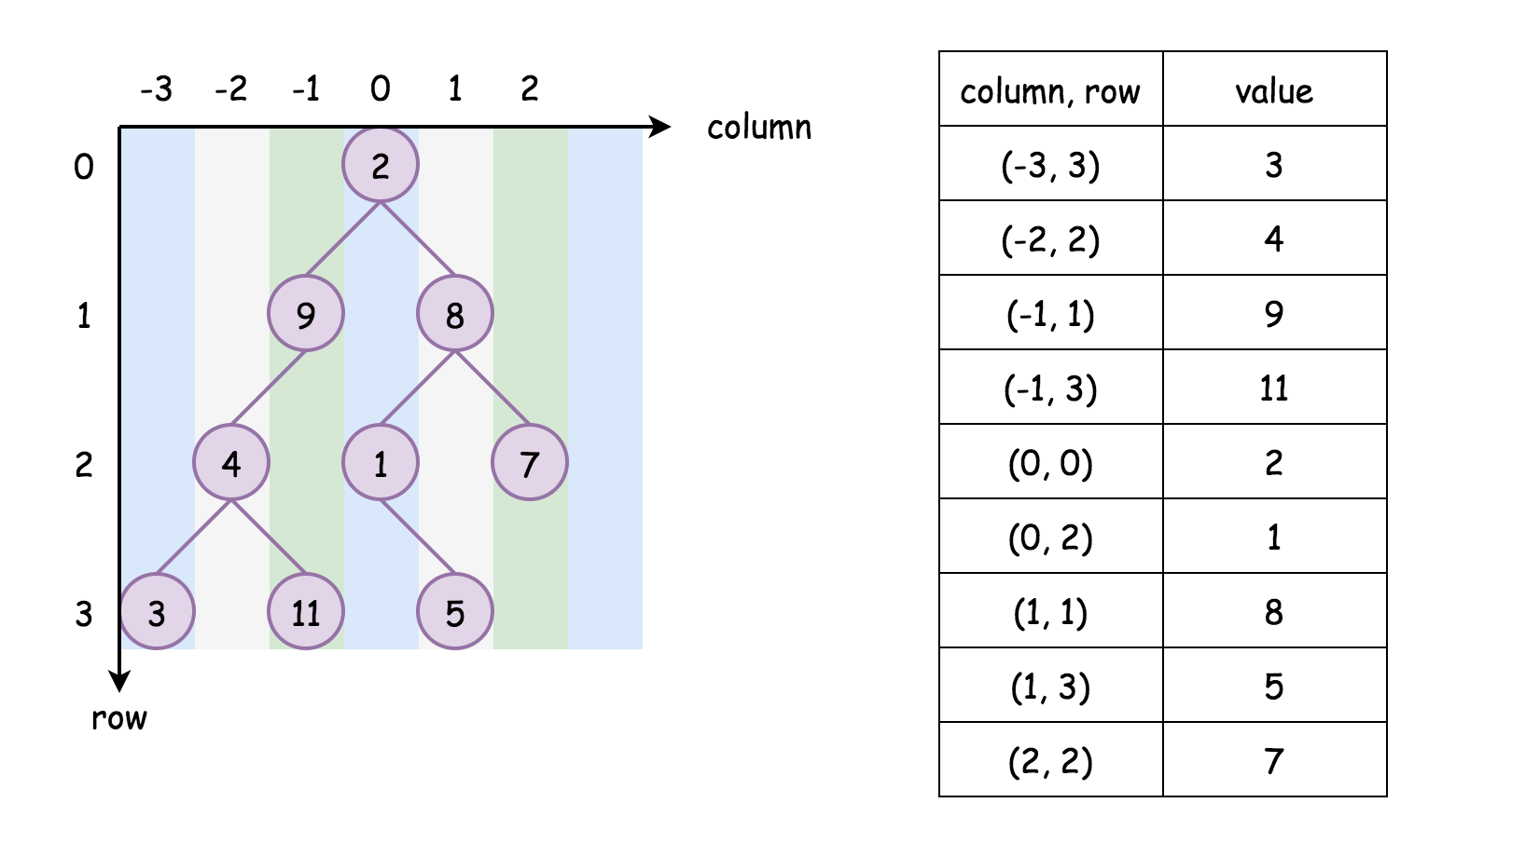

Compared to the DFS traversal, the BFS traversal gives us a head start, since the nodes in higher rows would be visited later than the ones in the lower lows. As a result, we only need to focus on the column order.

That being said, we could simply traverse the tree in any DFS order (preorder, inorder or postorder), then we sort the resulting list strictly based on two keys <column, row>, which would give us the same results as the BFS traversal.

An important note is that two nodes might share the same <column, row>, in the case, as stated in the problem, the order between these two nodes should be from **left** to **right** as we did for BFS traversals. As a result, to ensure such a priority, one should make sure to visit the left child node before the right child node during the DFS traversal.

**Algorithm**

* Here we implement the above algorithm, with the trick that we applied in Approach 2 (BFS without sorting) where we obtained the range of column during the traversal.
* First, we conduct a DFS traversal on the input tree. During the traversal, we would then build a similar columnTable with the column index as the key and the list of (row, val) tuples as the value.
* At the end of the DFS traversal, we iterate through the columnTable via the key of column index. Accordingly, we have a list of (row, val) tuples associated with each key. We then sort this list, based on the row index.
* After the above steps, we would then obtain a list of node values ordered firstly by its column index and then by its row index, which is exactly the the vertical order traversal of binary tree as defined in the problem.

|  |
| --- |
| class Solution {  Map<Integer, ArrayList<Pair<Integer, Integer>>> columnTable = new HashMap();  int minColumn = 0, maxColumn = 0;  private void DFS(TreeNode node, Integer row, Integer column) {  if (node == null)  return;  if (!columnTable.containsKey(column)) {  this.columnTable.put(column, new ArrayList<Pair<Integer, Integer>>());  }  this.columnTable.get(column).add(new Pair<Integer, Integer>(row, node.val));  this.minColumn = Math.min(minColumn, column);  this.maxColumn = Math.max(maxColumn, column);  // preorder DFS traversal  this.DFS(node.left, row + 1, column - 1);  this.DFS(node.right, row + 1, column + 1);  }  public List<List<Integer>> verticalOrder(TreeNode root) {  List<List<Integer>> output = new ArrayList();  if (root == null) {  return output;  }  this.DFS(root, 0, 0);  // Retrieve the resuts, by ordering by column and sorting by row  for (int i = minColumn; i < maxColumn + 1; ++i) {  Collections.sort(columnTable.get(i), new Comparator<Pair<Integer, Integer>>() {  @Override  public int compare(Pair<Integer, Integer> p1, Pair<Integer, Integer> p2) {  return p1.getKey() - p2.getKey();  }  });  List<Integer> sortedColumn = new ArrayList();  for (Pair<Integer, Integer> p : columnTable.get(i)) {  sortedColumn.add(p.getValue());  }  output.add(sortedColumn);  }  return output;  }  } |

**Complexity Analysis**

* Time Complexity:  O(*W*⋅*H*log*H*)) where W*W* is the width of the binary tree (*i.e.* the number of columns in the result) and H*H* is the height of the tree.  
  In the first part of the algorithm, we traverse the tree in DFS, which results in \mathcal{O}(N)O(*N*) time complexity.

Once we build the columnTable, we then have to sort it *column by column*.

Let us assume the time complexity of the sorting algorithm to be \mathcal{O}(K \log K)O(*K*log*K*) where K*K* is the length of the input. The maximal number of nodes in a column would be \frac{H}{2}2*H*​ where H*H* is the height of the tree, due to the zigzag nature of the node distribution. As a result, the upper bound of time complexity to sort a column in a binary tree would be \mathcal{O}(\frac{H}{2} \log \frac{H}{2})O(2*H*​log2*H*​).

Since we need to sort W*W* columns, the total time complexity of the sorting operation would then be \mathcal{O}\big(W \cdot (\frac{H}{2} \log{\frac{H}{2}})\big) = \mathcal{O}(W \cdot H \log{H})O(*W*⋅(2*H*​log2*H*​))=O(*W*⋅*H*log*H*). Note that, the total number of nodes N*N* in a tree is bounded by W \cdot H*W*⋅*H*, *i.e.* N < W \cdot H*N*<*W*⋅*H*. As a result, the time complexity of \mathcal{O}\big(W \cdot H \log{H}\big)O(*W*⋅*H*log*H*) will dominate the \mathcal{O}(N)O(*N*) of the DFS traversal in the first part.

At the end of the DFS traversal, we have to iterate through the columnTable in order to retrieve the values, which will take another \mathcal{O}(N)O(*N*) time.

To sum up, the overall time complexity of the algorithm would be \mathcal{O}\big(W \cdot H \log{H}\big)O(*W*⋅*H*log*H*).

An interesting thing to note is that in the case where the binary tree is completely imbalanced (*e.g.* node has only left child.), this DFS approach would have the \mathcal{O}(N)O(*N*) time complexity, since the sorting takes no time on columns that contains only a single node. While the time complexity for our first BFS approach would be \mathcal{O}{(N \log N)}O(*N*log*N*), since we have to sort the N*N* keys in the columnTable.

* Space Complexity: \mathcal{O}(N)O(*N*) where N*N* is the number of nodes in the tree.

We kept the columnTable which contains all the node values in the binary tree. Together with the keys, it would consume \mathcal{O}(N)O(*N*) space as we discussed in previous approaches.

Since we apply the recursion for our DFS traversal, it would incur additional space consumption on the function call stack. In the worst case where the tree is completely imbalanced, we would have the size of call stack up to \mathcal{O}(N)O(*N*).

Finally, we have the output which contains all the values in the binary tree, thus \mathcal{O}(N)O(*N*) space.

So in total, the overall space complexity of this algorithm remains  O(*N*).

## Recursion

Definitely know how to [generate permutations](https://leetcode.com/problems/permutations) and [combinations (subsets)](https://leetcode.com/problems/subsets), which are great backtracking exercises.

[Remove Invalid Parenthesis](https://leetcode.com/problems/remove-invalid-parentheses) is a popular one being asked at Facebook, and is also one of our favorite interview questions.

**Letter Combinations of a Phone Number**

Given a string containing digits from 2-9 inclusive, return all possible letter combinations that the number could represent. Return the answer in **any order**.

A mapping of digit to letters (just like on the telephone buttons) is given below. Note that 1 does not map to any letters.

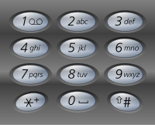

**Example 1:**

**Input:** digits = "23"

**Output:** ["ad","ae","af","bd","be","bf","cd","ce","cf"]

**Example 2:**

**Input:** digits = ""

**Output:** []

**Example 3:**

**Input:** digits = "2"

**Output:** ["a","b","c"]

**Constraints:**

* 0 <= digits.length <= 4
* digits[i] is a digit in the range ['2', '9'].

Google

**Permutations**

Given an array nums of distinct integers, return *all the possible permutations*. You can return the answer in **any order**.

**Example 1:**

**Input:** nums = [1,2,3]

**Output:** [[1,2,3],[1,3,2],[2,1,3],[2,3,1],[3,1,2],[3,2,1]]

**Example 2:**

**Input:** nums = [0,1]

**Output:** [[0,1],[1,0]]

**Example 3:**

**Input:** nums = [1]

**Output:** [[1]]

**Constraints:**

* 1 <= nums.length <= 6
* -10 <= nums[i] <= 10
* All the integers of nums are **unique**.

Recursion 2

**Permutations II**

Given a collection of numbers, nums, that might contain duplicates, return *all possible unique permutations****in any order****.*

**Example 1:**

**Input:** nums = [1,1,2]

**Output:**

[[1,1,2],

[1,2,1],

[2,1,1]]

**Example 2:**

**Input:** nums = [1,2,3]

**Output:** [[1,2,3],[1,3,2],[2,1,3],[2,3,1],[3,1,2],[3,2,1]]

**Constraints:**

* 1 <= nums.length <= 8
* -10 <= nums[i] <= 10

Solution

Overview

As the name of the problem suggests, this problem is an extension of the [Permutation](https://leetcode.com/problems/permutations/) problem. The problem is different from the previous permutation problem on the condition that the input array can contain ***duplicates***.

The key to solve the problem is still the ***backtracking*** algorithm. However, we need some adaptation to ensure that the *enumerated* solutions generated from our backtracking exploration do not have any duplicates.

As a reminder, [**backtracking**](https://leetcode.com/explore/learn/card/recursion-ii/472/backtracking/) is a general algorithm for finding all (or some) solutions to some problems with constraints. It incrementally builds candidates to the solutions, and abandons a candidate as soon as it determines that the candidate cannot possibly lead to a solution.

In this article, we will present a yet another backtracking solution to solve the problem.

Approach 1: Backtracking with Groups of Numbers

**Intuition**

First of all, let us review the general idea of permutation with an example.

Given the input array [1, 1, 2], to generate a permutation of the array, we could follow the *Depth-First Search* (DFS) approach, or more precisely the backtracking technique as one will see later.

The idea is that we pick the numbers one by one. For a permutation of length N*N*, we would then need N*N* stages to generate a valid permutation. At each stage, we need to pick one number into the permutation, out of the remaining available numbers. Later at the same stage, we will try out all available choices. By trying out, we progressively build up candidates to the solution, and revert each choice with another alternative until there is no more choice.

Let us walk through the example with paper and pencil, as follows:

* Given the input of [1, 1, 2], at the first stage, we have 2 choices to pick a number as the first number in the final permutation, *i.e.* 1 and 2. Suppose that we pick the number 1, now the remaining numbers would become [1, 2]. **Note:** The reason that we have only 2 choices instead of 3, is that there is a duplicate in the given input. Picking any of the duplicate numbers as the first number of the permutation would lead us to the same permutation at the end. Should the numbers in the array be all unique, we would then have the same number of choices as the length of the array.
* At the second stage, we now then have again 2 choices, *i.e.* [1, 2]. Let us pick again the number 1, which leaves us the only remaining number 2.
* Now at the third stage, we have only one candidate number left, *i.e.* [2]. We then pick the last remaining number, which leads to a final permutation sequence of [1, 1, 2].
* Moreover, we need to ***revisit*** each of the above stages, and make a different choice in order to try out all possibilities. The reversion of the choices is what we call ***backtracking***.

We illustrate all potential exploration in the following graph where each node represents a choice at a specific stage:

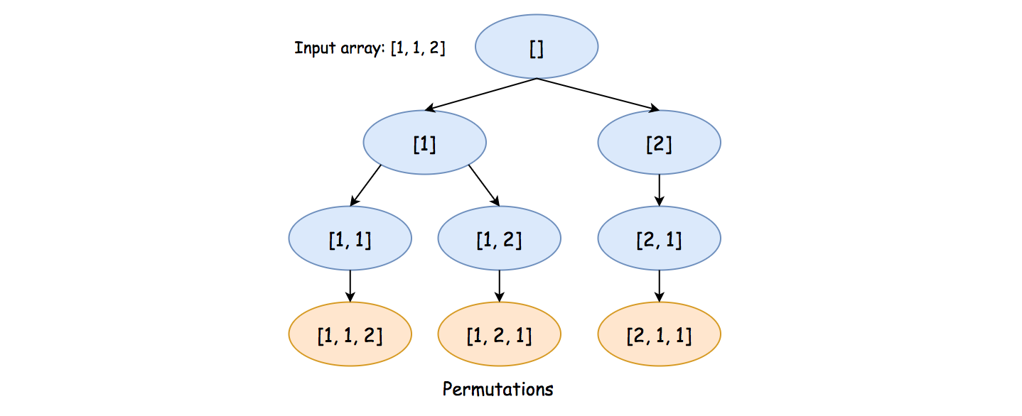

A key insight to avoid generating any ***redundant*** permutation is that at each step rather than viewing each number as a candidate, we consider each ***unique*** number as the true candidate. For instance, at the very beginning, given in the input of [1, 1, 2], we have only two true candidates instead of three.

**Algorithm**

Given the above insight, in order to find out all the unique numbers at each stage, we can build a ***hash table*** (denoted as counter), with each unique number as the key and its occurrence as the corresponding value.

To implement the algorithm, first we define a function called backtrack(comb, counter) which generates all permutations, starting from the current combination (comb) and the remaining numbers (counter).

Once the function is implemented, it suffices to invoke the function with the initial empty combination and the hash table we built out of the input array, to solve the problem.

Here are some sample implementations.

|  |
| --- |
| class Solution {  public List<List<Integer>> permuteUnique(int[] nums) {  List<List<Integer>> results = new ArrayList<>();  // count the occurrence of each number  HashMap<Integer, Integer> counter = new HashMap<>();  for (int num : nums) {  if (!counter.containsKey(num))  counter.put(num, 0);  counter.put(num, counter.get(num) + 1);  }  LinkedList<Integer> comb = new LinkedList<>();  this.backtrack(comb, nums.length, counter, results);  return results;  }  protected void backtrack(  LinkedList<Integer> comb,  Integer N,  HashMap<Integer, Integer> counter,  List<List<Integer>> results) {  if (comb.size() == N) {  // make a deep copy of the resulting permutation,  // since the permutation would be backtracked later.  results.add(new ArrayList<Integer>(comb));  return;  }  for (Map.Entry<Integer, Integer> entry : counter.entrySet()) {  Integer num = entry.getKey();  Integer count = entry.getValue();  if (count == 0)  continue;  // add this number into the current combination  comb.addLast(num);  counter.put(num, count - 1);  // continue the exploration  backtrack(comb, N, counter, results);  // revert the choice for the next exploration  comb.removeLast();  counter.put(num, count);  }  }  } |

**Note:** for a backtracking algorithm, usually there are some explorations that would lead to a *dead end*, and we have to abandon those explorations in the middle.

However, due to the specificity of this problem and our exploration strategy, each exploration will result in a valid permutation, *i.e.* none of the efforts is in vain. This insight would prove to be useful in the following complexity analysis.

**Complexity Analysis**

Let N*N* be the length of the input array. Hence, the number of permutations would be at maximum N!*N*!, *i.e.* N \cdot (N-1) \cdot (N-2) ... 1*N*⋅(*N*−1)⋅(*N*−2)...1, when each number in the array is unique.

* Time Complexity: \mathcal{O}\big(\sum_{k = 1}^{N}{P(N, k)}\big)O(∑*k*=1*N*​*P*(*N*,*k*)) where P(N, k) = \frac{N!}{(N - k)!} = N (N - 1) ... (N - k + 1)*P*(*N*,*k*)=(*N*−*k*)!*N*!​=*N*(*N*−1)...(*N*−*k*+1) is so-called [*k-permutations_of_N* or *partial permutation*](https://en.wikipedia.org/wiki/Permutation#k-permutations_of_n).
  + As one can see in the exploration graph we have shown earlier, the execution of the backtracking algorithm will unfold itself as a tree, where each node is an invocation of the recursive function backtrack(comb, counter). The total number of steps to complete the exploration is *exactly* the number of nodes in the tree. Therefore, the time complexity of the algorithm is linked directly with the size of the tree.
  + It now boils down to estimating the number of nodes in the tree. As we know now, each level of the tree corresponds to a specific *stage* of the exploration. At each stage, the number of candidates to explore is **bounded**. For instance, at the first stage, *at most* we would have N*N* candidates to explore, *i.e.* the number of nodes at this level would be N*N*. Moving on to the next stage, for each of the nodes in the first stage, we would have N-1*N*−1 child nodes. Therefore, the number of nodes at this stage would be N \cdot (N-1)*N*⋅(*N*−1). So on and so forwards.

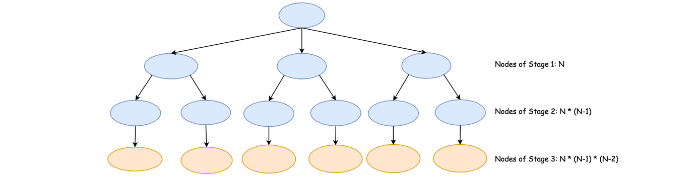

* + By summing up all the nodes across the stages, we would then obtain the total number of nodes as \sum_{k = 1}^{N}{P(N, k)}∑*k*=1*N*​*P*(*N*,*k*) where P(N, k) = \frac{N!}{(N - k)!} = N (N - 1) ... (N - k + 1)*P*(*N*,*k*)=(*N*−*k*)!*N*!​=*N*(*N*−1)...(*N*−*k*+1). As a result, the exact time complexity of the algorithm is \mathcal{O}\big(\sum_{k = 1}^{N}{P(N, k)}\big)O(∑*k*=1*N*​*P*(*N*,*k*)).
  + The above complexity might appear a bit too abstract to comprehend. Here we could provide another ***loose upper bound*** on the complexity.
  + It takes N*N* steps to generate a single permutation. Since there are in total N!*N*! possible permutations, at most it would take us N \cdot N!*N*⋅*N*! steps to generate all permutations, simply assuming that there is no overlapping effort (which is not true).
* Space Complexity: \mathcal{O}(N)O(*N*)
  + First of all, we build a hash table out of the input numbers. In the worst case where each number is unique, we would need \mathcal{O}(N)O(*N*) space for the table.
  + Since we applied recursion in the algorithm which consumes some extra space in the function call stack, we would need another \mathcal{O}(N)O(*N*) space for the recursion.
  + During the exploration, we keep a candidate of permutation along the way, which takes yet another \mathcal{O}(N)O(*N*).
  + To sum up, the total space complexity would be \mathcal{O}(N) + \mathcal{O}(N) + \mathcal{O}(N) = \mathcal{O}(N)O(*N*)+O(*N*)+O(*N*)=O(*N*).
  + **Note**, we did not take into account the space needed to hold the results. Otherwise, the space complexity would become \mathcal{O}(N \cdot N!)O(*N*⋅*N*!).

**Remove Invalid Parentheses**

Remove the minimum number of invalid parentheses in order to make the input string valid. Return all possible results.

**Note:** The input string may contain letters other than the parentheses ( and ).

**Example 1:**

**Input:** "()())()"

**Output:** ["()()()", "(())()"]

**Example 2:**

**Input:** "(a)())()"

**Output:** ["(a)()()", "(a())()"]

**Example 3:**

**Input:** ")("

**Output:** [""]

Hard

**Regular Expression Matching**

Given an input string (s) and a pattern (p), implement regular expression matching with support for '.' and '*' where:

* '.' Matches any single character.​​​​
* '*' Matches zero or more of the preceding element.

The matching should cover the **entire** input string (not partial).

**Example 1:**

**Input:** s = "aa", p = "a"

**Output:** false

**Explanation:** "a" does not match the entire string "aa".

**Example 2:**

**Input:** s = "aa", p = "a*"

**Output:** true

**Explanation:** '*' means zero or more of the preceding element, 'a'. Therefore, by repeating 'a' once, it becomes "aa".

**Example 3:**

**Input:** s = "ab", p = ".*"

**Output:** true

**Explanation:** ".*" means "zero or more (*) of any character (.)".

**Example 4:**

**Input:** s = "aab", p = "c*a*b"

**Output:** true

**Explanation:** c can be repeated 0 times, a can be repeated 1 time. Therefore, it matches "aab".

**Example 5:**

**Input:** s = "mississippi", p = "mis*is*p*."

**Output:** false

**Constraints:**

* 0 <= s.length <= 20
* 0 <= p.length <= 30
* s contains only lowercase English letters.
* p contains only lowercase English letters, '.', and '*'.
* It is guaranteed for each appearance of the character '*', there will be a previous valid character to match.

Hard

**Subsets**

Given an integer array nums of **unique** elements, return *all possible subsets (the power set)*.

The solution set **must not** contain duplicate subsets. Return the solution in **any order**.

**Example 1:**

**Input:** nums = [1,2,3]

**Output:** [[],[1],[2],[1,2],[3],[1,3],[2,3],[1,2,3]]

**Example 2:**

**Input:** nums = [0]

**Output:** [[],[0]]

**Constraints:**

* 1 <= nums.length <= 10
* -10 <= nums[i] <= 10
* All the numbers of nums are **unique**.

Medium

**Strobogrammatic Number II**

A strobogrammatic number is a number that looks the same when rotated 180 degrees (looked at upside down).

Find all strobogrammatic numbers that are of length = n.

**Example:**

**Input:** n = 2

**Output:** ["11","69","88","96"]

   Hide Hint #1

Try to use recursion and notice that it should recurse with *n* - 2 instead of *n* - 1.

## Sorting and Searching

Interval related problems are quite often asked at Facebook interviews, such as [Meeting Rooms II](https://leetcode.com/problems/meeting-rooms-ii) and [Merge Intervals](https://leetcode.com/problems/merge-intervals). These interval problems typically require you to sort it in order and apply some kind of linear search or binary search technique.

**Divide Two Integers**

Given two integers dividend and divisor, divide two integers without using multiplication, division, and mod operator.   
Return the quotient after dividing dividend by divisor.

The integer division should truncate toward zero, which means losing its fractional part. For example, truncate(8.345) = 8 and truncate(-2.7335) = -2.

* Assume we are dealing with an environment that could only store integers within the 32-bit signed integer range: [−231,  231 − 1]. For this problem, assume that your function **returns 231 − 1 when the division result overflows**.

**Example 1:**

**Input:** dividend = 10, divisor = 3  
**Output:** 3

**Explanation:** 10/3 = truncate(3.33333..) = 3.

**Example 2:**

**Input:** dividend = 7, divisor = -3  
**Output:** -2

**Explanation:** 7/-3 = truncate(-2.33333..) = -2.

**Example 3:**

**Input:** dividend = 0, divisor = 1  
**Output:** 0

**Example 4:**

**Input:** dividend = 1, divisor = 1  
**Output:** 1

**Constraints:**

-231 <= dividend, divisor <= 231 – 1 divisor != 0

Medium

**Search in Rotated Sorted Array**

There is an integer array nums sorted in ascending order (with **distinct** values).

Prior to being passed to your function, nums is **rotated** at an unknown pivot index k (0 <= k < nums.length) such that the resulting array is [nums[k], nums[k+1], ..., nums[n-1], nums[0], nums[1], ..., nums[k-1]] (**0-indexed**). For example, [0,1,2,4,5,6,7] might be rotated at pivot index 3 and become [4,5,6,7,0,1,2].

Given the array nums **after** the rotation and an integer target, return *the index of*target*if it is in*nums*, or*-1*if it is not in*nums.

**Example 1:**

**Input:** nums = [4,5,6,7,0,1,2], target = 0

**Output:** 4

**Example 2:**

**Input:** nums = [4,5,6,7,0,1,2], target = 3

**Output:** -1

**Example 3:**

**Input:** nums = [1], target = 0

**Output:** -1

**Constraints:**

* 1 <= nums.length <= 5000
* -104 <= nums[i] <= 104
* All values of nums are **unique**.
* nums is guaranteed to be rotated at some pivot.
* -104 <= target <= 104

**Follow up:** Can you achieve this in O(log n) time complexity?

Medium

**Find First and Last Position of Element in Sorted Array**

Given an array of integers nums sorted in ascending order, find the starting and ending position of a given target value.

If target is not found in the array, return [-1, -1].

**Follow up:** Could you write an algorithm with O(log n) runtime complexity?

**Example 1:**

**Input:** nums = [5,7,7,8,8,10], target = 8

**Output:** [3,4]

**Example 2:**

**Input:** nums = [5,7,7,8,8,10], target = 6

**Output:** [-1,-1]

**Example 3:**

**Input:** nums = [], target = 0

**Output:** [-1,-1]

**Constraints:**

* 0 <= nums.length <= 105
* -109 <= nums[i] <= 109
* nums is a non-decreasing array.
* -109 <= target <= 109

Google

**Pow(x, n)**

Implement [pow(*x*, *n*)](http://www.cplusplus.com/reference/valarray/pow/), which calculates *x* raised to the power *n* (i.e. xn).

**Example 1:**

**Input:** x = 2.00000, n = 10

**Output:** 1024.00000

**Example 2:**

**Input:** x = 2.10000, n = 3

**Output:** 9.26100

**Example 3:**

**Input:** x = 2.00000, n = -2

**Output:** 0.25000

**Explanation:** 2-2 = 1/22 = 1/4 = 0.25

**Constraints:**

* -100.0 < x < 100.0
* -231 <= n <= 231-1
* -104 <= xn <= 104

Medium

**Merge Intervals**

Given an array of intervals where intervals[i] = [starti, endi], merge all overlapping intervals, and return *an array of the non-overlapping intervals that cover all the intervals in the input*.

**Example 1:**

**Input:** intervals = [[1,3],[2,6],[8,10],[15,18]]

**Output:** [[1,6],[8,10],[15,18]]

**Explanation:** Since intervals [1,3] and [2,6] overlaps, merge them into [1,6].

**Example 2:**

**Input:** intervals = [[1,4],[4,5]]

**Output:** [[1,5]]

**Explanation:** Intervals [1,4] and [4,5] are considered overlapping.

**Constraints:**

* 1 <= intervals.length <= 104
* intervals[i].length == 2
* 0 <= starti <= endi <= 104

Medium

**Find Peak Element**

A peak element is an element that is strictly greater than its neighbors.

Given an integer array nums, find a peak element, and return its index. If the array contains multiple peaks, return the index to **any of the peaks**.

You may imagine that nums[-1] = nums[n] = -∞.

**Example 1:**

**Input:** nums = [1,2,3,1]

**Output:** 2

**Explanation:** 3 is a peak element and your function should return the index number 2.

**Example 2:**

**Input:** nums = [1,2,1,3,5,6,4]

**Output:** 5

**Explanation:** Your function can return either index number 1 where the peak element is 2, or index number 5 where the peak element is 6.

**Constraints:**

* 1 <= nums.length <= 1000
* -231 <= nums[i] <= 231 - 1
* nums[i] != nums[i + 1] for all valid i.

**Follow up:** Could you implement a solution with logarithmic complexity?

Medium

**First Bad Version**

You are a product manager and currently leading a team to develop a new product. Unfortunately, the latest version of your product fails the quality check. Since each version is developed based on the previous version, all the versions after a bad version are also bad.

Suppose you have n versions [1, 2, ..., n] and you want to find out the first bad one, which causes all the following ones to be bad.

You are given an API bool isBadVersion(version) which returns whether version is bad. Implement a function to find the first bad version. You should minimize the number of calls to the API.

**Example 1:**

**Input:** n = 5, bad = 4

**Output:** 4

**Explanation:**

call isBadVersion(3) -> false

call isBadVersion(5) -> true

call isBadVersion(4) -> true

Then 4 is the first bad version.

**Example 2:**

**Input:** n = 1, bad = 1

**Output:** 1

**Constraints:**

* 1 <= bad <= n <= 231 - 1

EZ

**Intersection of Two Arrays**

Given two arrays, write a function to compute their intersection.

**Example 1:**

**Input:** nums1 = [1,2,2,1], nums2 = [2,2]

**Output:** [2]

**Example 2:**

**Input:** nums1 = [4,9,5], nums2 = [9,4,9,8,4]

**Output:** [9,4]

**Note:**

* Each element in the result must be unique.
* The result can be in any order.

HashTable

**Intersection of Two Arrays II**

Given two arrays, write a function to compute their intersection.

**Example 1:**

**Input:** nums1 = [1,2,2,1], nums2 = [2,2]

**Output:** [2,2]

**Example 2:**

**Input:** nums1 = [4,9,5], nums2 = [9,4,9,8,4]

**Output:** [4,9]

**Note:**

* Each element in the result should appear as many times as it shows in both arrays.
* The result can be in any order.

**Follow up:**

* What if the given array is already sorted? How would you optimize your algorithm?
* What if *nums1*'s size is small compared to *nums2*'s size? Which algorithm is better?
* What if elements of *nums2* are stored on disk, and the memory is limited such that you cannot load all elements into the memory at once?

HashTable

## Dynamic Programming

[Decode Ways](https://leetcode.com/problems/decode-ways) is a popular one being asked by Facebook. It is actually a simplified version of [Squished Status](https://www.facebook.com/hackercup/problem/348968131789235/), which appeared in Facebook's coding competition. We also have its variation [Decode Ways II](https://leetcode.com/problems/decode-ways-ii) for you to practice.

**Longest Palindromic Substring**

Given a string s, return *the longest palindromic substring* in s.

**Example 1:**

**Input:** s = "babad"

**Output:** "bab"

**Note:** "aba" is also a valid answer.

**Example 2:**

**Input:** s = "cbbd"

**Output:** "bb"

**Example 3:**

**Input:** s = "a"

**Output:** "a"

**Example 4:**

**Input:** s = "ac"

**Output:** "a"

**Constraints:**

* 1 <= s.length <= 1000
* s consist of only digits and English letters (lower-case and/or upper-case),

Medium

**Longest Valid Parentheses**

Given a string containing just the characters '(' and ')', find the length of the longest valid (well-formed) parentheses substring.

**Example 1:**

**Input:** s = "(()"

**Output:** 2

**Explanation:** The longest valid parentheses substring is "()".

**Example 2:**

**Input:** s = ")()())"

**Output:** 4

**Explanation:** The longest valid parentheses substring is "()()".

**Example 3:**

**Input:** s = ""

**Output:** 0

**Constraints:**

* 0 <= s.length <= 3 * 104
* s[i] is '(', or ')'.

## Summary

We need to determine the length of the largest valid substring of parentheses from a given string.

## Solution

#### **Approach 1: Brute Force**

**Algorithm**

In this approach, we consider every possible non-empty even length substring from the given string and check whether it's a valid string of parentheses or not. In order to check the validity, we use the Stack's Method.

Every time we encounter a \text{‘(’}‘(’, we push it onto the stack. For every \text{‘)’}‘)’ encountered, we pop a \text{‘(’}‘(’ from the stack. If \text{‘(’}‘(’ isn't available on the stack for popping at anytime or if stack contains some elements after processing complete substring, the substring of parentheses is invalid. In this way, we repeat the process for every possible substring and we keep on storing the length of the longest valid string found so far.

Example:

"((())"

(( --> invalid

(( --> invalid

() --> valid, length=2

)) --> invalid

((()--> invalid

(())--> valid, length=4

maxlength=4

|  |
| --- |
| public class Solution {  public boolean isValid(String s) {  Stack<Character> stack = new Stack<Character>();  for (int i = 0; i < s.length(); i++) {  if (s.charAt(i) == '(') {  stack.push('(');  } else if (!stack.empty() && stack.peek() == '(') {  stack.pop();  } else {  return false;  }  }  return stack.empty();  }  public int longestValidParentheses(String s) {  int maxlen = 0;  for (int i = 0; i < s.length(); i++) {  for (int j = i + 2; j <= s.length(); j+=2) {  if (isValid(s.substring(i, j))) {  maxlen = Math.max(maxlen, j - i);  }  }  }  return maxlen;  }  } |

**Complexity Analysis**

* Time complexity : O(n^3)*O*(*n*3). Generating every possible substring from a string of length n*n* requires O(n^2)*O*(*n*2). Checking validity of a string of length n*n* requires O(n)*O*(*n*).
* Space complexity : O(n)*O*(*n*). A stack of depth n*n* will be required for the longest substring.

#### **Approach 2: Using Dynamic Programming**

**Algorithm**

This problem can be solved by using Dynamic Programming. We make use of a \text{dp}dp array where i*i*th element of \text{dp}dp represents the length of the longest valid substring ending at i*i*th index. We initialize the complete \text{dp}dp array with 0's. Now, it's obvious that the valid substrings must end with \text{‘)’}‘)’. This further leads to the conclusion that the substrings ending with \text{‘(’}‘(’ will always contain '0' at their corresponding \text{dp}dp indices. Thus, we update the \text{dp}dp array only when \text{‘)’}‘)’ is encountered.

To fill \text{dp}dp array we will check every two consecutive characters of the string and if

1. \text{s}[i] = \text{‘)’}s[*i*]=‘)’ and \text{s}[i - 1] = \text{‘(’}s[*i*−1]=‘(’, i.e. string looks like ``.......()" \Rightarrow‘‘.......()"⇒

\text{dp}[i]=\text{dp}[i-2]+2dp[*i*]=dp[*i*−2]+2

We do so because the ending "()" portion is a valid substring anyhow and leads to an increment of 2 in the length of the just previous valid substring's length.

1. \text{s}[i] = \text{‘)’}s[*i*]=‘)’ and \text{s}[i - 1] = \text{‘)’}s[*i*−1]=‘)’, i.e. string looks like ``.......))" \Rightarrow‘‘.......))"⇒

if \text{s}[i - \text{dp}[i - 1] - 1] = \text{‘(’}s[*i*−dp[*i*−1]−1]=‘(’ then

\text{dp}[i]=\text{dp}[i-1]+\text{dp}[i-\text{dp}[i-1]-2]+2dp[*i*]=dp[*i*−1]+dp[*i*−dp[*i*−1]−2]+2

The reason behind this is that if the 2nd last \text{‘)’}‘)’ was a part of a valid substring (say sub_s*subs*​), for the last \text{‘)’}‘)’ to be a part of a larger substring, there must be a corresponding starting \text{‘(’}‘(’ which lies before the valid substring of which the 2nd last \text{‘)’}‘)’ is a part (i.e. before sub_s*subs*​). Thus, if the character before sub_s*subs*​ happens to be \text{‘(’}‘(’, we update the \text{dp}[i]dp[*i*] as an addition of 22 in the length of sub_s*subs*​ which is \text{dp}[i-1]dp[*i*−1]. To this, we also add the length of the valid substring just before the term "(,sub_s,)" , i.e. \text{dp}[i-\text{dp}[i-1]-2]dp[*i*−dp[*i*−1]−2].

For better understanding of this method, see this example:



|  |
| --- |
| public class Solution {  public int longestValidParentheses(String s) {  int maxans = 0;  int dp[] = new int[s.length()];  for (int i = 1; i < s.length(); i++) {  if (s.charAt(i) == ')') {  if (s.charAt(i - 1) == '(') {  dp[i] = (i >= 2 ? dp[i - 2] : 0) + 2;  } else if (i - dp[i - 1] > 0 && s.charAt(i - dp[i - 1] - 1) == '(') {  dp[i] = dp[i - 1] + ((i - dp[i - 1]) >= 2 ? dp[i - dp[i - 1] - 2] : 0) + 2;  }  maxans = Math.max(maxans, dp[i]);  }  }  return maxans;  }  } |

**Complexity Analysis**

* Time complexity : O(n)*O*(*n*). Single traversal of string to fill dp array is done.
* Space complexity : O(n)*O*(*n*). dp array of size n*n* is used.

#### **Approach 3: Using Stack**

**Algorithm**

Instead of finding every possible string and checking its validity, we can make use of stack while scanning the given string to check if the string scanned so far is valid, and also the length of the longest valid string. In order to do so, we start by pushing -1−1 onto the stack.

For every \text{‘(’}‘(’ encountered, we push its index onto the stack.

For every \text{‘)’}‘)’ encountered, we pop the topmost element and subtract the current element's index from the top element of the stack, which gives the length of the currently encountered valid string of parentheses. If while popping the element, the stack becomes empty, we push the current element's index onto the stack. In this way, we keep on calculating the lengths of the valid substrings, and return the length of the longest valid string at the end.

See this example for better understanding.



|  |
| --- |
| public class Solution {  public int longestValidParentheses(String s) {  int maxans = 0;  Stack<Integer> stack = new Stack<>();  stack.push(-1);  for (int i = 0; i < s.length(); i++) {  if (s.charAt(i) == '(') {  stack.push(i);  } else {  stack.pop();  if (stack.empty()) {  stack.push(i);  } else {  maxans = Math.max(maxans, i - stack.peek());  }  }  }  return maxans;  }  } |

**Complexity Analysis**

* Time complexity : O(n)*O*(*n*). n*n* is the length of the given string..
* Space complexity : O(n)*O*(*n*). The size of stack can go up to n*n*.

#### **Approach 4: Without extra space**

**Algorithm**

In this approach, we make use of two counters left*left* and right*right*. First, we start traversing the string from the left towards the right and for every \text{‘(’}‘(’ encountered, we increment the left*left* counter and for every \text{‘)’}‘)’ encountered, we increment the right*right* counter. Whenever left*left* becomes equal to right*right*, we calculate the length of the current valid string and keep track of maximum length substring found so far. If right*right* becomes greater than left*left* we reset left*left* and right*right* to 00.

Next, we start traversing the string from right to left and similar procedure is applied.

Example of this approach:



|  |
| --- |
| public class Solution {  public int longestValidParentheses(String s) {  int left = 0, right = 0, maxlength = 0;  for (int i = 0; i < s.length(); i++) {  if (s.charAt(i) == '(') {  left++;  } else {  right++;  }  if (left == right) {  maxlength = Math.max(maxlength, 2 * right);  } else if (right >= left) {  left = right = 0;  }  }  left = right = 0;  for (int i = s.length() - 1; i >= 0; i--) {  if (s.charAt(i) == '(') {  left++;  } else {  right++;  }  if (left == right) {  maxlength = Math.max(maxlength, 2 * left);  } else if (left >= right) {  left = right = 0;  }  }  return maxlength;  }  } |

**Complexity Analysis**

* Time complexity : O(n)*O*(*n*). Two traversals of the string.
* Space complexity : O(1)*O*(1). Only two extra variables left*left* and right*right* are needed.

**Decode Ways**

A message containing letters from A-Z can be **encoded** into numbers using the following mapping:

'A' -> "1"

'B' -> "2"

...

'Z' -> "26"

To **decode** an encoded message, all the digits must be grouped then mapped back into letters using the reverse of the mapping above (there may be multiple ways). For example, "11106" can be mapped into:

* "AAJF" with the grouping (1 1 10 6)
* "KJF" with the grouping (11 10 6)

Note that the grouping (1 11 06) is invalid because "06" cannot be mapped into 'F' since "6" is different from "06".

Given a string s containing only digits, return *the****number****of ways to****decode****it*.

The answer is guaranteed to fit in a **32-bit** integer.

**Example 1:**

**Input:** s = "12"

**Output:** 2

**Explanation:** "12" could be decoded as "AB" (1 2) or "L" (12).

**Example 2:**

**Input:** s = "226"

**Output:** 3

**Explanation:** "226" could be decoded as "BZ" (2 26), "VF" (22 6), or "BBF" (2 2 6).

**Example 3:**

**Input:** s = "0"

**Output:** 0

**Explanation:** There is no character that is mapped to a number starting with 0.

The only valid mappings with 0 are 'J' -> "10" and 'T' -> "20", neither of which start with 0.

Hence, there are no valid ways to decode this since all digits need to be mapped.

**Example 4:**

**Input:** s = "06"

**Output:** 0

**Explanation:** "06" cannot be mapped to "F" because of the leading zero ("6" is different from "06").

**Constraints:**

* 1 <= s.length <= 100
* s contains only digits and may contain leading zero(s).

Hard

**Best Time to Buy and Sell Stock**

You are given an array prices where prices[i] is the price of a given stock on the ith day.

You want to maximize your profit by choosing a **single day** to buy one stock and choosing a **different day in the future** to sell that stock.

Return *the maximum profit you can achieve from this transaction*. If you cannot achieve any profit, return 0.

**Example 1:**

**Input:** prices = [7,1,5,3,6,4]

**Output:** 5

**Explanation:** Buy on day 2 (price = 1) and sell on day 5 (price = 6), profit = 6-1 = 5.

Note that buying on day 2 and selling on day 1 is not allowed because you must buy before you sell.

**Example 2:**

**Input:** prices = [7,6,4,3,1]

**Output:** 0

**Explanation:** In this case, no transactions are done and the max profit = 0.

**Constraints:**

* 1 <= prices.length <= 105
* 0 <= prices[i] <= 104

Hard

**Word Break**

Given a **non-empty** string *s* and a dictionary *wordDict* containing a list of **non-empty** words, determine if *s* can be segmented into a space-separated sequence of one or more dictionary words.

**Note:**

* The same word in the dictionary may be reused multiple times in the segmentation.
* You may assume the dictionary does not contain duplicate words.

**Example 1:**

**Input:** s = "leetcode", wordDict = ["leet", "code"]

**Output:** true

**Explanation:** Return true because "leetcode" can be segmented as "leet code".

**Example 2:**

**Input:** s = "applepenapple", wordDict = ["apple", "pen"]

**Output:** true

**Explanation:** Return true because "applepenapple" can be segmented as "apple pen apple".

  Note that you are allowed to reuse a dictionary word.

**Example 3:**

**Input:** s = "catsandog", wordDict = ["cats", "dog", "sand", "and", "cat"]

**Output:** false

Hard

**Range Sum Query 2D - Immutable**

Given a 2D matrix *matrix*, find the sum of the elements inside the rectangle defined by its upper left corner (*row*1, *col*1) and lower right corner (*row*2, *col*2).

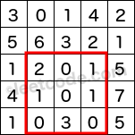  
The above rectangle (with the red border) is defined by (row1, col1) = **(2, 1)** and (row2, col2) = **(4, 3)**, which contains sum = **8**.

**Example:**

Given matrix = [

[3, 0, 1, 4, 2],

[5, 6, 3, 2, 1],

[1, 2, 0, 1, 5],

[4, 1, 0, 1, 7],

[1, 0, 3, 0, 5]

]

sumRegion(2, 1, 4, 3) -> 8

sumRegion(1, 1, 2, 2) -> 11

sumRegion(1, 2, 2, 4) -> 12

**Note:**

1. You may assume that the matrix does not change.
2. There are many calls to *sumRegion* function.
3. You may assume that *row*1 ≤ *row*2 and *col*1 ≤ *col*2.

Solution

Approach #1 (Brute Force) [Time Limit Exceeded]

**Algorithm**

Each time *sumRegion* is called, we use a double for loop to sum all elements from (row1, col1) \rightarrow (row2, col2)(*row*1,*col*1)→(*row*2,*col*2).

|  |
| --- |
| private int[][] data;  public NumMatrix(int[][] matrix) {  data = matrix;  }  public int sumRegion(int row1, int col1, int row2, int col2) {  int sum = 0;  for (int r = row1; r <= row2; r++) {  for (int c = col1; c <= col2; c++) {  sum += data[r][c];  }  }  return sum;  } |

**Complexity analysis**

* Time complexity : O(mn)*O*(*mn*) time per query. Assume that m*m* and n*n* represents the number of rows and columns respectively, each *sumRegion* query can go through at most m \times n*m*×*n* elements.
* Space complexity : O(1)*O*(1). Note that data is a *reference* to matrix and is not a copy of it.

Approach #2 (Caching) [Memory Limit Exceeded]

**Intuition**

Since *sumRegion* could be called many times, we definitely need to do some pre-processing.

**Algorithm**

We could trade in extra space for speed by pre-calculating all possible rectangular region sum and store them in a hash table. Each *sumRegion* query now takes only constant time complexity.

**Complexity analysis**

* Time complexity : O(1)*O*(1) time per query, O(m^2n^2)*O*(*m*2*n*2) time pre-computation. Each *sumRegion* query takes O(1)*O*(1) time as the hash table lookup's time complexity is constant. The pre-computation will take O(m^2n^2)*O*(*m*2*n*2) time as there are a total of m^2 \times n^2*m*2×*n*2 possibilities need to be cached.
* Space complexity : O(m^2n^2)*O*(*m*2*n*2). Since there are mn*mn* different possibilities for both top left and bottom right points of the rectangular region, the extra space required is O(m^2n^2)*O*(*m*2*n*2).

Approach #3 (Caching Rows) [Accepted]

**Intuition**

Remember from the [1D version](https://leetcode.com/course/chapters/leetcode-101/range-sum-query-immutable/) where we used a cumulative sum array? Could we apply that directly to solve this 2D version?

**Algorithm**

Try to see the 2D matrix as m*m* rows of 1D arrays. To find the region sum, we just accumulate the sum in the region row by row.

|  |
| --- |
| private int[][] dp;  public NumMatrix(int[][] matrix) {  if (matrix.length == 0 || matrix[0].length == 0) return;  dp = new int[matrix.length][matrix[0].length + 1];  for (int r = 0; r < matrix.length; r++) {  for (int c = 0; c < matrix[0].length; c++) {  dp[r][c + 1] = dp[r][c] + matrix[r][c];  }  }  }  public int sumRegion(int row1, int col1, int row2, int col2) {  int sum = 0;  for (int row = row1; row <= row2; row++) {  sum += dp[row][col2 + 1] - dp[row][col1];  }  return sum;  } |

**Complexity analysis**

* Time complexity : O(m)*O*(*m*) time per query, O(mn)*O*(*mn*) time pre-computation. The pre-computation in the constructor takes O(mn)*O*(*mn*) time. The *sumRegion* query takes O(m)*O*(*m*) time.
* Space complexity : O(mn)*O*(*mn*). The algorithm uses O(mn)*O*(*mn*) space to store the cumulative sum of all rows.

Approach #4 (Caching Smarter) [Accepted]

**Algorithm**

We used a cumulative sum array in the [1D version](https://leetcode.com/course/chapters/leetcode-101/range-sum-query-immutable/). We notice that the cumulative sum is computed with respect to the origin at index 0. Extending this analogy to the 2D case, we could pre-compute a cumulative region sum with respect to the origin at (0, 0)(0,0).

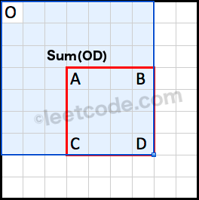  
Sum(OD) is the cumulative region sum with respect to the origin at (0, 0).

How do we derive Sum(ABCD)*Sum*(*ABCD*) using the pre-computed cumulative region sum?

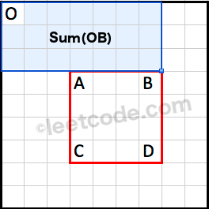  
Sum(OB) is the cumulative region sum on top of the rectangle.

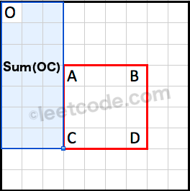  
Sum(OC) is the cumulative region sum to the left of the rectangle.

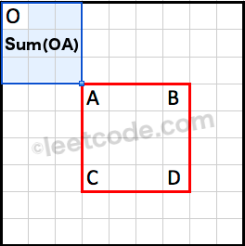  
Sum(OA) is the cumulative region sum to the top left corner of the rectangle.

Note that the region Sum(OA)*Sum*(*OA*) is covered twice by both Sum(OB)*Sum*(*OB*) and Sum(OC)*Sum*(*OC*). We could use the principle of inclusion-exclusion to calculate Sum(ABCD)*Sum*(*ABCD*) as following:

Sum(ABCD) = Sum(OD) - Sum(OB) - Sum(OC) + Sum(OA)*Sum*(*ABCD*)=*Sum*(*OD*)−*Sum*(*OB*)−*Sum*(*OC*)+*Sum*(*OA*)

|  |
| --- |
| private int[][] dp;  public NumMatrix(int[][] matrix) {  if (matrix.length == 0 || matrix[0].length == 0) return;  dp = new int[matrix.length + 1][matrix[0].length + 1];  for (int r = 0; r < matrix.length; r++) {  for (int c = 0; c < matrix[0].length; c++) {  dp[r + 1][c + 1] = dp[r + 1][c] + dp[r][c + 1] + matrix[r][c] - dp[r][c];  }  }  }  public int sumRegion(int row1, int col1, int row2, int col2) {  return dp[row2 + 1][col2 + 1] - dp[row1][col2 + 1] - dp[row2 + 1][col1] + dp[row1][col1];  } |

**Complexity analysis**

* Time complexity : O(1)*O*(1) time per query, O(mn)*O*(*mn*) time pre-computation. The pre-computation in the constructor takes O(mn)*O*(*mn*) time. Each *sumRegion* query takes O(1)*O*(1) time.
* Space complexity : O(mn)*O*(*mn*). The algorithm uses O(mn)*O*(*mn*) space to store the cumulative region sum.

**Continuous Subarray Sum**

Given a list of **non-negative** numbers and a target **integer** k, write a function to check if the array has a continuous subarray of size at least 2 that sums up to a multiple of **k**, that is, sums up to n*k where n is also an **integer**.

**Example 1:**

**Input:** [23, 2, 4, 6, 7], k=6

**Output:** True

**Explanation:** Because [2, 4] is a continuous subarray of size 2 and sums up to 6.

**Example 2:**

**Input:** [23, 2, 6, 4, 7], k=6

**Output:** True

**Explanation:** Because [23, 2, 6, 4, 7] is an continuous subarray of size 5 and sums up to 42.

**Constraints:**

* The length of the array won't exceed 10,000.
* You may assume the sum of all the numbers is in the range of a signed 32-bit integer.

## Solution

#### **Approach 1: Brute Force**

The brute force approach is trivial. We consider every possible subarray of size greater than or equal to 2, find out its sum by iterating over the elements of the subarray, and then we check if the sum obtained is an integer multiple of the given k*k*.

|  |
| --- |
| public class Solution {  public boolean checkSubarraySum(int[] nums, int k) {  for (int start = 0; start < nums.length - 1; start++) {  for (int end = start + 1; end < nums.length; end++) {  int sum = 0;  for (int i = start; i <= end; i++)  sum += nums[i];  if (sum == k || (k != 0 && sum % k == 0))  return true;  }  }  return false;  }  } |

**Complexity Analysis**

* Time complexity : O(n^3)*O*(*n*3). Three for loops iterating over the array are used.
* Space complexity : O(1)*O*(1). Constant extra space is used.

#### **Approach 2: Better Brute Force**

**Algorithm**

We can optimize the brute force approach to some extent, if we make use of an array sum*sum* that stores the cumulative sum of the elements of the array, such that sum[i]*sum*[*i*] stores the sum of the elements upto the i^{th}*ith* element of the array.

Thus, now as before, we consider every possible subarray for checking its sum. But, instead of iterating over a new subarray everytime to determine its sum, we make use of the cumulative sum array. Thus, to determine the sum of elements from the i^{th}*ith* index to the j^{th}*jth* index, including both the corners, we can use: sum[j] - sum[i] + nums[i]*sum*[*j*]−*sum*[*i*]+*nums*[*i*].

|  |
| --- |
| public class Solution {  public boolean checkSubarraySum(int[] nums, int k) {  int[] sum = new int[nums.length];  sum[0] = nums[0];  for (int i = 1; i < nums.length; i++)  sum[i] = sum[i - 1] + nums[i];  for (int start = 0; start < nums.length - 1; start++) {  for (int end = start + 1; end < nums.length; end++) {  int summ = sum[end] - sum[start] + nums[start];  if (summ == k || (k != 0 && summ % k == 0))  return true;  }  }  return false;  }  } |

**Complexity Analysis**

* Time complexity : O(n^2)*O*(*n*2). Two for loops are used for considering every subarray possible.
* Space complexity : O(n)*O*(*n*). sum*sum* array of size n*n* is used.

#### **Approach 3: Using HashMap**

**Algorithm**

In this solution, we make use of a HashMap that is used to store the cumulative sums upto the i^{th}*ith* index after some processing along with the index i*i*. The processing done is taking the modulus of the the sum upto the i^{th}*ith* index with the given k*k*. The reasoning behind this will become clear soon.

We traverse over the given array, and keep on calculating the sum%k*sum* values upto the current index. Whenever we find a new sum%k*sum* value, which isn't present in the HashMap already, we make an entry in the HashMap of the form, (sum%k, i)(*sum*.

Now, assume that the given sum%k*sum* value at the i^{th}*ith* index be equal to rem*rem*. Now, if any subarray follows the i^{th}*ith* element, which has a sum equal to the integer multiple of k*k*, say extending upto the j^{th}*jth* index, the sum value to be stored in the HashMap for the j^{th}*jth* index will be: (rem + n*k)%k(*rem*+*n*∗*k*), where n*n* is some integer > 0. We can observe that (rem + n*k)%k = rem(*rem*+*n*∗*k*), which is the same value as stored corresponding to the i^{th}*ith* index.

From this observation, we come to the conclusion that whenever the same sum%k*sum* value is obtained corresponding to two indices i*i* and j*j*, it implies that sum of elements betweeen those indices is an integer multiple of k*k*. Thus, if the same sum%k*sum* value is encountered again during the traversal, we return a \text{True}True directly.

The slideshow below depicts the process for the array nums: [2, 5, 33, 6, 7, 25, 15] and k=13.



|  |
| --- |
| public class Solution {  public boolean checkSubarraySum(int[] nums, int k) {  int sum = 0;  HashMap < Integer, Integer > map = new HashMap < > ();  map.put(0, -1);  for (int i = 0; i < nums.length; i++) {  sum += nums[i];  if (k != 0)  sum = sum % k;  if (map.containsKey(sum)) {  if (i - map.get(sum) > 1)  return true;  } else  map.put(sum, i);  }  return false;  }  } |

**Complexity Analysis**

* Time complexity : O(n)*O*(*n*). Only one traversal of the array nums*nums* is done.
* Space complexity : O(min(n,k))*O*(*min*(*n*,*k*)). The HashMap can contain upto min(n,k)*min*(*n*,*k*) different pairings.

## Design

[Read N Characters Given Read4](https://leetcode.com/problems/read-n-characters-given-read4) and its follow up ([part II](https://leetcode.com/problems/read-n-characters-given-read4-ii-call-multiple-times)) are quite often asked at Facebook according to our user survey. This is a pure coding problem, which corresponds well to the type of questions Facebook prefers. It is simple to think of an idea, but translating it to code and taking care of all edge cases is no trivial task.

**LRU Cache**

Design a data structure that follows the constraints of a [**Least Recently Used (LRU) cache**](https://en.wikipedia.org/wiki/Cache_replacement_policies#LRU).

Implement the LRUCache class:

* LRUCache(int capacity) Initialize the LRU cache with **positive** size capacity.
* int get(int key) Return the value of the key if the key exists, otherwise return -1.
* void put(int key, int value) Update the value of the key if the key exists. Otherwise, add the key-value pair to the cache. If the number of keys exceeds the capacity from this operation, **evict** the least recently used key.

**Follow up:**  
Could you do get and put in O(1) time complexity?

**Example 1:**

**Input**

["LRUCache", "put", "put", "get", "put", "get", "put", "get", "get", "get"]

[[2], [1, 1], [2, 2], [1], [3, 3], [2], [4, 4], [1], [3], [4]]

**Output**

[null, null, null, 1, null, -1, null, -1, 3, 4]

**Explanation**

LRUCache lRUCache = new LRUCache(2);

lRUCache.put(1, 1); // cache is {1=1}

lRUCache.put(2, 2); // cache is {1=1, 2=2}

lRUCache.get(1); // return 1

lRUCache.put(3, 3); // LRU key was 2, evicts key 2, cache is {1=1, 3=3}

lRUCache.get(2); // returns -1 (not found)

lRUCache.put(4, 4); // LRU key was 1, evicts key 1, cache is {4=4, 3=3}

lRUCache.get(1); // return -1 (not found)

lRUCache.get(3); // return 3

lRUCache.get(4); // return 4

**Constraints:**

* 1 <= capacity <= 3000
* 0 <= key <= 3000
* 0 <= value <= 104
* At most 3 * 104 calls will be made to get and put.

Gooogle

**Binary Search Tree Iterator**

Implement the BSTIterator class that represents an iterator over the [**in-order traversal**](https://en.wikipedia.org/wiki/Tree_traversal#In-order_(LNR)) of a binary search tree (BST):

* BSTIterator(TreeNode root) Initializes an object of the BSTIterator class. The root of the BST is given as part of the constructor. The pointer should be initialized to a non-existent number smaller than any element in the BST.
* boolean hasNext() Returns true if there exists a number in the traversal to the right of the pointer, otherwise returns false.
* int next() Moves the pointer to the right, then returns the number at the pointer.

Notice that by initializing the pointer to a non-existent smallest number, the first call to next() will return the smallest element in the BST.

You may assume that next() calls will always be valid. That is, there will be at least a next number in the in-order traversal when next() is called.

**Example 1:**

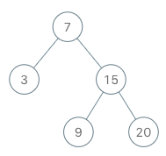

**Input**

["BSTIterator", "next", "next", "hasNext", "next", "hasNext", "next", "hasNext", "next", "hasNext"]

[[[7, 3, 15, null, null, 9, 20]], [], [], [], [], [], [], [], [], []]

**Output**

[null, 3, 7, true, 9, true, 15, true, 20, false]

**Explanation**

BSTIterator bSTIterator = new BSTIterator([7, 3, 15, null, null, 9, 20]);

bSTIterator.next(); // return 3

bSTIterator.next(); // return 7

bSTIterator.hasNext(); // return True

bSTIterator.next(); // return 9

bSTIterator.hasNext(); // return True

bSTIterator.next(); // return 15

bSTIterator.hasNext(); // return True

bSTIterator.next(); // return 20

bSTIterator.hasNext(); // return False

**Constraints:**

* The number of nodes in the tree is in the range [1, 105].
* 0 <= Node.val <= 106
* At most 105 calls will be made to hasNext, and next.

**Follow up:**

* Could you implement next() and hasNext() to run in average O(1) time and use O(h) memory, where h is the height of the tree?

Binary Search Tree

**Add and Search Word - Data structure design**

Design a data structure that supports adding new words and finding if a string matches any previously added string.

Implement the WordDictionary class:

* WordDictionary() Initializes the object.
* void addWord(word) Adds word to the data structure, it can be matched later.
* bool search(word) Returns true if there is any string in the data structure that matches word or false otherwise. word may contain dots '.' where dots can be matched with any letter.

**Example:**

**Input**

["WordDictionary","addWord","addWord","addWord","search","search","search","search"]

[[],["bad"],["dad"],["mad"],["pad"],["bad"],[".ad"],["b.."]]

**Output**

[null,null,null,null,false,true,true,true]

**Explanation**

WordDictionary wordDictionary = new WordDictionary();

wordDictionary.addWord("bad");

wordDictionary.addWord("dad");

wordDictionary.addWord("mad");

wordDictionary.search("pad"); // return False

wordDictionary.search("bad"); // return True

wordDictionary.search(".ad"); // return True

wordDictionary.search("b.."); // return True

**Constraints:**

* 1 <= word.length <= 500
* word in addWord consists lower-case English letters.
* word in search consist of  '.' or lower-case English letters.
* At most 50000 calls will be made to addWord and search.

Tries

**Serialize and Deserialize Binary Tree**

Serialization is the process of converting a data structure or object into a sequence of bits so that it can be stored in a file or memory buffer, or transmitted across a network connection link to be reconstructed later in the same or another computer environment.

Design an algorithm to serialize and deserialize a binary tree. There is no restriction on how your serialization/deserialization algorithm should work. You just need to ensure that a binary tree can be serialized to a string and this string can be deserialized to the original tree structure.

**Clarification:** The input/output format is the same as [how LeetCode serializes a binary tree](https://leetcode.com/faq/#binary-tree). You do not necessarily need to follow this format, so please be creative and come up with different approaches yourself.

**Example 1:**

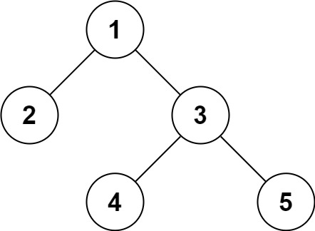

**Input:** root = [1,2,3,null,null,4,5]

**Output:** [1,2,3,null,null,4,5]

**Example 2:**

**Input:** root = []

**Output:** []

**Example 3:**

**Input:** root = [1]

**Output:** [1]

**Example 4:**

**Input:** root = [1,2]

**Output:** [1,2]

**Constraints:**

* The number of nodes in the tree is in the range [0, 104].
* -1000 <= Node.val <= 1000

Binary Tree

## Others

Here are some other Facebook interview questions for you to practice. [Integer to English Words](https://leetcode.com/problems/integer-to-english-words) is quite frequently asked according to our user survey.

[Find the Celebrity](https://leetcode.com/problems/find-the-celebrity) is a cute problem but requires some out of box thinking and Facebook seems to like this problem, too.

**Expression Add Operators**

Given a string that contains only digits 0-9 and a target value, return all possibilities to add **binary** operators (not unary) +, -, or * between the digits so they evaluate to the target value.

**Example 1:**

**Input:** *num* = "123", *target* = 6

**Output:** ["1+2+3", "1*2*3"]

**Example 2:**

**Input:** *num* = "232", *target* = 8

**Output:** ["2*3+2", "2+3*2"]

**Example 3:**

**Input:** *num* = "105", *target* = 5

**Output:** ["1*0+5","10-5"]

**Example 4:**

**Input:** *num* = "00", *target* = 0

**Output:** ["0+0", "0-0", "0*0"]

**Example 5:**

**Input:** *num* = "3456237490", *target* = 9191

**Output:** []

**Constraints:**

* 0 <= num.length <= 10
* num only contain digits.

## olution

#### **Approach 1: Backtracking**

**Intuition**

Let us first look at what the question asks us to do before getting at the approach to solve it. So, we are given a string of numbers and 3 different operators:

* + Addition,
* - Subtraction or
* * Multiplication

We have to find all possible combinations of binary operators between the digits so that the overall value of the resulting expression becomes equal to a given target value. Let us look at a few possibilities of what it means exactly to place the operators between digits so that the question becomes clearer.

Let's say we are given the following set of digits "123456789" and the target value given to us is 45. Let us see some of the possible resulting expressions that we can get by placing the operators in different locations.

1 + 2 + 3 + 4 + 5 + 6 + 7 + 8 + 9 = 45

1 + 2 - 3 + 4 - 5 + 6 - 7 + 8 - 9 = -3

1 + 2 * 3 - 4 + 5 + 6 - 7 * 8 - 9 = -51

1 + 2 + 3 + 4 + 5 - 6 * 7 + 8 * 9 = 45

These are just 4 of the many resulting expressions that are possible by using the given string of digits and the three operators.

By looking at the above examples we can't really figure out any specific pattern among the resulting expressions that tells us which of them will give us the resulting target.

Since the question explicitly states that we are given binary operators, this means that each of the operator would require two operands.

We can consider each of our digits as an operand.

This means that between every pair of digits we can have any of the three operators i.e. ++, -− or \times×.

If you've looked at the question's statement and the examples that are given in the question, you would realize that there is an example where the digits are "105" and the target value is 5. For this particular example, there are two expressions given to us and they are 1*0+5 and 10-5.

The second expression is something that you need to look out for before getting to solve this question because this complicates things a bit.

It would have been an easier question to solve if we just had to consider those expressions that simply had digits as operands.

But, in this question, we can have all sorts of digits getting together and forming a bigger number that becomes a part of the expression. Let us look at some example expressions for the digits "123456" and target 30.

1 * 23 - 4 + 5 + 6 = 30

12 - 3 * 4 + 5 * 6 = 30

1 - 23 - 4 + 56 = 30

So this means that although the number of operators are defined for us i.e. 3 different binary operators, but the number of operands are **not really well defined for us**.

This is a big portion of the original problem that we need to address in our solution.

Since we are asked to find out all of the valid expressions whose value equals the given target and we don't really know what specific operator between two operands would eventually give us a valid expression,

We try out all of the options.

This means once we have defined what the operands are for our given expression, we would have three possible choices of operators between each consecutive pair of operands.

From an implementation perspective, what would an operand imply with respect to our original string?

An operand would be an integer formed from a substring of our original string.

Let's look at two different array partitions for the given string "123456789"

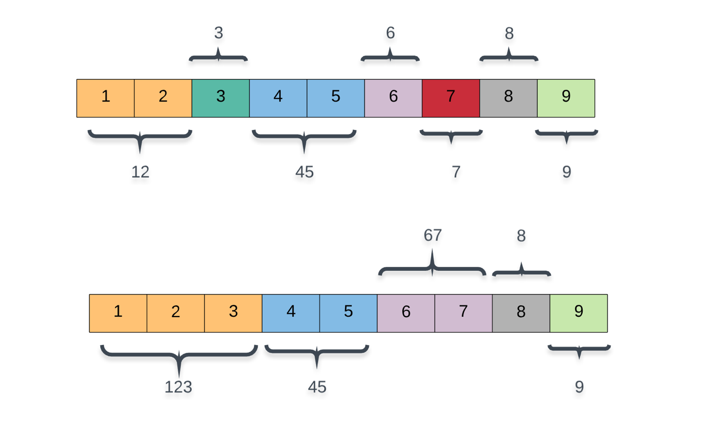

Since we are required to return all of the valid expressions that evaluate to a given target value, we have to try all possible partitions of the given array thereby considering all of the possible operands that can be formed from the digits.

There is a very simple way of incorporating this into our algorithm. Right now, at every point in the algorithm, we have three different choices corresponding to the three different operators.

The way we incorporate these partitions is by considering a 4th operator as well which simply moves one step forward and extends the current operand by one digit. Essentially, going from 12 --> 123 is a NO OP operand in our implementation. (12 * 10) + 3.

Now we have 4 different recursion paths in our algorithm and we have to try out all of them to see which ones lead to a potential solution.

This try out everything hints at a backtracking solution and that is exactly what we are going to look at here.

**Algorithm**

Let's quickly look at the steps involved in our backtracking algorithm before looking at the pseudo-code.

1. As discussed above, we have multiple choices of what operators to use and what the operands can be and hence, we have to look at all the possibilities to find ***all*** valid expressions.
2. Our recursive call will have an index which represents the current digit we're looking at in the original nums string and also the expression string built till now.
3. At every step, we have exactly 4 different recursive calls. The NO OP call simply extends the current_operand by the current digit and moves ahead. Rest of the recursive calls correspond to +, -, and *.
4. We keep on building our expression like this and eventually, the entire nums string would be processed. At that time we check if the expression we built till now is a valid expression or not and we record it if it is a valid one.

1. procedure recurse(digits, index, expression):

2. if we have reached the end of the string:

3. if the expression evaluates to the target:

4. Valid Expression found!

5. else:

6. try out operator 'NO OP' and recurse

7. try out operator * and recurse

8. try out operator + and recurse

9. try out operator - and recurse

The algorithm now looks pretty straightforward. However, the implementation is something that needs more thought and there are some things that we need to address before actually looking at the implementation.

When we are done building an expression out of all of the digits in our original string i.e. the base case, then we check if the expression is a valid expression or not. Right ?

How do we actually check if an expression is a valid one or not if all we have is a string representing the expression and not the integer value for the same?

Well, one way to go about this is to write a custom eval function that takes in a string and returns the value of that expression. If you do that (Python people can use the inbuilt function eval for this), you will get a TLE i.e. time limit exceeded error.

**Can't we keep track of the expression's value on the fly?**

Well yes. That's the idea we will go with. Instead of just keeping track of what the expression string is, we will also keep track of it's value along the way so that when the recursion hits the base case, we can check in O(1)*O*(1) time if the expression's value equals the target value or not.

The implementation would have been straightforward had it just been + and - operators involved. This is because both these operators have an equal precedence. That means that we can continue to evaluate the expression on the fly without any problems. Have a look at the following example.

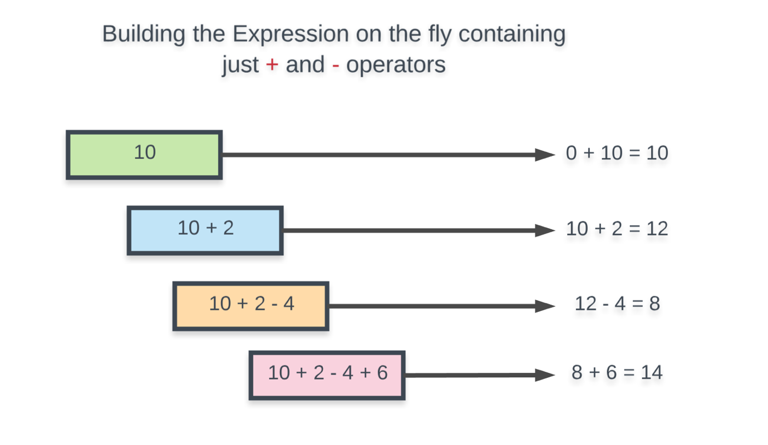

So far so good. Now let us add the * operator as well and see how building the expression on the fly like this breaks.

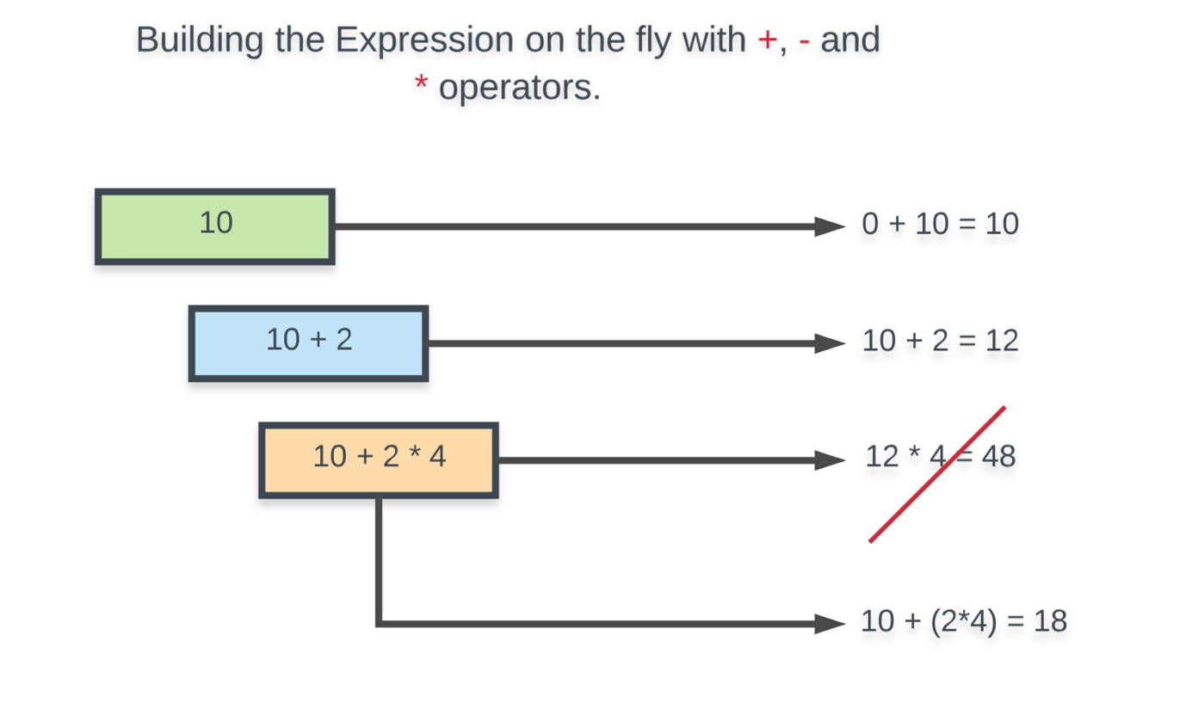

What we mean by building the expression on the fly is that we keep track of the expression's value till now and we simply consider that value as one of the two operands for our operators. As we can see from the two examples above, this would have worked had it just been + and - operators.

But, this approach is bound to fail because the * operator takes precedence over + and -. The * operator would require the ***actual*** previous operand in our expression rather than the current value of the expression. i.e. In the above example, the * operator needed 2 rather than 12 to get us the correct value of 18.

**How to handle this?**

The idea on how to handle this problem springs from the discussion above. We simply need to keep track of the last operand in our expression and how it modified the expression's value overall so that when we consider the * operator, we can **reverse** the effects of the previous operand and consider it for multiplication. Let's take a look at the example that was breaking before.

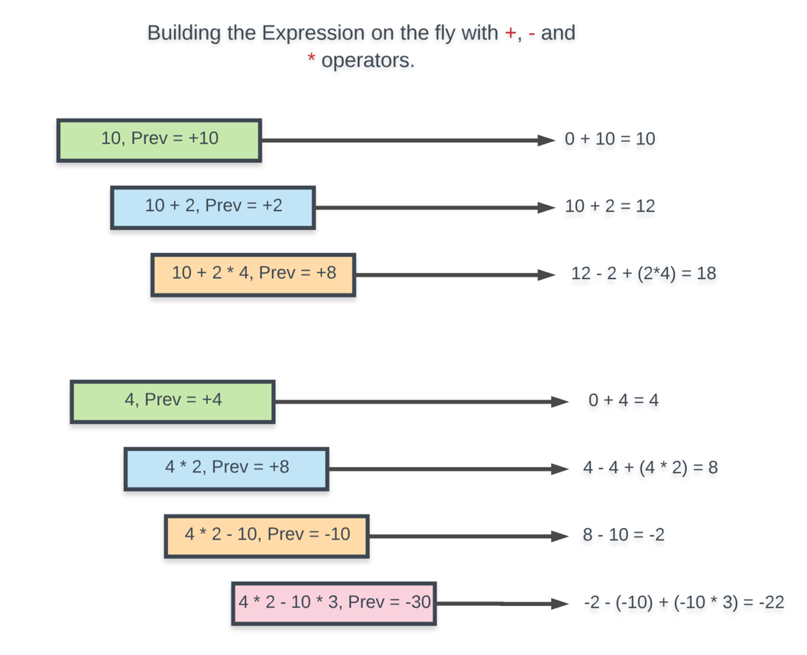

Now we can look at the actual implementation of this algorithm.

|  |
| --- |
| class Solution {  public ArrayList<String> answer;  public String digits;  public long target;  public void recurse(  int index, long previousOperand, long currentOperand, long value, ArrayList<String> ops) {  String nums = this.digits;  // Done processing all the digits in num  if (index == nums.length()) {  // If the final value == target expected AND  // no operand is left unprocessed  if (value == this.target && currentOperand == 0) {  StringBuilder sb = new StringBuilder();  ops.subList(1, ops.size()).forEach(v -> sb.append(v));  this.answer.add(sb.toString());  }  return;  }  // Extending the current operand by one digit  currentOperand = currentOperand * 10 + Character.getNumericValue(nums.charAt(index));  String current_val_rep = Long.toString(currentOperand);  int length = nums.length();  // To avoid cases where we have 1 + 05 or 1 * 05 since 05 won't be a  // valid operand. Hence this check  if (currentOperand > 0) {  // NO OP recursion  recurse(index + 1, previousOperand, currentOperand, value, ops);  }  // ADDITION  ops.add("+");  ops.add(current_val_rep);  recurse(index + 1, currentOperand, 0, value + currentOperand, ops);  ops.remove(ops.size() - 1);  ops.remove(ops.size() - 1);  if (ops.size() > 0) {  // SUBTRACTION  ops.add("-");  ops.add(current_val_rep);  recurse(index + 1, -currentOperand, 0, value - currentOperand, ops);  ops.remove(ops.size() - 1);  ops.remove(ops.size() - 1);  // MULTIPLICATION  ops.add("*");  ops.add(current_val_rep);  recurse(  index + 1,  currentOperand * previousOperand,  0,  value - previousOperand + (currentOperand * previousOperand),  ops);  ops.remove(ops.size() - 1);  ops.remove(ops.size() - 1);  }  }  public List<String> addOperators(String num, int target) {  if (num.length() == 0) {  return new ArrayList<String>();  }  this.target = target;  this.digits = num;  this.answer = new ArrayList<String>();  this.recurse(0, 0, 0, 0, new ArrayList<String>());  return this.answer;  }  } |

**Complexity Analysis**

* Time Complexity:
  + At every step along the way, we consider exactly 4 different choices or 4 different recursive paths. The base case is when the value of index reaches N*N* i.e. the length of the nums array. Hence, our complexity would be O(4^N)*O*(4*N*).
  + For the base case we use a StringBuilder::toString operation in Java and .join() operation in Python and that takes O(N)*O*(*N*) time. Here N*N* represents the length of our expression. In the worst case, each digit would be an operand and we would have N*N* digits and N - 1*N*−1 operators. So O(N)*O*(*N*). This is for one expression. In the worst case, we can have O(4^N)*O*(4*N*) valid expressions.
  + Overall time complexity = O(N \times 4^N)*O*(*N*×4*N*).
* Space Complexity:
  + For both Python and Java implementations we have a list data structure that we update on the fly and only for valid expressions do we create a new string and add to our answers array. So, the space occupied by the intermediate list would be O(N)*O*(*N*) since in the worst case the expression would be built out of all the digits as operands.
  + Additionally, the space used up by the recursion stack would also be O(N)*O*(*N*) since the size of recursion stack is determined by the value of index and it goes from 00 all the way to N*N*.
  + We don't consider the space occupied by the answers array since that is a part of the question's requirement and we can't reduce that in any way

**EDIT:** The previous implementation of the algorithm, although correct, lead me to write an incorrect complexity analysis section. I've re-written the algorithm from scratch and corrected the complexity analysis as well. Sorry for the inconvenience to all the readers. The core idea of the algorithm is still the same. That hasn't changed.

Special thanks to [@ufarooqi](https://leetcode.com/ufarooqi/), [@vortexwolf](https://leetcode.com/vortexwolf) for providing correct complexity analysis in the discussion forum leading to corrections in the article. Pardon me if I've missed out on any other names :)

**Find All Anagrams in a String**

Given a string **s** and a **non-empty** string **p**, find all the start indices of **p**'s anagrams in **s**.

Strings consists of lowercase English letters only and the length of both strings **s** and **p** will not be larger than 20,100.

The order of output does not matter.

**Example 1:**

**Input:**

s: "cbaebabacd" p: "abc"

**Output:**

[0, 6]

**Explanation:**

The substring with start index = 0 is "cba", which is an anagram of "abc".

The substring with start index = 6 is "bac", which is an anagram of "abc".

**Example 2:**

**Input:**

s: "abab" p: "ab"

**Output:**

[0, 1, 2]

**Explanation:**

The substring with start index = 0 is "ab", which is an anagram of "ab".

The substring with start index = 1 is "ba", which is an anagram of "ab".

The substring with start index = 2 is "ab", which is an anagram of "ab".

Solution

Solution Template

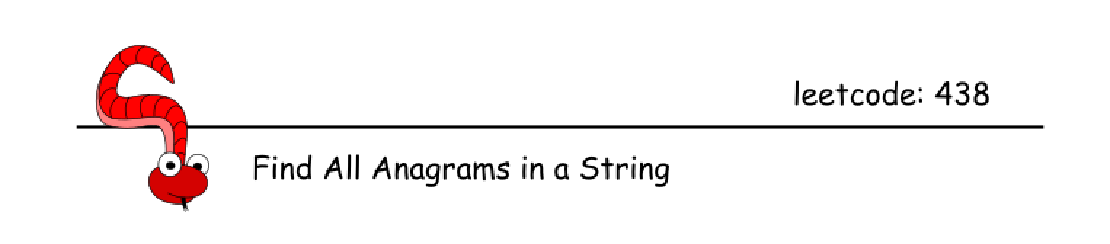

This is a problem of multiple pattern search in a string. All such problems usually could be solved by sliding window approach in a linear time. The challenge here is how to implement constant-time slice to fit into this linear time.

If the patterns are not known in advance, i.e. it's "find duplicates" problem, one could use one of two ways to implement constant-time slice: Bitmasks or Rabin-Karp. Please check article [Repeated DNA Sequences](https://leetcode.com/articles/repeated-dna-sequences/) for the detailed comparison of these two algorithms.

Here the situation is more simple: patterns are known in advance, and the set of characters in the patterns is very limited as well: 26 lowercase English letters. Hence one could allocate array or hashmap with 26 elements and use it as a letter counter in the sliding window.

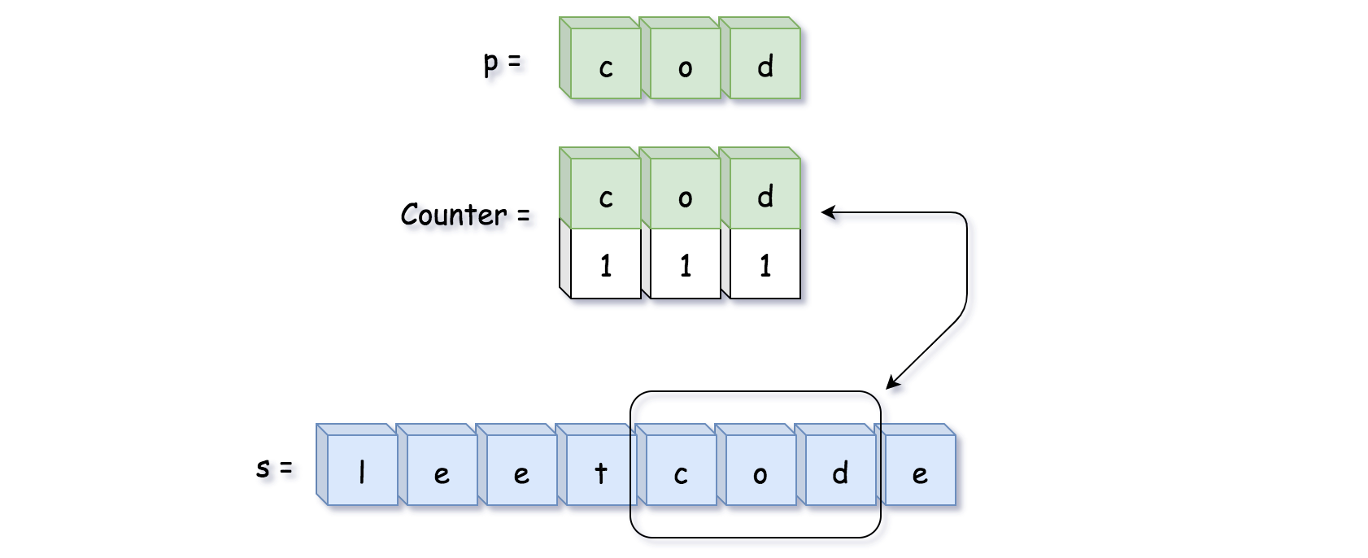

Approach 1: Sliding Window with HashMap

Let's start from the simplest approach: sliding window + two counter hashmaps letter -> its count. The first hashmap is a reference counter pCount for string p, and the second one is a counter sCount for string in the sliding window.

The idea is to move sliding window along the string s, recompute the second hashmap sCount in a constant time and compare it with the first hashmap pCount. If sCount == pCount, then the string in the sliding window is a permutation of string p, and one could add its start position in the output list.

**Algorithm**

* Build reference counter pCount for string p.
* Move sliding window along the string s:
  + Recompute sliding window counter sCount at each step by adding one letter on the right and removing one letter on the left.
  + If sCount == pCount, update the output list.
* Return output list.

**Implementation**



|  |
| --- |
| class Solution {  public List<Integer> findAnagrams(String s, String p) {  int ns = s.length(), np = p.length();  if (ns < np) return new ArrayList();  Map<Character, Integer> pCount = new HashMap();  Map<Character, Integer> sCount = new HashMap();  // build reference hashmap using string p  for (char ch : p.toCharArray()) {  if (pCount.containsKey(ch)) {  pCount.put(ch, pCount.get(ch) + 1);  }  else {  pCount.put(ch, 1);  }  }  List<Integer> output = new ArrayList();  // sliding window on the string s  for (int i = 0; i < ns; ++i) {  // add one more letter  // on the right side of the window  char ch = s.charAt(i);  if (sCount.containsKey(ch)) {  sCount.put(ch, sCount.get(ch) + 1);  }  else {  sCount.put(ch, 1);  }  // remove one letter  // from the left side of the window  if (i >= np) {  ch = s.charAt(i - np);  if (sCount.get(ch) == 1) {  sCount.remove(ch);  }  else {  sCount.put(ch, sCount.get(ch) - 1);  }  }  // compare hashmap in the sliding window  // with the reference hashmap  if (pCount.equals(sCount)) {  output.add(i - np + 1);  }  }  return output;  }  } |

**Complexity Analysis**

* Time complexity: \mathcal{O}(N_s + N_p)O(*Ns*​+*Np*​) since it's one pass along both strings.
* Space complexity: \mathcal{O}(1)O(1), because pCount and sCount contain not more than 26 elements.

#### **Approach 2: Sliding Window with Array**

**Algorithm**

Hashmap is quite complex structure, [with known performance issues in Java](https://github.com/vavr-io/vavr/issues/571). Let's implement approach 1 using 26-elements array instead of hashmap:

* Element number 0 contains count of letter a.
* Element number 1 contains count of letter b.
* ...
* Element number 26 contains count of letter z.

**Algorithm**

* Build reference array pCount for string p.
* Move sliding window along the string s:
  + Recompute sliding window array sCount at each step by adding one letter on the right and removing one letter on the left.
  + If sCount == pCount, update the output list.
* Return output list.

**Implementation**

|  |
| --- |
| class Solution {  public List<Integer> findAnagrams(String s, String p) {  int ns = s.length(), np = p.length();  if (ns < np) return new ArrayList();  int [] pCount = new int[26];  int [] sCount = new int[26];  // build reference array using string p  for (char ch : p.toCharArray()) {  pCount[(int)(ch - 'a')]++;  }  List<Integer> output = new ArrayList();  // sliding window on the string s  for (int i = 0; i < ns; ++i) {  // add one more letter  // on the right side of the window  sCount[(int)(s.charAt(i) - 'a')]++;  // remove one letter  // from the left side of the window  if (i >= np) {  sCount[(int)(s.charAt(i - np) - 'a')]--;  }  // compare array in the sliding window  // with the reference array  if (Arrays.equals(pCount, sCount)) {  output.add(i - np + 1);  }  }  return output;  }  } |

**Complexity Analysis**

* Time complexity: \mathcal{O}(N_s + N_p)O(*Ns*​+*Np*​) since it's one pass along both strings.
* Space complexity: \mathcal{O}(1)O(1), because pCount and sCount contain 26 elements each.

**Permutation in String**

Given two strings **s1** and **s2**, write a function to return true if **s2** contains the permutation of **s1**. In other words, one of the first string's permutations is the **substring** of the second string.

**Example 1:**

**Input:** s1 = "ab" s2 = "eidbaooo"

**Output:** True

**Explanation:** s2 contains one permutation of s1 ("ba").

**Example 2:**

**Input:**s1= "ab" s2 = "eidboaoo"

**Output:** False

**Constraints:**

* The input strings only contain lower case letters.
* The length of both given strings is in range [1, 10,000].

 Hide Hint #1

Obviously, brute force will result in TLE. Think of something else.

   Hide Hint #2

How will you check whether one string is a permutation of another string?

   Hide Hint #3

One way is to sort the string and then compare. But, Is there a better way?

   Hide Hint #4

If one string is a permutation of another string then they must one common metric. What is that?

   Hide Hint #5

Both strings must have same character frequencies, if one is permutation of another. Which data structure should be used to store frequencies?

   Hide Hint #6

What about hash table? An array of size 26?

## Solution

#### **Approach #1 Brute Force [Time Limit Exceeded]**

**Algorithm**

The simplest method is to generate all the permutations of the short string and to check if the generated permutation is a substring of the longer string.

In order to generate all the possible pairings, we make use of a function permute(string_1, string_2, current_index). This function creates all the possible permutations of the short string s1*s*1.

To do so, permute takes the index of the current element current_index*currenti*​*ndex* as one of the arguments. Then, it swaps the current element with every other element in the array, lying towards its right, so as to generate a new ordering of the array elements. After the swapping has been done, it makes another call to permute but this time with the index of the next element in the array. While returning back, we reverse the swapping done in the current function call.

Thus, when we reach the end of the array, a new ordering of the array's elements is generated. The following animation depicts the process of generating the permutations.



|  |
| --- |
| public class Solution {  boolean flag = false;  public boolean checkInclusion(String s1, String s2) {  permute(s1, s2, 0);  return flag;  }  public String swap(String s, int i0, int i1) {  if (i0 == i1)  return s;  String s1 = s.substring(0, i0);  String s2 = s.substring(i0 + 1, i1);  String s3 = s.substring(i1 + 1);  return s1 + s.charAt(i1) + s2 + s.charAt(i0) + s3;  }  void permute(String s1, String s2, int l) {  if (l == s1.length()) {  if (s2.indexOf(s1) >= 0)  flag = true;  } else {  for (int i = l; i < s1.length(); i++) {  s1 = swap(s1, l, i);  permute(s1, s2, l + 1);  s1 = swap(s1, l, i);  }  }  }  } |

**Complexity Analysis**

* Time complexity : O(n!)*O*(*n*!). We match all the permutations of the short string s1*s*1, of length s1*s*1, with s2*s*2. Here, n*n* refers to the length of s1*s*1.
* Space complexity : O(n^2)*O*(*n*2). The depth of the recursion tree is n*n*(n*n* refers to the length of the short string s1*s*1). Every node of the recursion tree contains a string of max. length n*n*.

#### **Approach #2 Using sorting [Time Limit Exceeded]:**

**Algorithm**

The idea behind this approach is that one string will be a permutation of another string only if both of them contain the same characters the same number of times. One string x*x* is a permutation of other string y*y* only if sorted(x)=sorted(y)*sorted*(*x*)=*sorted*(*y*).

In order to check this, we can sort the two strings and compare them. We sort the short string s1*s*1 and all the substrings of s2*s*2, sort them and compare them with the sorted s1*s*1 string. If the two match completely, s1*s*1's permutation is a substring of s2*s*2, otherwise not.

|  |
| --- |
| public class Solution {  public boolean checkInclusion(String s1, String s2) {  s1 = sort(s1);  for (int i = 0; i <= s2.length() - s1.length(); i++) {  if (s1.equals(sort(s2.substring(i, i + s1.length()))))  return true;  }  return false;  }  public String sort(String s) {  char[] t = s.toCharArray();  Arrays.sort(t);  return new String(t);  }  } |

**Complexity Analysis**

* Time complexity : O\big(l_1log(l_1)+(l_2-l_1)l_1log(l_1)\big)*O*(*l*1​*log*(*l*1​)+(*l*2​−*l*1​)*l*1​*log*(*l*1​)). where l_1*l*1​ is the length of string l_1*l*1​ and l_2*l*2​ is the length of string l_2*l*2​.
* Space complexity : O(l_1)*O*(*l*1​). t*t* array is used .

#### **Approach #3 Using Hashmap [Time Limit Exceeded]**

**Algorithm**

As discussed above, one string will be a permutation of another string only if both of them contain the same charaters with the same frequency. We can consider every possible substring in the long string s2*s*2 of the same length as that of s1*s*1 and check the frequency of occurence of the characters appearing in the two. If the frequencies of every letter match exactly, then only s1*s*1's permutation can be a substring of s2*s*2.

In order to implement this approach, instead of sorting and then comparing the elements for equality, we make use of a hashmap s1map*s*1*map* which stores the frequency of occurence of all the characters in the short string s1*s*1. We consider every possible substring of s2*s*2 of the same length as that of s1*s*1, find its corresponding hashmap as well, namely s2map*s*2*map*. Thus, the substrings considered can be viewed as a window of length as that of s1*s*1 iterating over s2*s*2. If the two hashmaps obtained are identical for any such window, we can conclude that s1*s*1's permutation is a substring of s2*s*2, otherwise not.

|  |
| --- |
| public class Solution {  public boolean checkInclusion(String s1, String s2) {  if (s1.length() > s2.length())  return false;  HashMap < Character, Integer > s1map = new HashMap < > ();  for (int i = 0; i < s1.length(); i++)  s1map.put(s1.charAt(i), s1map.getOrDefault(s1.charAt(i), 0) + 1);  for (int i = 0; i <= s2.length() - s1.length(); i++) {  HashMap < Character, Integer > s2map = new HashMap < > ();  for (int j = 0; j < s1.length(); j++) {  s2map.put(s2.charAt(i + j), s2map.getOrDefault(s2.charAt(i + j), 0) + 1);  }  if (matches(s1map, s2map))  return true;  }  return false;  }  public boolean matches(HashMap < Character, Integer > s1map, HashMap < Character, Integer > s2map) {  for (char key: s1map.keySet()) {  if (s1map.get(key) - s2map.getOrDefault(key, -1) != 0)  return false;  }  return true;  }  } |

**Complexity Analysis**

* Time complexity : O(l_1+26*l_1*(l_2-l_1))*O*(*l*1​+26∗*l*1​∗(*l*2​−*l*1​)). hashmap contains atmost 26 keys. where l_1*l*1​ is the length of string l_1*l*1​ and l_2*l*2​ is the length of string l_2*l*2​.
* Space complexity : O(1)*O*(1). hashmap contains atmost 26 key-value pairs.

#### **Approach #4 Using Array [Accepted]**

**Algorithm**

Instead of making use of a special HashMap datastructure just to store the frequency of occurence of characters, we can use a simpler array data structure to store the frequencies. Given strings contains only lowercase alphabets ('a' to 'z'). So we need to take an array of size 26.The rest of the process remains the same as the last approach.

|  |
| --- |
| public class Solution {  public boolean checkInclusion(String s1, String s2) {  if (s1.length() > s2.length())  return false;  int[] s1map = new int[26];  for (int i = 0; i < s1.length(); i++)  s1map[s1.charAt(i) - 'a']++;  for (int i = 0; i <= s2.length() - s1.length(); i++) {  int[] s2map = new int[26];  for (int j = 0; j < s1.length(); j++) {  s2map[s2.charAt(i + j) - 'a']++;  }  if (matches(s1map, s2map))  return true;  }  return false;  }  public boolean matches(int[] s1map, int[] s2map) {  for (int i = 0; i < 26; i++) {  if (s1map[i] != s2map[i])  return false;  }  return true;  }  } |

**Complexity Analysis**

* Time complexity : O(l_1+26*l_1*(l_2-l_1))*O*(*l*1​+26∗*l*1​∗(*l*2​−*l*1​)), where l_1*l*1​ is the length of string l_1*l*1​ and l_2*l*2​ is the length of string l_2*l*2​.
* Space complexity : O(1)*O*(1). s1map*s*1*map* and s2map*s*2*map* of size 26 is used.

#### **Approach #5 Sliding Window [Accepted]:**

**Algorithm**

Instead of generating the hashmap afresh for every window considered in s2*s*2, we can create the hashmap just once for the first window in s2*s*2. Then, later on when we slide the window, we know that we remove one preceding character and add a new succeeding character to the new window considered. Thus, we can update the hashmap by just updating the indices associated with those two characters only. Again, for every updated hashmap, we compare all the elements of the hashmap for equality to get the required result.

|  |
| --- |
| public class Solution {  public boolean checkInclusion(String s1, String s2) {  if (s1.length() > s2.length())  return false;  int[] s1map = new int[26];  int[] s2map = new int[26];  for (int i = 0; i < s1.length(); i++) {  s1map[s1.charAt(i) - 'a']++;  s2map[s2.charAt(i) - 'a']++;  }  for (int i = 0; i < s2.length() - s1.length(); i++) {  if (matches(s1map, s2map))  return true;  s2map[s2.charAt(i + s1.length()) - 'a']++;  s2map[s2.charAt(i) - 'a']--;  }  return matches(s1map, s2map);  }  public boolean matches(int[] s1map, int[] s2map) {  for (int i = 0; i < 26; i++) {  if (s1map[i] != s2map[i])  return false;  }  return true;  }  } |

**Complexity Analysis**

* Time complexity : O(l_1+26*(l_2-l_1))*O*(*l*1​+26∗(*l*2​−*l*1​)), where l_1*l*1​ is the length of string l_1*l*1​ and l_2*l*2​ is the length of string l_2*l*2​.
* Space complexity : O(1)*O*(1). Constant space is used.

#### **Approach #6 Optimized Sliding Window [Accepted]:**

**Algorithm**

The last approach can be optimized, if instead of comparing all the elements of the hashmaps for every updated s2map*s*2*map* corresponding to every window of s2*s*2 considered, we keep a track of the number of elements which were already matching in the earlier hashmap and update just the count of matching elements when we shift the window towards the right.

To do so, we maintain a count*count* variable, which stores the number of characters(out of the 26 alphabets), which have the same frequency of occurence in s1*s*1 and the current window in s2*s*2. When we slide the window, if the deduction of the last element and the addition of the new element leads to a new frequency match of any of the characters, we increment the count*count* by 1. If not, we keep the count*count* intact. But, if a character whose frequency was the same earlier(prior to addition and removal) is added, it now leads to a frequency mismatch which is taken into account by decrementing the same count*count* variable. If, after the shifting of the window, the count*count* evaluates to 26, it means all the characters match in frequency totally. So, we return a True in that case immediately.

|  |
| --- |
| public class Solution {  public boolean checkInclusion(String s1, String s2) {  if (s1.length() > s2.length())  return false;  int[] s1map = new int[26];  int[] s2map = new int[26];  for (int i = 0; i < s1.length(); i++) {  s1map[s1.charAt(i) - 'a']++;  s2map[s2.charAt(i) - 'a']++;  }  int count = 0;  for (int i = 0; i < 26; i++)  if (s1map[i] == s2map[i])  count++;  for (int i = 0; i < s2.length() - s1.length(); i++) {  int r = s2.charAt(i + s1.length()) - 'a', l = s2.charAt(i) - 'a';  if (count == 26)  return true;  s2map[r]++;  if (s2map[r] == s1map[r])  count++;  else if (s2map[r] == s1map[r] + 1)  count--;  s2map[l]--;  if (s2map[l] == s1map[l])  count++;  else if (s2map[l] == s1map[l] - 1)  count--;  }  return count == 26;  }  } |

**Complexity Analysis**

* Time complexity : O(l_1+(l_2-l_1))*O*(*l*1​+(*l*2​−*l*1​)). where l_1*l*1​ is the length of string l_1*l*1​ and l_2*l*2​ is the length of string l_2*l*2​.
* Space complexity : O(1)*O*(1). Constant space is used.

**Verifying an Alien Dictionary**

In an alien language, surprisingly they also use english lowercase letters, but possibly in a different order. The order of the alphabet is some permutation of lowercase letters.

Given a sequence of words written in the alien language, and the order of the alphabet, return true if and only if the given words are sorted lexicographicaly in this alien language.

**Example 1:**

**Input:** words = ["hello","leetcode"], order = "hlabcdefgijkmnopqrstuvwxyz"

**Output:** true

**Explanation:** As 'h' comes before 'l' in this language, then the sequence is sorted.

**Example 2:**

**Input:** words = ["word","world","row"], order = "worldabcefghijkmnpqstuvxyz"

**Output:** false

**Explanation:** As 'd' comes after 'l' in this language, then words[0] > words[1], hence the sequence is unsorted.

**Example 3:**

**Input:** words = ["apple","app"], order = "abcdefghijklmnopqrstuvwxyz"

**Output:** false

**Explanation:** The first three characters "app" match, and the second string is shorter (in size.) According to lexicographical rules "apple" > "app", because 'l' > '∅', where '∅' is defined as the blank character which is less than any other character ([More info](https://en.wikipedia.org/wiki/Lexicographical_order)).

**Constraints:**

* 1 <= words.length <= 100
* 1 <= words[i].length <= 20
* order.length == 26
* All characters in words[i] and order are English lowercase letters.

Solution

Approach 1: Check Adjacent Words

**Intuition**

The words are sorted lexicographically if and only if adjacent words are. This is because order is transitive: a <= b and b <= c implies a <= c.

**Algorithm**

Let's check whether all adjacent words a and b have a <= b.

To check whether a <= b for two adjacent words a and b, we can find their first difference. For example, "applying" and "apples" have a first difference of y vs e. After, we compare these characters to the index in order.

Care must be taken to deal with the blank character effectively. If for example, we are comparing "app" to "apply", this is a first difference of (null) vs "l".

|  |
| --- |
| class Solution {  public boolean isAlienSorted(String[] words, String order) {  int[] index = new int[26];  for (int i = 0; i < order.length(); ++i)  index[order.charAt(i) - 'a'] = i;  search: for (int i = 0; i < words.length - 1; ++i) {  String word1 = words[i];  String word2 = words[i+1];  // Find the first difference word1[k] != word2[k].  for (int k = 0; k < Math.min(word1.length(), word2.length()); ++k) {  if (word1.charAt(k) != word2.charAt(k)) {  // If they compare badly, it's not sorted.  if (index[word1.charAt(k) - 'a'] > index[word2.charAt(k) - 'a'])  return false;  continue search;  }  }  // If we didn't find a first difference, the  // words are like ("app", "apple").  if (word1.length() > word2.length())  return false;  }  return true;  }  } |

**Complexity Analysis**

* Time Complexity: O(\mathcal{C})*O*(C), where \mathcal{C}C is the total *content* of words.
* Space Complexity: O(1)*O*(1).

**Interval List Intersections**

You are given two lists of closed intervals, firstList and secondList, where firstList[i] = [starti, endi] and secondList[j] = [startj, endj]. Each list of intervals is pairwise **disjoint** and in **sorted order**.

Return *the intersection of these two interval lists*.

A **closed interval** [a, b] (with a < b) denotes the set of real numbers x with a <= x <= b.

The **intersection** of two closed intervals is a set of real numbers that are either empty or represented as a closed interval. For example, the intersection of [1, 3] and [2, 4] is [2, 3].

**Example 1:**

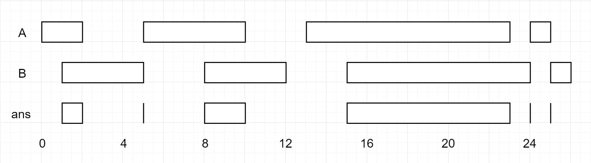

**Input:** firstList = [[0,2],[5,10],[13,23],[24,25]], secondList = [[1,5],[8,12],[15,24],[25,26]]

**Output:** [[1,2],[5,5],[8,10],[15,23],[24,24],[25,25]]

**Example 2:**

**Input:** firstList = [[1,3],[5,9]], secondList = []

**Output:** []

**Example 3:**

**Input:** firstList = [], secondList = [[4,8],[10,12]]

**Output:** []

**Example 4:**

**Input:** firstList = [[1,7]], secondList = [[3,10]]

**Output:** [[3,7]]

**Constraints:**

* 0 <= firstList.length, secondList.length <= 1000
* firstList.length + secondList.length >= 1
* 0 <= starti < endi <= 109
* endi < starti+1
* 0 <= startj < endj <= 109
* endj < startj+1

## Solution

#### **Approach 1: Merge Intervals**

**Intuition**

In an interval [a, b], call b the "endpoint".

Among the given intervals, consider the interval A[0] with the smallest endpoint. (Without loss of generality, this interval occurs in array A.)

Then, among the intervals in array B, A[0] can only intersect one such interval in array B. (If two intervals in B intersect A[0], then they both share the endpoint of A[0] -- but intervals in B are disjoint, which is a contradiction.)

**Algorithm**

If A[0] has the smallest endpoint, it can only intersect B[0]. After, we can discard A[0] since it cannot intersect anything else.

Similarly, if B[0] has the smallest endpoint, it can only intersect A[0], and we can discard B[0] after since it cannot intersect anything else.

We use two pointers, i and j, to virtually manage "discarding" A[0] or B[0] repeatedly.

|  |
| --- |
| class Solution {  public int[][] intervalIntersection(int[][] A, int[][] B) {  List<int[]> ans = new ArrayList();  int i = 0, j = 0;  while (i < A.length && j < B.length) {  // Let's check if A[i] intersects B[j].  // lo - the startpoint of the intersection  // hi - the endpoint of the intersection  int lo = Math.max(A[i][0], B[j][0]);  int hi = Math.min(A[i][1], B[j][1]);  if (lo <= hi)  ans.add(new int[]{lo, hi});  // Remove the interval with the smallest endpoint  if (A[i][1] < B[j][1])  i++;  else  j++;  }  return ans.toArray(new int[ans.size()][]);  }  } |

**Complexity Analysis**

* Time Complexity: O(M + N)*O*(*M*+*N*), where M, N*M*,*N* are the lengths of A and B respectively.
* Space Complexity: O(M + N)*O*(*M*+*N*), the maximum size of the answer.

## SQL

Are you applying for a Data Scientist position? You may be asked some basic SQL questions.

Here are some SQL questions which has been asked by Facebook available for you to practice.

**Second Highest Salary**

Write a SQL query to get the second highest salary from the Employee table.

+----+--------+

| Id | Salary |

+----+--------+

| 1 | 100 |

| 2 | 200 |

| 3 | 300 |

+----+--------+

For example, given the above Employee table, the query should return 200 as the second highest salary. If there is no second highest salary, then the query should return null.

+---------------------+

| SecondHighestSalary |

+---------------------+

| 200 |

+---------------------+

## Solution

#### **Approach: Using sub-query and LIMIT clause [Accepted]**

**Algorithm**

Sort the distinct salary in descend order and then utilize the [LIMIT](https://dev.mysql.com/doc/refman/5.7/en/select.html) clause to get the second highest salary.

SELECT DISTINCT

Salary AS SecondHighestSalary

FROM

Employee

ORDER BY Salary DESC

LIMIT 1 OFFSET 1

However, this solution will be judged as 'Wrong Answer' if there is no such second highest salary since there might be only one record in this table. To overcome this issue, we can take this as a temp table.

**MySQL**

SELECT

(SELECT DISTINCT

Salary

FROM

Employee

ORDER BY Salary DESC

LIMIT 1 OFFSET 1) AS SecondHighestSalary

;

#### **Approach: Using IFNULL and LIMIT clause [Accepted]**

Another way to solve the 'NULL' problem is to use IFNULL funtion as below.

**MySQL**

SELECT

IFNULL(

(SELECT DISTINCT Salary

FROM Employee

ORDER BY Salary DESC

LIMIT 1 OFFSET 1),

NULL) AS SecondHighestSalary

**Nth Highest Salary**

Write a SQL query to get the nth highest salary from the Employee table.

+----+--------+

| Id | Salary |

+----+--------+

| 1 | 100 |

| 2 | 200 |

| 3 | 300 |

+----+--------+

For example, given the above Employee table, the nth highest salary where n = 2 is 200. If there is no nth highest salary, then the query should return null.

+------------------------+

| getNthHighestSalary(2) |

+------------------------+

| 200 |

+------------------------+

**Customers Who Never Order**

Suppose that a website contains two tables, the Customers table and the Orders table. Write a SQL query to find all customers who never order anything.

Table: Customers.

+----+-------+

| Id | Name |

+----+-------+

| 1 | Joe |

| 2 | Henry |

| 3 | Sam |

| 4 | Max |

+----+-------+

Table: Orders.

+----+------------+

| Id | CustomerId |

+----+------------+

| 1 | 3 |

| 2 | 1 |

+----+------------+

Using the above tables as example, return the following:

+-----------+

| Customers |

+-----------+

| Henry |

| Max |

+-----------+

## Solution

#### **Approach: Using sub-query and NOT IN clause [Accepted]**

**Algorithm**

If we have a list of customers who have ever ordered, it will be easy to know who never ordered.

We can use the following code to get such list.

select customerid from orders;

Then, we can use NOT IN to query the customers who are not in this list.

**MySQL**

select customers.name as 'Customers'

from customers

where customers.id not in

(

select customerid from orders

);

**Friend Requests I: Overall Acceptance Rate**

Table: FriendRequest

+----------------+---------+

| Column Name | Type |

+----------------+---------+

| sender_id | int |

| send_to_id | int |

| request_date | date |

+----------------+---------+

There is no primary key for this table, it may contain duplicates.

This table contains the ID of the user who sent the request, the ID of the user who received the request, and the date of the request.

Table: RequestAccepted

+----------------+---------+

| Column Name | Type |

+----------------+---------+

| requester_id | int |

| accepter_id | int |

| accept_date | date |

+----------------+---------+

There is no primary key for this table, it may contain duplicates.

This table contains the ID of the user who sent the request, the ID of the user who received the request, and the date when the request was accepted.

Write an SQL query to find the overall acceptance rate of requests, which is the number of acceptance divided by the number of requests. Return the answer rounded to 2 decimals places.

**Note that:**

* The accepted requests are not necessarily from the table friend_request. In this case, you just need to simply count the total accepted requests (no matter whether they are in the original requests), and divide it by the number of requests to get the acceptance rate.
* It is possible that a sender sends multiple requests to the same receiver, and a request could be accepted more than once. In this case, the ‘duplicated’ requests or acceptances are only counted once.
* If there are no requests at all, you should return 0.00 as the accept_rate.

The query result format is in the following example:

FriendRequest table:

+-----------+------------+--------------+

| sender_id | send_to_id | request_date |

+-----------+------------+--------------+

| 1 | 2 | 2016/06/01 |

| 1 | 3 | 2016/06/01 |

| 1 | 4 | 2016/06/01 |

| 2 | 3 | 2016/06/02 |

| 3 | 4 | 2016/06/09 |

+-----------+------------+--------------+

RequestAccepted table:

+--------------+-------------+-------------+

| requester_id | accepter_id | accept_date |

+--------------+-------------+-------------+

| 1 | 2 | 2016/06/03 |

| 1 | 3 | 2016/06/08 |

| 2 | 3 | 2016/06/08 |

| 3 | 4 | 2016/06/09 |

| 3 | 4 | 2016/06/10 |

+--------------+-------------+-------------+

Result table:

+-------------+

| accept_rate |

+-------------+

| 0.8 |

+-------------+

There are 4 unique accepted requests, and there are 5 requests in total. So the rate is 0.80.

**Follow up:**

* Could you write a query to return the acceptance rate for every month?
* Could you write a query to return the cumulative acceptance rate for every day?

  Hide Hint #1

Still remember how to count the number of rows in a table?

   Hide Hint #2

What is the keyword to filter the duplicated records in a table?

## Solution

#### **Approach: Using round and ifnull [Accepted]**

**Intuition**

Count the accepted requests and then divides it by the number of all requests.

**Algorithm**

To get the distinct number of accepted requests, we can query from the **request_accepted** table.

select count(*) from (select distinct requester_id, accepter_id from request_accepted;

With the same technique, we can have the total number of requests from the **friend_request** table:

select count(*) from (select distinct sender_id, send_to_id from friend_request;

At last, divide these two numbers and [round](https://dev.mysql.com/doc/refman/5.7/en/mathematical-functions.html#function_round) it to a scale of 2 decimal places to get the required acceptance rate.

Wait! The divisor (total number of requests) could be '0' if the table **friend_request** is empty. So, we have to utilize [ifnull](https://dev.mysql.com/doc/refman/5.7/en/control-flow-functions.html#function_ifnull) to deal with this special case.

**MySQL**

select

round(

ifnull(

(select count(*) from (select distinct requester_id, accepter_id from request_accepted) as A)

/

(select count(*) from (select distinct sender_id, send_to_id from friend_request) as B),

0)

, 2) as accept_rate;

**Friend Requests II: Who Has the Most Friends**

**Solution**

In social network like Facebook or Twitter, people send friend requests and accept others' requests as well.

Table request_accepted

+--------------+-------------+------------+

| requester_id | accepter_id | accept_date|

|--------------|-------------|------------|

| 1 | 2 | 2016_06-03 |

| 1 | 3 | 2016-06-08 |

| 2 | 3 | 2016-06-08 |

| 3 | 4 | 2016-06-09 |

+--------------+-------------+------------+

This table holds the data of friend acceptance, while **requester_id** and **accepter_id** both are the id of a person.

Write a query to find the the people who has most friends and the most friends number under the following rules:

* It is guaranteed there is only 1 people having the most friends.
* The friend request could only been accepted once, which mean there is no multiple records with the same **requester_id** and **accepter_id** value.

For the sample data above, the result is:

Result table:

+------+------+

| id | num |

|------|------|

| 3 | 3 |

+------+------+

The person with id '3' is a friend of people '1', '2' and '4', so he has 3 friends in total, which is the most number than any others.

**Follow-up:**  
In the real world, multiple people could have the same most number of friends, can you find all these people in this case?

Hide Hint #1

Being friends is bidirectional. If you accept someone's adding friend request, both you and the other person will have one more friend.

## Solution

#### **Approach: Union requester_id and accepter_id [Accepted]**

**Algorithm**

Being friends is bidirectional, so if one person accepts a request from another person, both of them will have one more friend.

Thus, we can union column requester_id and accepter_id, and then count the number of the occurrence of each person.

select requester_id as ids from request_accepted

union all

select accepter_id from request_accepted;

Note: Here we should use union all instead of union because union all will keep all the records even the 'duplicated' one.

Taking the sample as an example, the output is:

| **ids** |
| --- |
| 1 |
| 1 |
| 2 |
| 3 |
| 2 |
| 3 |
| 3 |
| 4 |

Then it will be fairly easy to get the 'ids' with most occurrence using the same technique as mentioned in problem [580. Customer Placing the Largest Number of Orders](https://leetcode.com/problems/count-student-number-in-departments/#/description).

**MySQL**

select ids as id, cnt as num

from

(

select ids, count(*) as cnt

from

(

select requester_id as ids from request_accepted

union all

select accepter_id from request_accepted

) as tbl1

group by ids

) as tbl2

order by cnt desc

limit 1

;

**Department Top Three Salaries**

The Employee table holds all employees. Every employee has an Id, and there is also a column for the department Id.

+----+-------+--------+--------------+

| Id | Name | Salary | DepartmentId |

+----+-------+--------+--------------+

| 1 | Joe | 85000 | 1 |

| 2 | Henry | 80000 | 2 |

| 3 | Sam | 60000 | 2 |

| 4 | Max | 90000 | 1 |

| 5 | Janet | 69000 | 1 |

| 6 | Randy | 85000 | 1 |

| 7 | Will | 70000 | 1 |

+----+-------+--------+--------------+

The Department table holds all departments of the company.

+----+----------+

| Id | Name |

+----+----------+

| 1 | IT |

| 2 | Sales |

+----+----------+

Write a SQL query to find employees who earn the top three salaries in each of the department. For the above tables, your SQL query should return the following rows (order of rows does not matter).

+------------+----------+--------+

| Department | Employee | Salary |

+------------+----------+--------+

| IT | Max | 90000 |

| IT | Randy | 85000 |

| IT | Joe | 85000 |

| IT | Will | 70000 |

| Sales | Henry | 80000 |

| Sales | Sam | 60000 |

+------------+----------+--------+

**Explanation:**

In IT department, Max earns the highest salary, both Randy and Joe earn the second highest salary, and Will earns the third highest salary. There are only two employees in the Sales department, Henry earns the highest salary while Sam earns the second highest salary.

## Solution

#### **Approach: Using JOIN and sub-query [Accepted]**

**Algorithm**

A top 3 salary in this company means there is no more than 3 salary bigger than itself in the company.

select e1.Name as 'Employee', e1.Salary

from Employee e1

where 3 >

(

select count(distinct e2.Salary)

from Employee e2

where e2.Salary > e1.Salary

)

;

In this code, we count the salary number of which is bigger than e1.Salary. So the output is as below for the sample data.

| Employee | Salary |

|----------|--------|

| Henry | 80000 |

| Max | 90000 |

| Randy | 85000 |

Then, we need to join the **Employee** table with **Department** in order to retrieve the department information.

**MySQL**

SELECT

d.Name AS 'Department', e1.Name AS 'Employee', e1.Salary

FROM

Employee e1

JOIN

Department d ON e1.DepartmentId = d.Id

WHERE

3 > (SELECT

COUNT(DISTINCT e2.Salary)

FROM

Employee e2

WHERE

e2.Salary > e1.Salary

AND e1.DepartmentId = e2.DepartmentId

)

;

| Department | Employee | Salary |

|------------|----------|--------|

| IT | Joe | 70000 |

| Sales | Henry | 80000 |

| Sales | Sam | 60000 |

| IT | Max | 90000 |

| IT | Randy | 85000 |